**Emory RAS (Research Administration Services)**

**Employee Turnover**

**Xiao (Susie) Bai**

**Section 1. Graphical Analysis (Kaplan-Meier survival plots) and Descriptive Statistics -- How Employee Turnover Varied with Individual Variables**

First of all, to get a general sense of what our data looks like and gain some basic descriptive information of the data, we look at the frequency tables (and histograms for continuous-valued variables) of every variables here. Here let’s see some brief notes about meaningful discussions on frequencies below. ***(See Appendix)***

As for missing values, except the “education level” variable has 19 missing values, none of the other categorical variables has missing values.

1).”rank” variable: it seems that the three more junior levels of rank(“I”,”II”&”III”) take up more than 87% of the dataset, so the more senior levels of rank(“Mgr”,“Dir”&”Sr Dir”) really take up only a small portion(less than 13%) of the data.

2).”title” variable: there are 45+ unique titles, and except certain specific titles—such as “Research Admin, Post Award II”, “Research Admin, Post Award III”, “Research Admin, Pre-Award II”, “Research Admin, Pre-Award III”(seemingly the biggest ‘group’ is “Research Admin” related)—which have apparently quite more observations(e.g. 258 observations in “Research Admin, Post Award III”), most of the titles only have a few observations (‘scattered’).

3).”division” variable: the majority of the observations concentrate in “School Of Medicine” (~70%), followed by “School Of Public Health”(~20%); the remaining levels have fewer entries.

4).”gender” & “supervisor gender” variables: there are much more “female” observations(>81%) than “male” observations in the data; similarly, there are much more observations with “female supervisor”(~86%) than “male supervisor”. “white” & “supervisor race” variables: while there are relatively even distribution in “non-white” and “white” observations, there are more observations with “white supervisor”(~75%) than “non-white supervisor”.

5).”education level” variable: there are only very few observations with a “doctoral degree”, which only takes up 1% of the data. The biggest group here is “Bachelor’s degree”(~50%).

6).”department” and “RAS unit” variables basically represent the same thing.

We also look at the basic summary statistics and histograms of the 3 continuous-valued variables here—“annual rt”, “age” & “tenure at Emory”. As for “annual rt” variable, while the mean value is about $69500, the value range seems somehow wide—ranging from a little more than $23K to as high as nearly 160K (standard deviation is 17717). As for “age” variable, the mean is about 46 (years old) with a range of roughly (22, 72). As for “tenure at Emory” variable, the mean is about 97 (months) with a range of (0, 374.2). ***Based on the histogram and statistics, “annual rt” is the most skewed (skewness 1.421) among the three here; it has a long right tail. With consideration of its skewness and relatively big original scale(wide range), we would consider taking natural log of “annual rt”.*** “Age” is only very slightly left skewed, which seems to have 3 peaks around 35~36.5, 46.7~48.4, 56.7~58.4 from the graph. “Tenure at Emory” is also a little right skewed.

We then also have a quick look at the cross-tabs (and Chi-square statistics) for all categorical variables to supplement our general understanding of data. Here are some noteworthy comments:

1).”rank” variable: we discover that the 3 more junior level ranks take up the majority of the cases of “quits”(including “voluntary quit” & “involuntary quit”), while there are very few portions of quit on the more senior level ranks (only about 10% for “voluntary quit” and actually 0% for “involuntary quit” for “Mgr”&”Dir”&”Sr Dir” together), which makes sense.

2).”title” variable: we find here that besides most observations concentrating in “Research Admin” related title levels, also most of the quit cases happen in “Research Admin” related title levels—particularly, in more “junior” title levels(“Pre-Award I/II/III” & “Post-Award I/II/III”) than in more management title levels(e.g. “Mgr” & “Lead”(“Pre-Award” & “Post-Award”)) within the “Research Admin”, in terms of both “voluntary quit”(“Pre/Post-Award I/II/III”: 73.4% of “voluntary quit”) and “involuntary quit”(“Pre/Post-Award I/II/III”: actually 100%!).

3).”gender” variable: while the proportions of “voluntary quit” across “male” and “female” are roughly corresponding to the proportions of number of observations (“female” higher than “male”), the proportions of “involuntary quit” are different—actually, exactly evenly distributed across the two groups “male” and “female”.

4).”white” variable: similar to “gender” variable, while “non-white” and “white” observations have corresponding proportions in “voluntary quit” to those in number of observations, the “non-white” group sees a much higher proportion getting “involuntary quit”(like dismissals) than the “white” group.

5).”education level” variable: there is actually only 1 observation of “quit”(“voluntary quit”) (1% of all quits) in the “doctoral degree” group, we may consider just combining this group into the “master’s degree” group.

According to the Chi-square tests, we can know that *only the “ras_entrymode” variable shows (strong) statistical significance with regard to “Pearson Chi-square” statistics among all. This is to say, the difference in the outcome of whether an employee would quit or not at certain point varies statistically significantly across the levels of origins of RAS employees*.

Based on our inspection of basic statistics and cross-tabs, I have decided to manipulate the original variables into new ones as follows:

1).”rank” variable -> new “rank_upt” variable: integrate the original more senior levels of rank(“Mgr”, “Asst Dir”, “Dir”, “Sr Dir”) into a new level, “management”, while keeping the original “I”, “II”, “III” levels of rank unchanged.

2).”title” variable -> new “title_upt” variable: group original levels of management titles(“Mgr” & “Lead”) in “Research Admin” as new level “Research Admin, management”, keep the more junior levels(“I/II/III”) in “Research Admin” as unchanged, and all the other remaining levels as “others”

3).”educlv” variable -> new “educlv_upt” variable: integrate the original two levels of “master’s degree” and “doctorial degree” into one new level “graduate degree”

4).”annualrt” variable -> new “annualrt_log” variable: take natural log of the “annualrt” variable

5).exclude “department” and use “rastype” variable only (to avoid redundancy of variables)

Checking cross-tabs and Chi-square statistics for the newly created categorical variables again, we find that the “rank_upt” variable shows statistical significance in Chi-square test now (p-value for Pearson Chi-square 0.007).

Now, we look at the Kaplan-Meier plots and the Log-rank statistics accordingly to figure out the differences in patterns of the survival function across groups defined by the following individual variables: “rank_upt”, “award”, “gender”, “supvgender”, “rastype”, “ras_entrymode”, “white”, “supvwhite”, educlv_upt” and “ras_treat”. ***(See Appendix)*** Here are some notable findings as follows:

1).”rank_upt”: from the plot, we can see that the rank “I” group gets the fewest survived overall (the most “quitted”), while the rank “III” group (and roughly “management” group) gets the most survived till the end(the fewest “quitted”). Also the rank “I” group is the one with the quickest quits since the beginning, and the “management” group is the one with slowest quits. So it seems if an employee has a somehow higher rank, he/she may be less likely to quit.

2).”award”: while the three groups(“Pre”(Award), “Post”(Award) & “Other”) have very similar cumulative survival rates over most of the time window(roughly the first 50 months), the “Pre”(Award) group has the fewest survived (the most “quitted”) in the end among the three.

3).”gender”: while both “male” and “female” groups have similar cumulative survival rates most of the time (before 30th month, and after 50th month), there’s some slight interesting difference in the decreasing pattern of the survival function curve in the middle of the time window(roughly 30th-50th month): during this period, the decrease in cumulative survival rate for the “female” group is apparently more steady in the beginning and then becomes more drastic (“no one quitted in the beginning and suddenly quite a few females started quitting”), while the decrease for the “male” group suddenly turns faster in the beginning and then levels off (“a lot of males quitted in the beginning and then it calmed down”). After this period, the cumulative survival function for the two groups returns to be the same.

4).”supvgender”: overall, more employees with a “female supervisor” quitted than employees with a “male supervisor” over time (those with a “male supervisor” actually did not likely quit).

5).”rastype”(RAS Unit): from the plot, the “Shared Services Center” group has the most employees quitted over time, while the “SOM Specialty & Hospital RAS” group almost do not have anyone quitted.

6).”ras_entrymode”(origin of RAS employee): while the “different division” and the “new entry” groups have similar cumulative survival rates(similar number of people quitted) at the beginning of the time window(roughly the first 20 months) (higher quit rate than the “same division” group), the “new entry” group has much more employees quitted than the other two groups at the end of the time window(only about 60% of the original population in the “new entry” group stayed till the end). A possible reason might be that some newly hired employees did not survive after the employment probation period.

7).”white” & “supvwhite”: “non-white” employees are more likely to quit than “white” employees over time; similarly, employees with a “non-white supervisor” are also more likely to quit than those with a “white supervisor” over time.

8).”educlv_upt”: while all three education level groups have similar cumulative survival rates at the beginning of the time window (roughly the first 20 months), the group with “HS and Associate’s degree”(lower education level) turns out to be the one with the most people quitted, and the group with “graduate degree”(high education level) turns out to be the one with the most people stayed as time passes by.

*With regard to the Log-rank test statistics, “rank_upt”(updated “rank”), “ras_entrymode”(origin of RAS employee), “supvgender”(supervisor gender), and “white”(employee race) are the statistically significant individual variables at the 0.05 level according to the p-value of Chi-square stats. This indicates that there are statistically significant differences in the probability distribution of the “employee turnover” event over the time window between the groups of population with different rank, employment origin, race and supervisor gender.*

**Section 2. Statistical Modeling -- Identify Explanatory Factors for the Rate of Employee Turnover (using Cox Regression) for the Three Types of Quits: a). All Types of Quits; b). Voluntary Quits Only; c). Involuntary Quits Only**

a). **statistical modeling for factors explaining variations in the rate of “All type of quits”(coded as “1”&”2” in original data altogether)**

In this section, we try to build models with different appropriate combinations of independent variables to explain variations in the “turnover” event over time. We use Cox Regression in SPSS as our analytical tool here. A very important notice, first of all, is the potential multicollinearity issue in the set of independent variables – based on our real-life managerial understanding, we would suppose that variables “age” and “tenure_te” would be highly correlated, and variables “annualrt_log”(logged annual pay rate) and “rank_upt”(updated “rank”) would be quite correlated. Therefore, we would not include these pairs in a same model in order to prevent multicollinearity. We also plot the pair-wise correlation matrix for quick reference. (Notice a little as well that “rastype”(RAS unit) and “ras_treat”(treatment group) might be correlated; “tenure_te”(tenure at Emory) and “ras_entrymode”(origin of RAS employee) might be correlated. These actually somehow makes sense based on the data understanding. We pay some extra attention to them in the modeling process.) ***(See Appendix)***

We start our first model with a set of demographic related independent variables—“white”, “gender” and “educlv_upt”, and then add more indicators such as those related to organizational characteristics. We explore a bunch of models to see their goodness of fit and significance.

Here is a summary table created to provide an overview of all the versions of the statistical model(Cox Regression) we’ve built in the process:

|  |  |  |
| --- | --- | --- |
| **Model attempted** | **Model “-2 Log Likelihood” (sig. of overall Chi-square)** | **Significant independent variables (at 95% level)** |
| white, gender, educlv_upt(“graduate degree” default) | 699.405 (0.05*) | White(0.03*) |
| white, educlv_upt(“graduate degree” default), rank_upt(“management” default) | 679.893(0.000***) | rank_upt(0.000***) |
| gender, white, educlv_upt(“graduate degree” default), rank_upt(“management” default) | 679.781(0.000***) | rank_upt(0.000***) |
| white, rank_upt(“management” default) | 695.397(0.000***) | rank_upt(0.000***) |
| rank_upt(“management” default), ras_entrymode(“same division” default) | 685.767(0.000***) | rank_upt(0.000***), ras_entrymode(0.002**) |
| white, rank_upt(“management” default), ras_entrymode(“same division” default) | 682.016(0.000***) | rank_upt(0.000***), ras_entrymode(0.001***) |
| white, rank_upt(“management” default), ras_entrymode(“same division” default), supvgender | 671.735(0.000***) | rank_upt(0.000***), ras_entrymode(0.000***), supvgender(0.007**) |
| white, rank_upt(“management” default), ras_entrymode(“same division” default), supvgender, supvwhite | 669.998(0.000***) | rank_upt(0.000***), ras_entrymode(0.001***), supvgender(0.014*) |
| white, rank_upt(“management” default), ras_entrymode(“same division” default), supvwhite | 678.297(0.000***) | rank_upt(0.000***), ras_entrymode(0.002**), supvwhite(0.048*) |
| white, rank_upt(“management” default), ras_entrymode(“same division” default), supvgender, age | 669.777(0.000***) | rank_upt(0.001***), ras_entrymode(0.004**), supvgender(0.011*) |
| white, rank_upt(“management” default), ras_entrymode(“same division” default), supvgender, tenure_te | 671.521(0.000***) | rank_upt(0.000***), ras_entrymode(0.02*), supvgender(0.009**) |
| white, annualrt_log, ras_entrymode(“same division” default), supvgender | 674.871(0.000***) | ras_entrymode(0.001***), supvgender(0.023*), white(0.033*), annualrt_log(0.000***) |
| white, annualrt_log, ras_entrymode(“same division” default), supvgender, rastype(“shared service centers” default) | 657.527(0.000***) | ras_entrymode(0.000***), supvgender(0.032*), white(0.037*), annualrt_log(0.000***) |
| white, annualrt_log, ras_entrymode(“same division” default), supvgender, award(“other” default) | 674.795(0.000***) | ras_entrymode(0.001***), supvgender(0.025*), white(0.036*), annualrt_log(0.000***) |
| white, annualrt_log, ras_entrymode(“same division” default), supvgender, ras_treat | 674.871(0.000***) | ras_entrymode(0.001***), supvgender(0.025*), white(0.033*), annualrt_log(0.000***) |

Here we find that our 12th model tried—the one with “white”(race), “annualrt_log”(logged annual pay rate), “ras_entrymode”(origin of RAS employee) and “supvgender”(supervisor gender) as independent variables—seems to be the most meaningful one among all versions of models explored with regard to the rate of “all types of quits(both voluntary and involuntary)”, as all the four independent variables in this model are statistically significant at least at the 95% level. These four independent variables can explain the variations in the turnover rate for all types of quits over time.

Let’s take a closer look at this specific model. We find that the p-value for the Overall Chi-square stats of this model indicates strong statistical significance in the “Omnibus Tests of Model Coefficients” table (and the “change from previous step/block” are also strongly statistically significant), which means the model here is statistically significantly better than the intercept-only model. Inspecting the “Variables in the equation” table for individual variable significance and regression coefficients, the “ras_entrymode” and “annualrt_log” variables are the two indicators with the strongest statistical significance(at 0.001 significance level), while the significances of “supvgender” and “white” are weaker. From “B” column we can see that the coefficients for “white” and “annualrt_log” are negative, indicating that these two variables are negatively correlated with the “all type” quit rate—“white” employees(coded as level “1”) are less likely to quit overall than “non-white” employees(coded as level “0”); and as an employee’s annual pay increases, he/she becomes less likely to quit overall. Yet the coefficients for “supvgender” and “ras_entrymode” are positive, indicating that the two variables are positively correlated with the “all type” quit rate, so that an employee with a “female supervisor”(coded as level “1”) is more likely to quit than an employee with a “male supervisor”(coded “0”); and compared to the default “same division” level, those newly hired(coded “Origin of RAS employee(1)”) and coming from a different division(coded “Origin of RAS employee(2)”) are more likely to quit.

Based on the “Exp(B)” column, we can tell that being a “white” employee decreases the hazard (risk of quit) by multiplicative factor of 0.550 compared to being a “non-white” employee, and having a “female supervisor” increases the hazard (risk of quit) by multiplicative factor of 3.306 compared to having a “male supervisor”. Compared to employees coming from the “same divison”, being an employee newly hired increases the hazard (risk of quit) by multiplicative factor of 3.073, and being an employee coming from a “different division” also increases the hazard by factor of 2.515(a little bit less effect than those newly hired). Regarding the logged annual pay rate, since it’s a continuous-valued variable, we plot a “Exp(B)” table across its entire range of values at intervals in Excel to examine its effect more accurately:

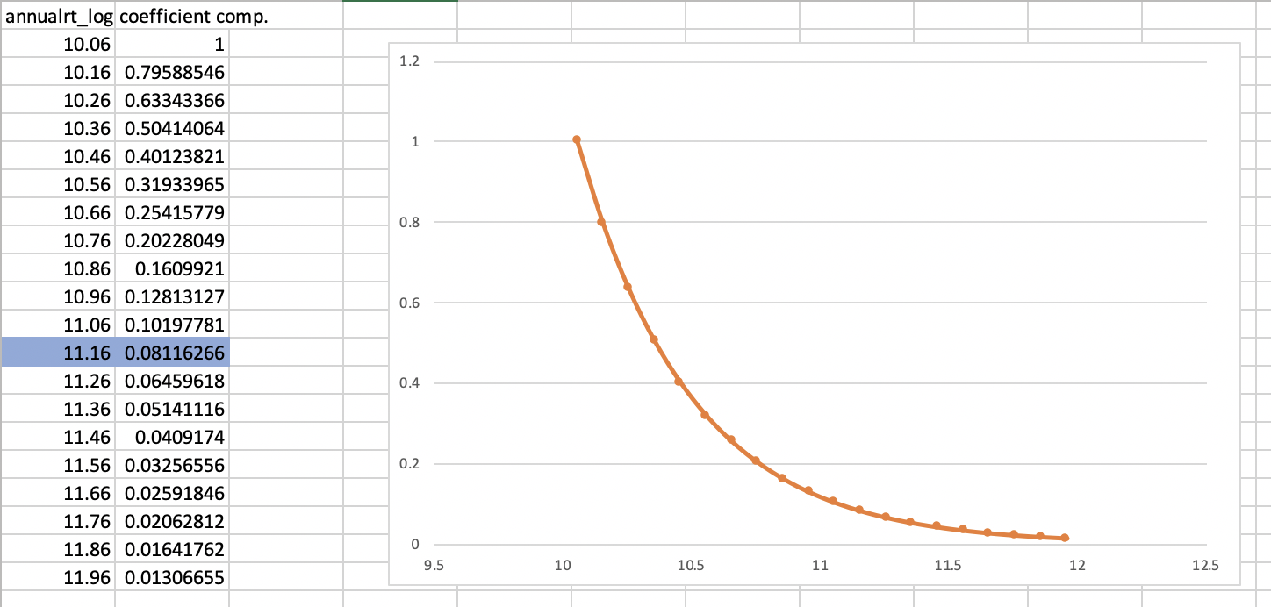

So, for example, we can see that compared to the minimum value of “annualrt_log”(logged annual pay rate), if an employee has a roughly mean value of “annualrt_log”(11.16), his/her hazard (risk of quit) would decrease by multiplicative factor of 0.081.

During the process, we also notice that some independent variables—such as “white”—may not be statistically significant all the time (and the significance may be weaker, or sometimes close to significance). Also, given the “annual rate(logged)” is highly correlated with “rank(updated)”, it seems “annualrt(logged)” turns out to be a better indicator than “rank(updated)” here.

b). **statistical modeling for factors explaining variations in the rate of “Voluntary Quits only”(coded as “1” in original data)**

The type of model(Cox Regression in SPSS) and the basic idea of the procedure are literally the same. We also pay attention to the same details. Now here is the summary table for all versions of models(Cox Regression model with different combinations of meaningful independent variables) tried during the process:

|  |  |  |
| --- | --- | --- |
| Model attempted | Model “-2 Log Likelihood” (sig. of overall Chi-square) | Significant independent variables (at 95% level) |
| white, gender, educlv_upt(“graduate degree” default) | 609.791(0.219) | / |
| rank_upt(“management” default) | 597.083(0.000***) | rank_upt(0.000***) |
| white, gender, educlv_upt(“graduate degree” default), rank_upt(“management” default) | 591.626(0.000***) | rank_upt(0.000***) |
| white, rank_upt(“management” default) | 595.695(0.000***) | rank_upt(0.000***) |
| rank_upt(“management” default), ras_entrymode(“same division” default) | 584.635(0.000***) | rank_upt(0.001***), ras_entrymode(0.003**) |
| rank_upt(“management” default), ras_entrymode(“same division” default), supvgender | 573.680(0.000***) | rank_upt(0.000***), ras_entrymode(0.001***), supvgender(0.008**) |
| rank_upt(“management” default), ras_entrymode(“same division” default), supvgender, supvwhite | 571.917(0.000***) | rank_upt(0.000***), ras_entrymode(0.001***), supvgender(0.014*) |
| rank_upt(“management” default), ras_entrymode(“same division” default), supvwhite | 580.847(0.000***) | rank_upt(0.000***), ras_entrymode(0.002**), supvwhite(0.045*) |
| rank_upt(“management” default), ras_entrymode(“same division” default), supvgender, tenure_te | 573.442(0.000***) | rank_upt(0.000***), ras_entrymode(0.026*), supvgender(0.009**) |
| annualrt_log, ras_entrymode(“same division” default), supvgender | 576.529(0.000***) | ras_entrymode(0.001***), supvgender(0.019*), annualrt_log(0.000***) |
| annualrt_log, ras_entrymode(“same division” default), supvgender, rastype(“shared service centers” default) | 565.625(0.000***) | ras_entrymode(0.000***), supvgender(0.015*), annualrt_log(0.000***) |
| annualrt_log, ras_entrymode(“same division” default), supvgender, award(“other” default) | 576.172(0.000***) | ras_entrymode(0.001***), supvgender(0.02*), annualrt_log(0.000***) |
| annualrt_log, ras_entrymode(“same division” default), supvgender, ras_treat | 576.518(0.000***) | Ras_entrymode(0.001***), supvgender(0.021*), annualrt_log(0.000***) |

The 6th model here—the one with “rank_upt”(“rank updated”), “ras_entrymode”(origin of RAS employee) and “supvgender”(supervisor gender) as independent variables—appears to be the most meaningful one among all in terms of the “voluntary quit” rate; all three indicators are or are close to strongly statistically significant. So the variations in the turnover rate for “voluntary quits” can be explained by an employee’s rank, working origin, and his/her supervisor’s gender.

In the “Omnibus Tests of Model Coefficients” table for this particular model, the p-value for the Overall Chi-square stats indicates strong statistical significance, thus the model here is statistically significantly better than the intercept-only model. Speaking of the “Variables in the equation” table for the model, all three independent variables here have positive regression coefficients, so all these three variables are positively correlated with the “voluntary quit” rate (as of the defaulted level respectively): compared to the “management” level rank, employees with lower ranks are more likely to voluntarily quit; compared to employees coming from the “same division”, those newly hired and coming from a “different division” are more likely to voluntarily quit; and having a “female supervisor” also increases the likelihood of voluntary quits than having a “male supervisor”. Further, based on the “Exp(B)” column, having a “female supervisor”, compared to having a “male supervisor”, increases the hazard (risk of voluntary quit) by multiplicative factor of 5.121; compared to those coming from the “same division”, being new hires(“Origin of RAS employee(1)”) increases the “voluntary” hazard by factor of 3.264, which is higher than the increase in the “voluntary” hazard for those coming from a “different division”(the increase in hazard for being an employee from a “different division” is by factor of 2.753). Additionally, compared to the “management” level employees, for example, being an employee with only the “I” rank(most junior rank) increases the “voluntary” hazard the most—it increases the hazard by multiplicative factor of up to 6.993.

A finding here might be that the model results for “voluntary quits” seem to be quite similar to those in the first task(for “All type of quits”); yet certain difference would be the insignificance of “white”(race) variable here.

c). **statistical modeling for factors explaining variations in the rate of “Involuntary Quits only”(coded as ”2” in original data)**

As previously, we still use Cox Regression models in SPSS and explore different meaningful combinations of independent variables to explain variations in the “involuntary quit” rate. The summary table of all versions of the models examined in this stage is as follows:

|  |  |  |
| --- | --- | --- |
| **Model attempted** | **Model “-2 Log Likelihood” (sig. of overall Chi-square)** | **Significant independent variables (at 95% level)** |
| white, gender | 96.227(0.004**) | white(0.028*), gender(0.009**) |
| white, gender, educlv_upt(“graduate degree” default) | 78.522(0.004**) | white(0.024*), gender(0.003**) |
| white, gender, rank_upt(“management” default) | *(did not converge after 9 iterations)* 92.071(0.004**) | white(0.048*), gender(0.039*) |
| white, gender, ras_entrymode(“same division” default) | 94.806(0.014*) | white(0.029*), gender(0.009**) |
| white, gender, supvgender | 96.202(0.01**) | white(0.028*), gender(0.009**) |
| white, gender, supvwhite | 95.953(0.01**) | white(0.032*), gender(0.008**) |
| white, gender, supvgender, supvwhite | 95.902(0.022*) | white(0.031*), gender(0.008**) |
| white, gender, age | 96.096(0.01**) | white(0.029*), gender(0.011*) |
| white, gender, tenure_te | 96.127(0.01**) | white(0.029*), gender(0.013*) |
| white, gender, annualrt_log | 93.521(0.003**) | white(0.036*), gender(0.039*) |
| white, gender, rastype(“shared service centers” default) | *(did not converge after 4 iterations)* 86.991(0.004**) | white(0.016*), gender(0.037*) |
| white, gender, award(“other” default) | *(did not converge after 10 iterations)* 95.166(0.019*) | white(0.034*), gender(0.013*) |
| white, gender, ras_treat | 96.102(0.01**) | white(0.028*), gender(0.009**) |

The model results for “involuntary quits” here might seem a little surprising, as they look quite different from the results in the first two tasks(for “All type of quits” and for “voluntary quits”). Across all attempts of exploring the models here, “white”(race) and “gender” turn out to be the only two variables that stay statistically significant at the 95% level all the time(though the significance may not seem to be very strong either), while the other available variables do not present much statistical significance. So here, perhaps the occurrence of “involuntary quits” may indeed be attributed to only the two simple demographics variables, an employee’s race and gender; or perhaps the attributes in the original data set may not reflect the nature of the generating process of “involuntary quits”(e.g. dismissal of an employee) so well.

Overall, the significances of the entire models here seem a little weaker than those in the first two tasks. As we look at the first model--the one with only “white” and “gender” variables, the overall p-value for model Chi-square is 0.004, indicating moderate statistical significance, so our model is moderately significantly better than the intercept-only model. According to the “Variables in the Equation” result table for this model, both variables, “white” and “gender”, have negative regression coefficients(“B”), signaling negative correlations with the “involuntary quit” rate. That is to say, based on the “Exp(B)” column, being a “white” employee(coded as “1”) decreases the hazard for “involuntary quits” by multiplicative factor of 0.093 in comparison with being a “non-white” employee(coded as “0”), and being a “female” employee(coded as “1”) also decreases the hazard for “involuntary quits” by factor of 0.155 in comparison with being a “male” employee.

These results and analyses may shed some light on the reality of employee turnovers among Emory RAS staff.

**Appendix**

**Section 1:**

**I. Frequency Tables & Histograms**

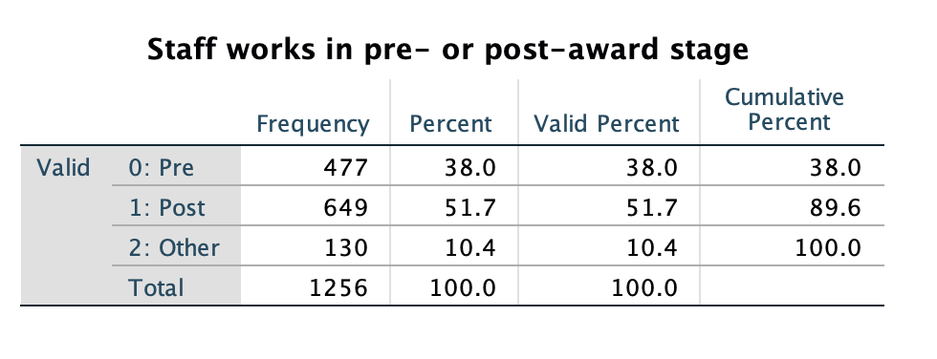

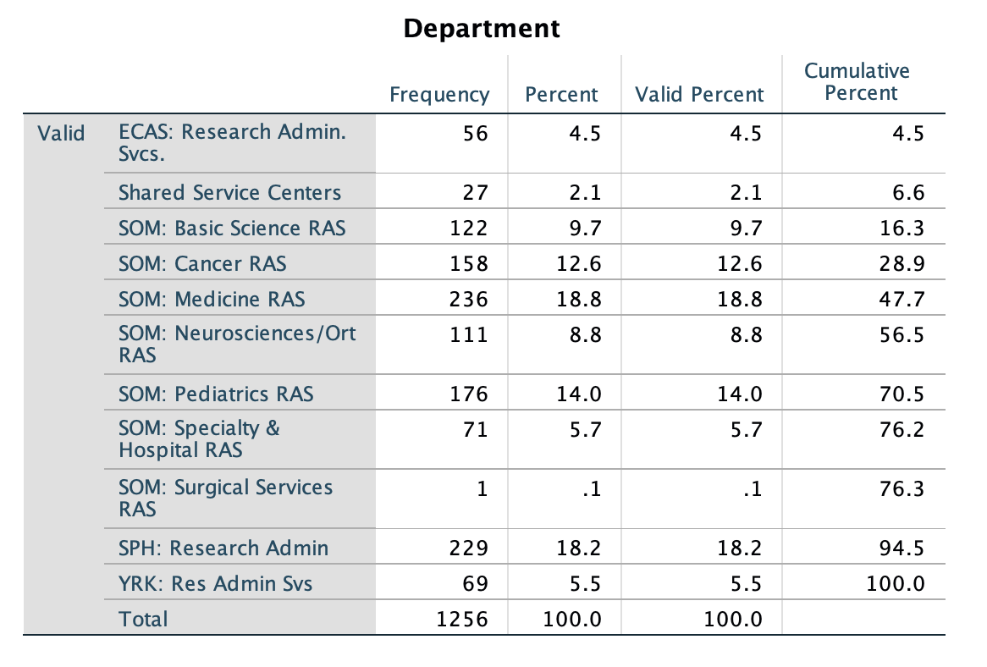

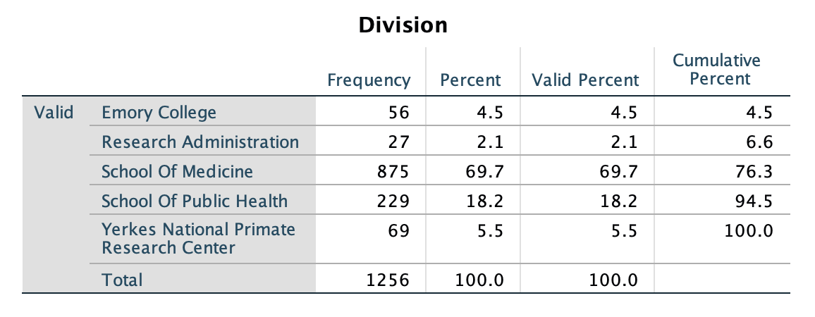

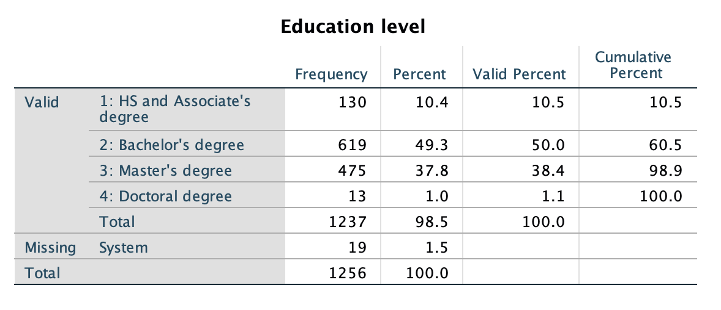

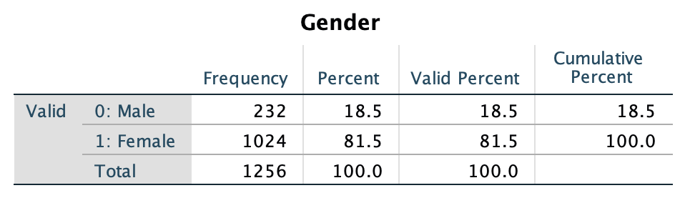

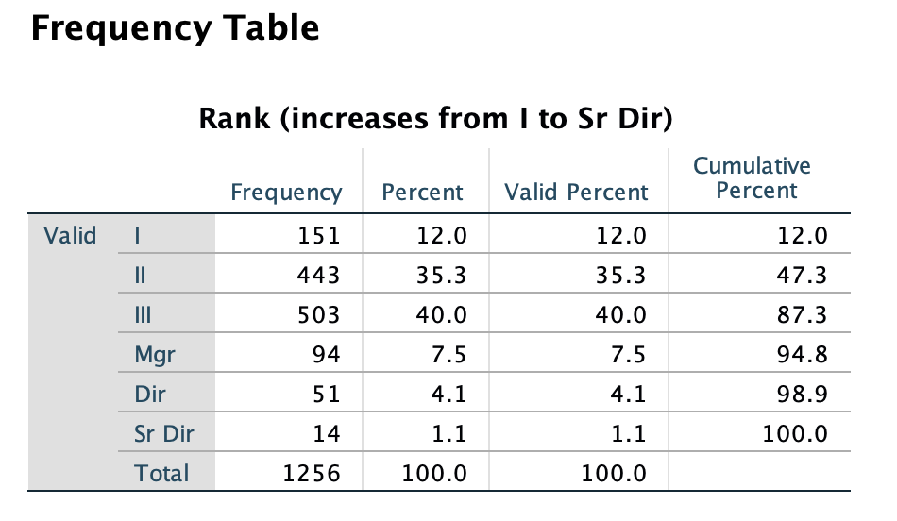

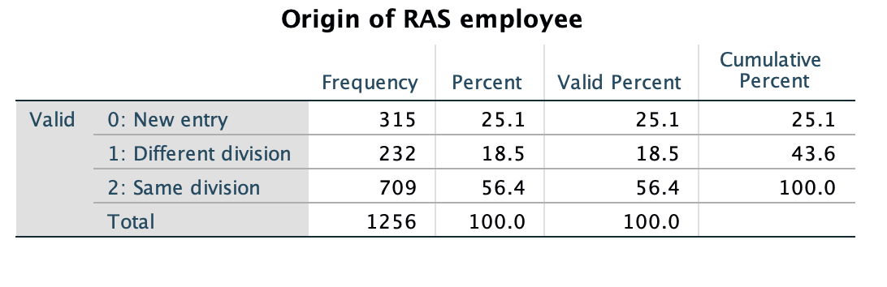

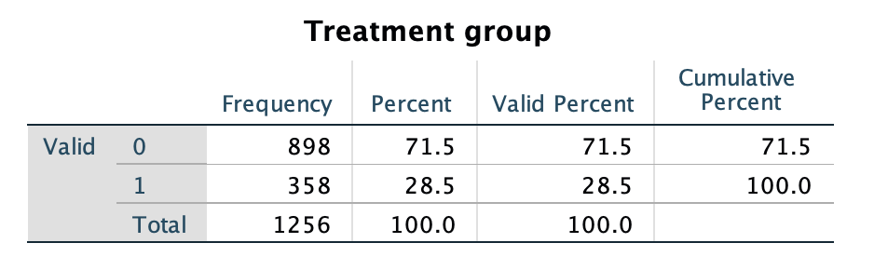

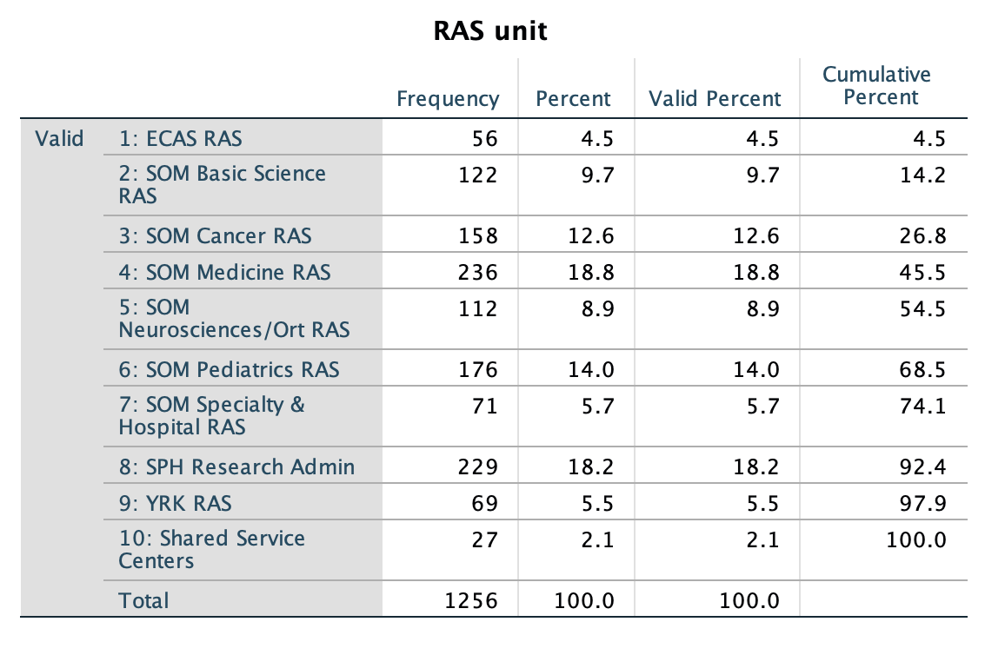

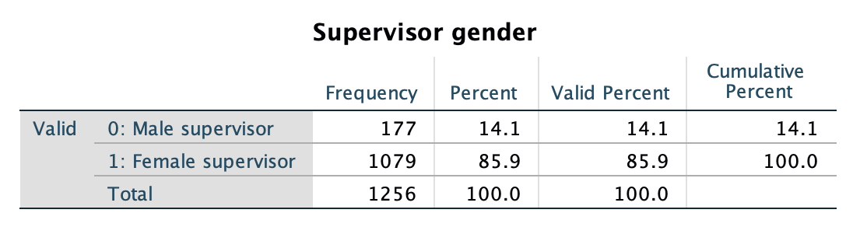

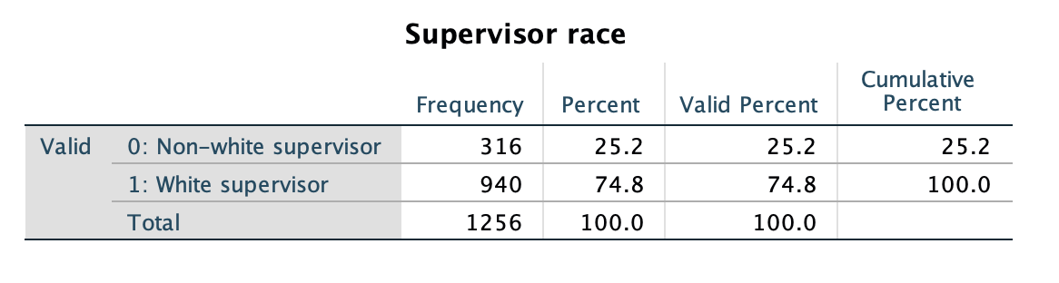

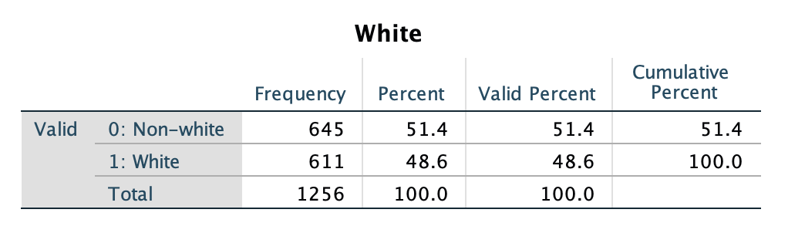

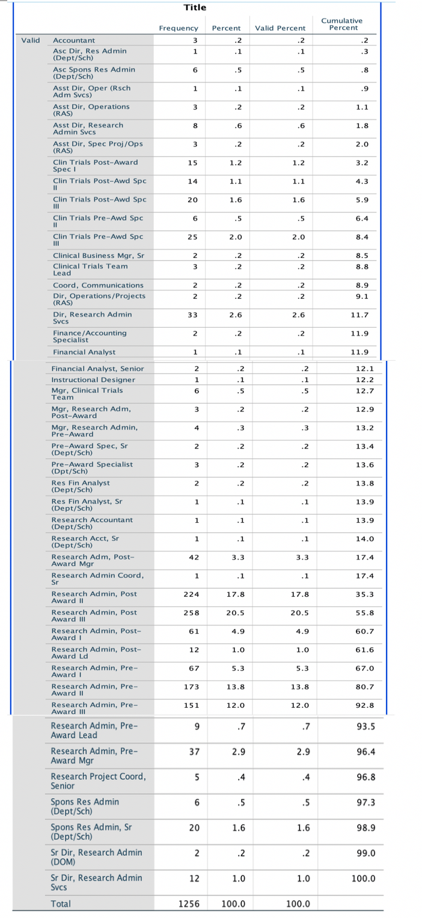

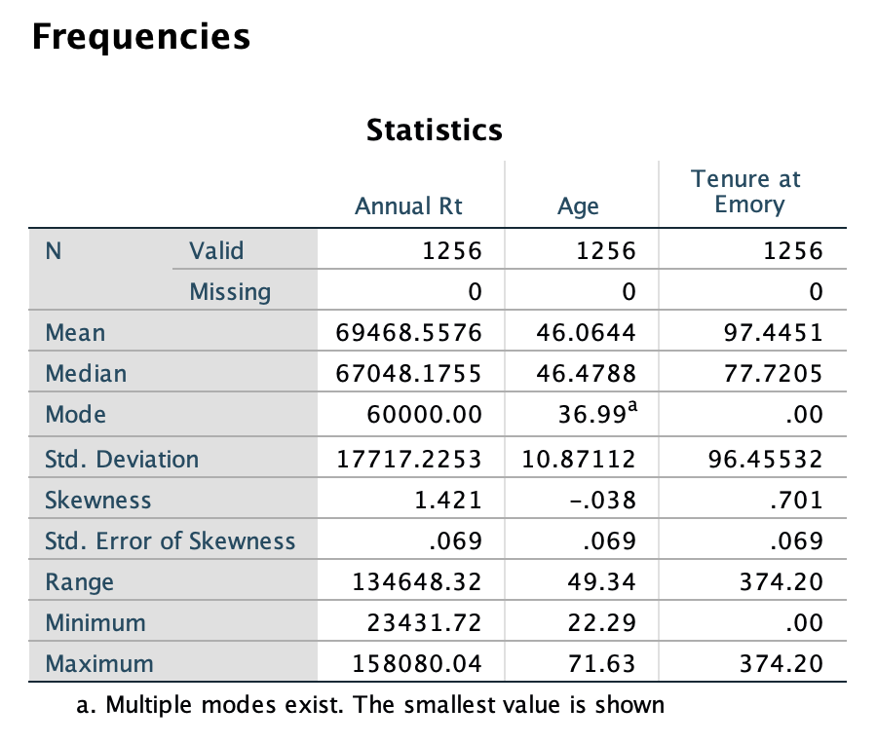

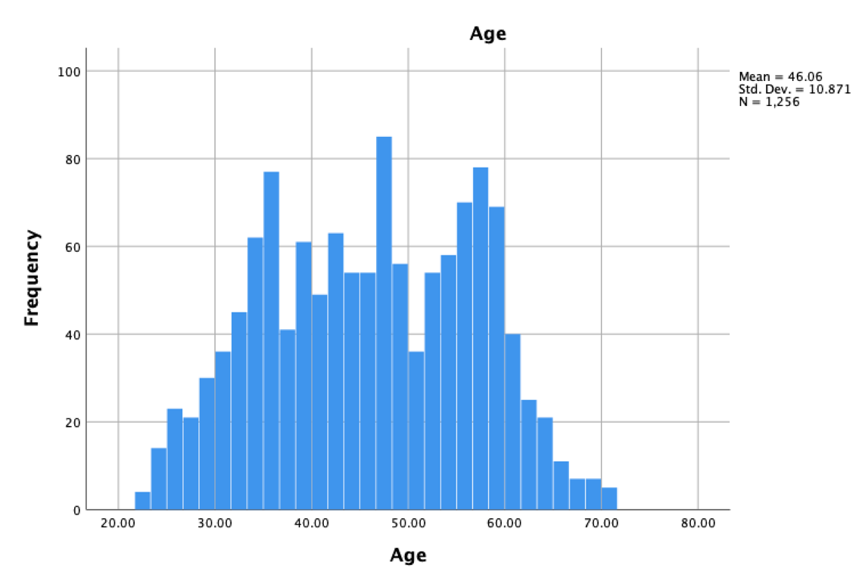

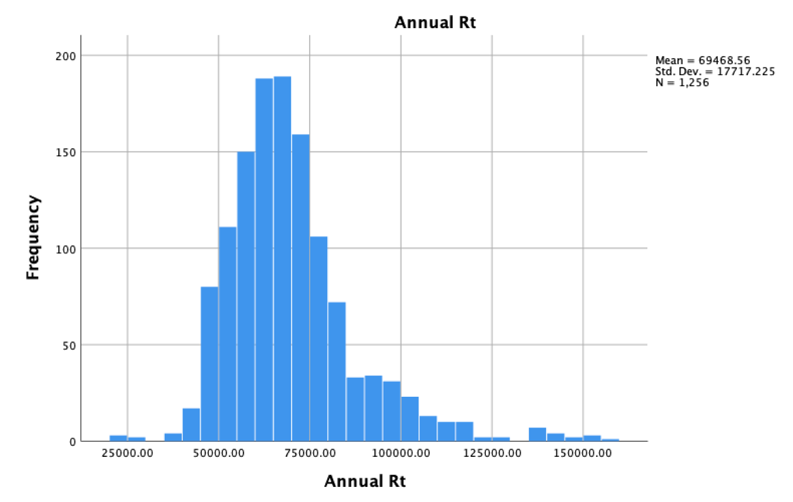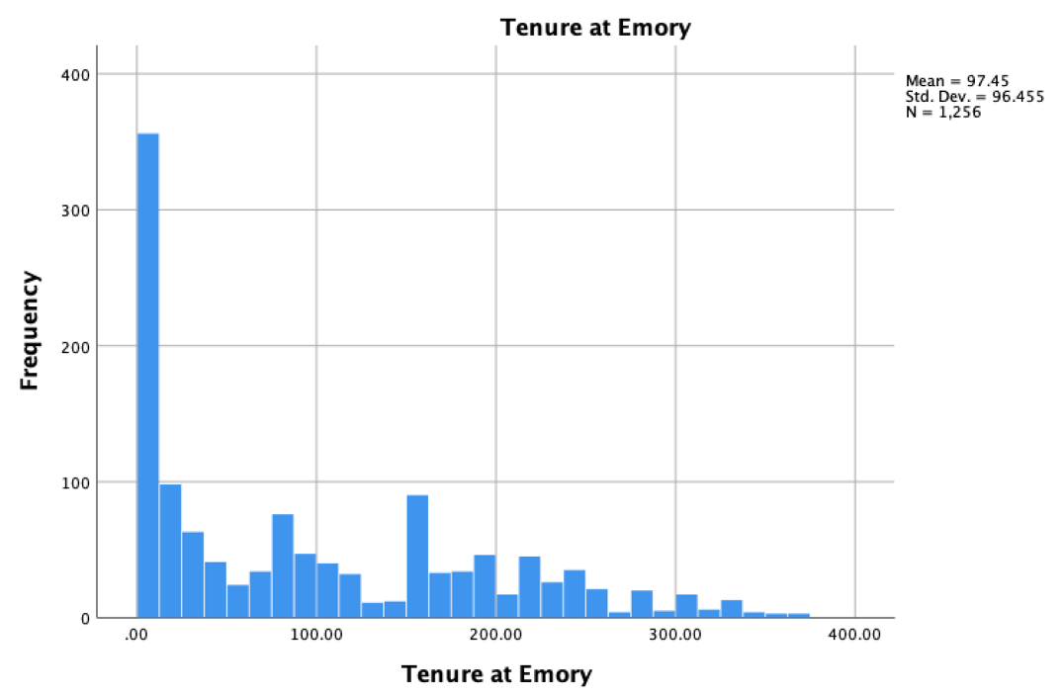

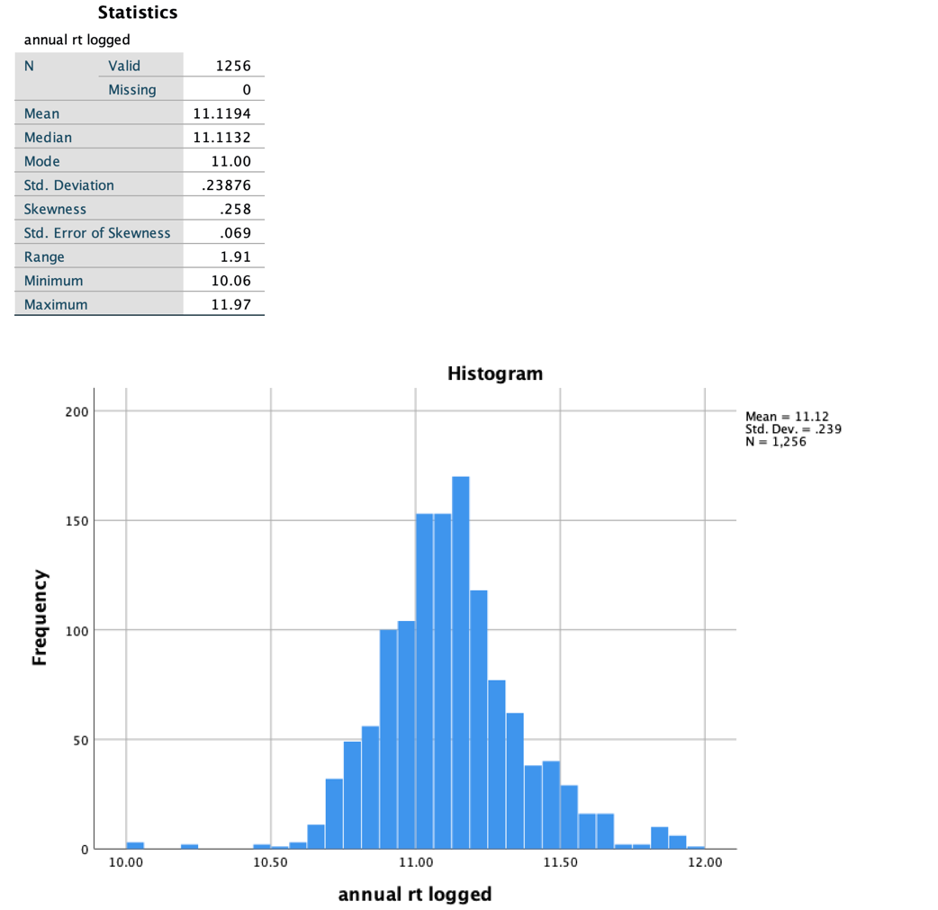

**II. Cross-tab Tables & Chi-squares**

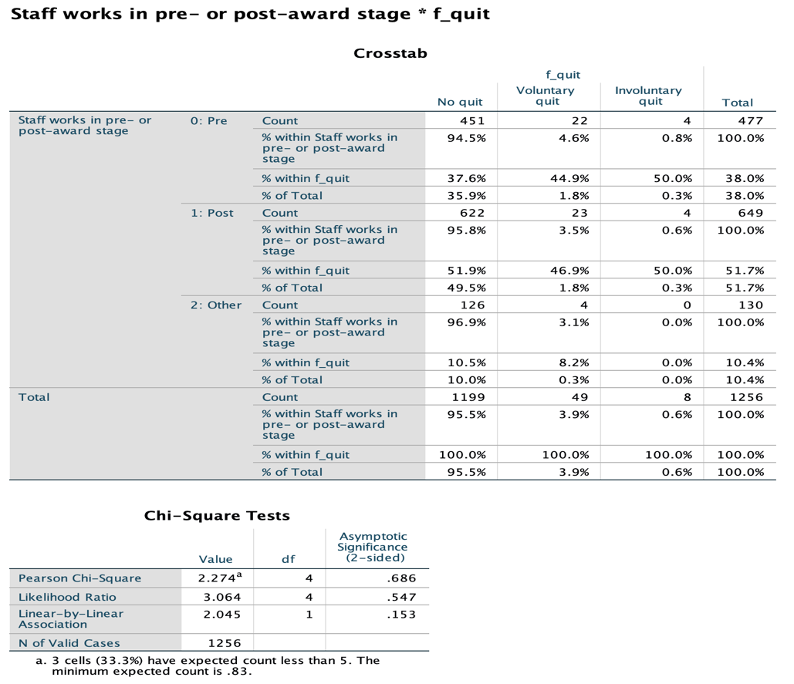

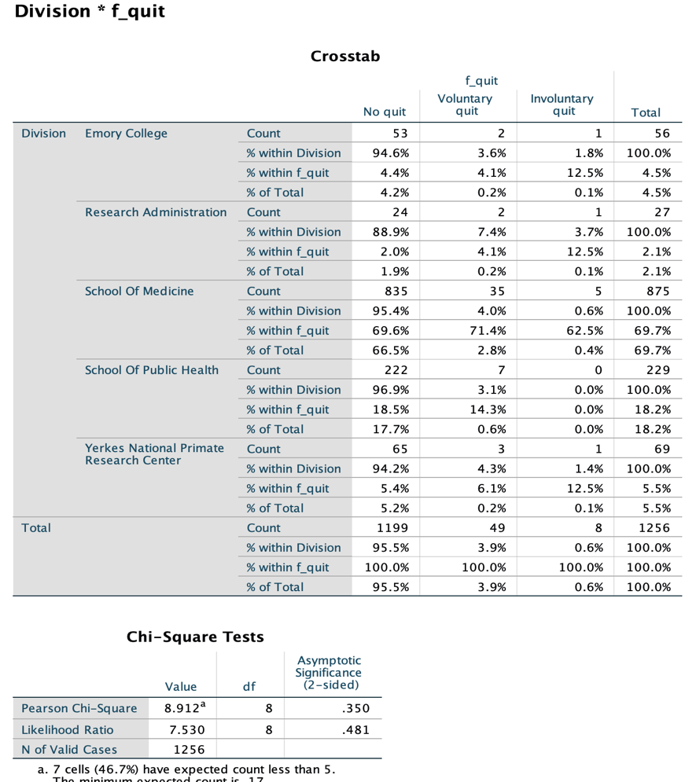

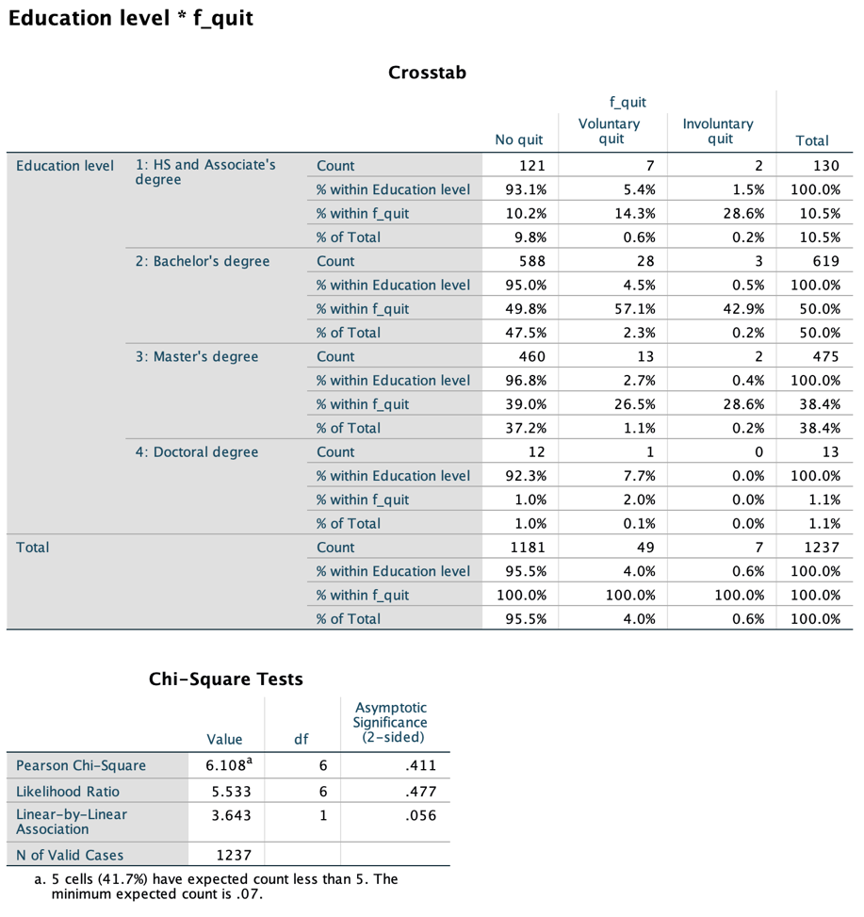

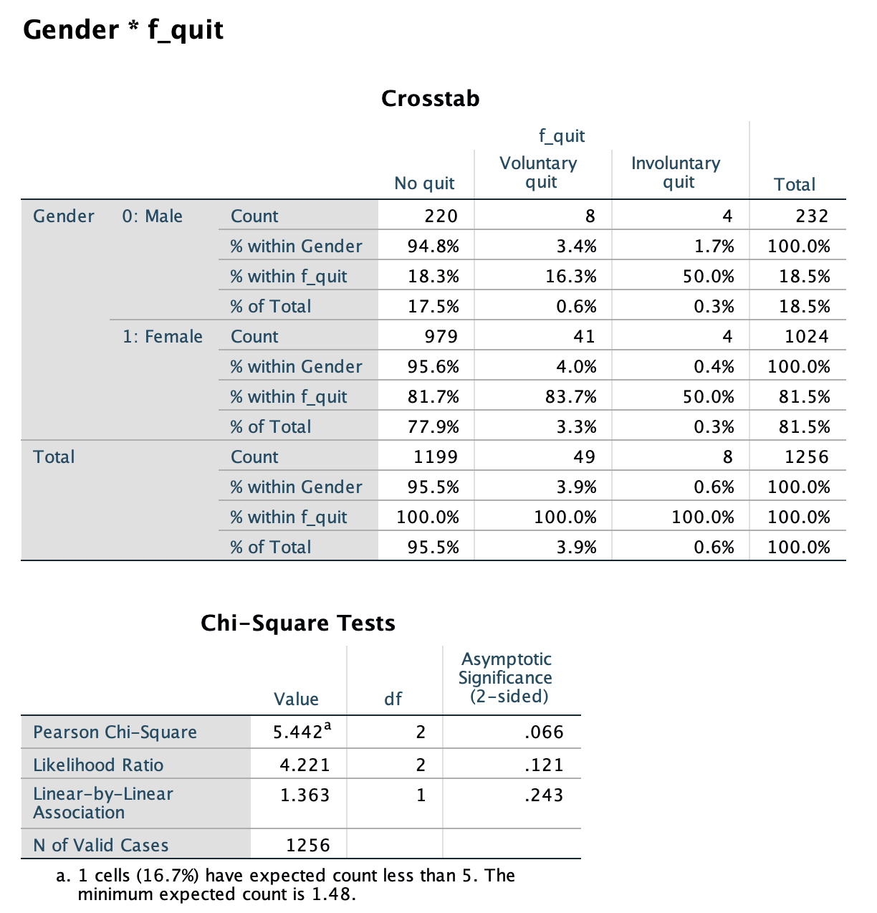

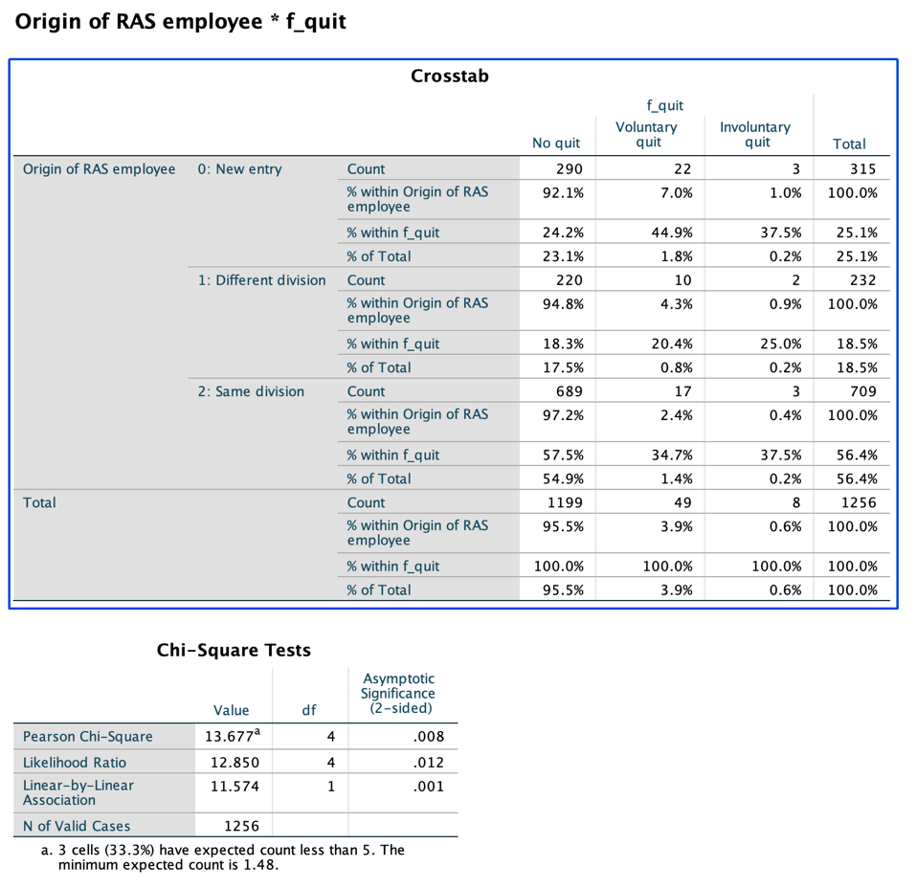

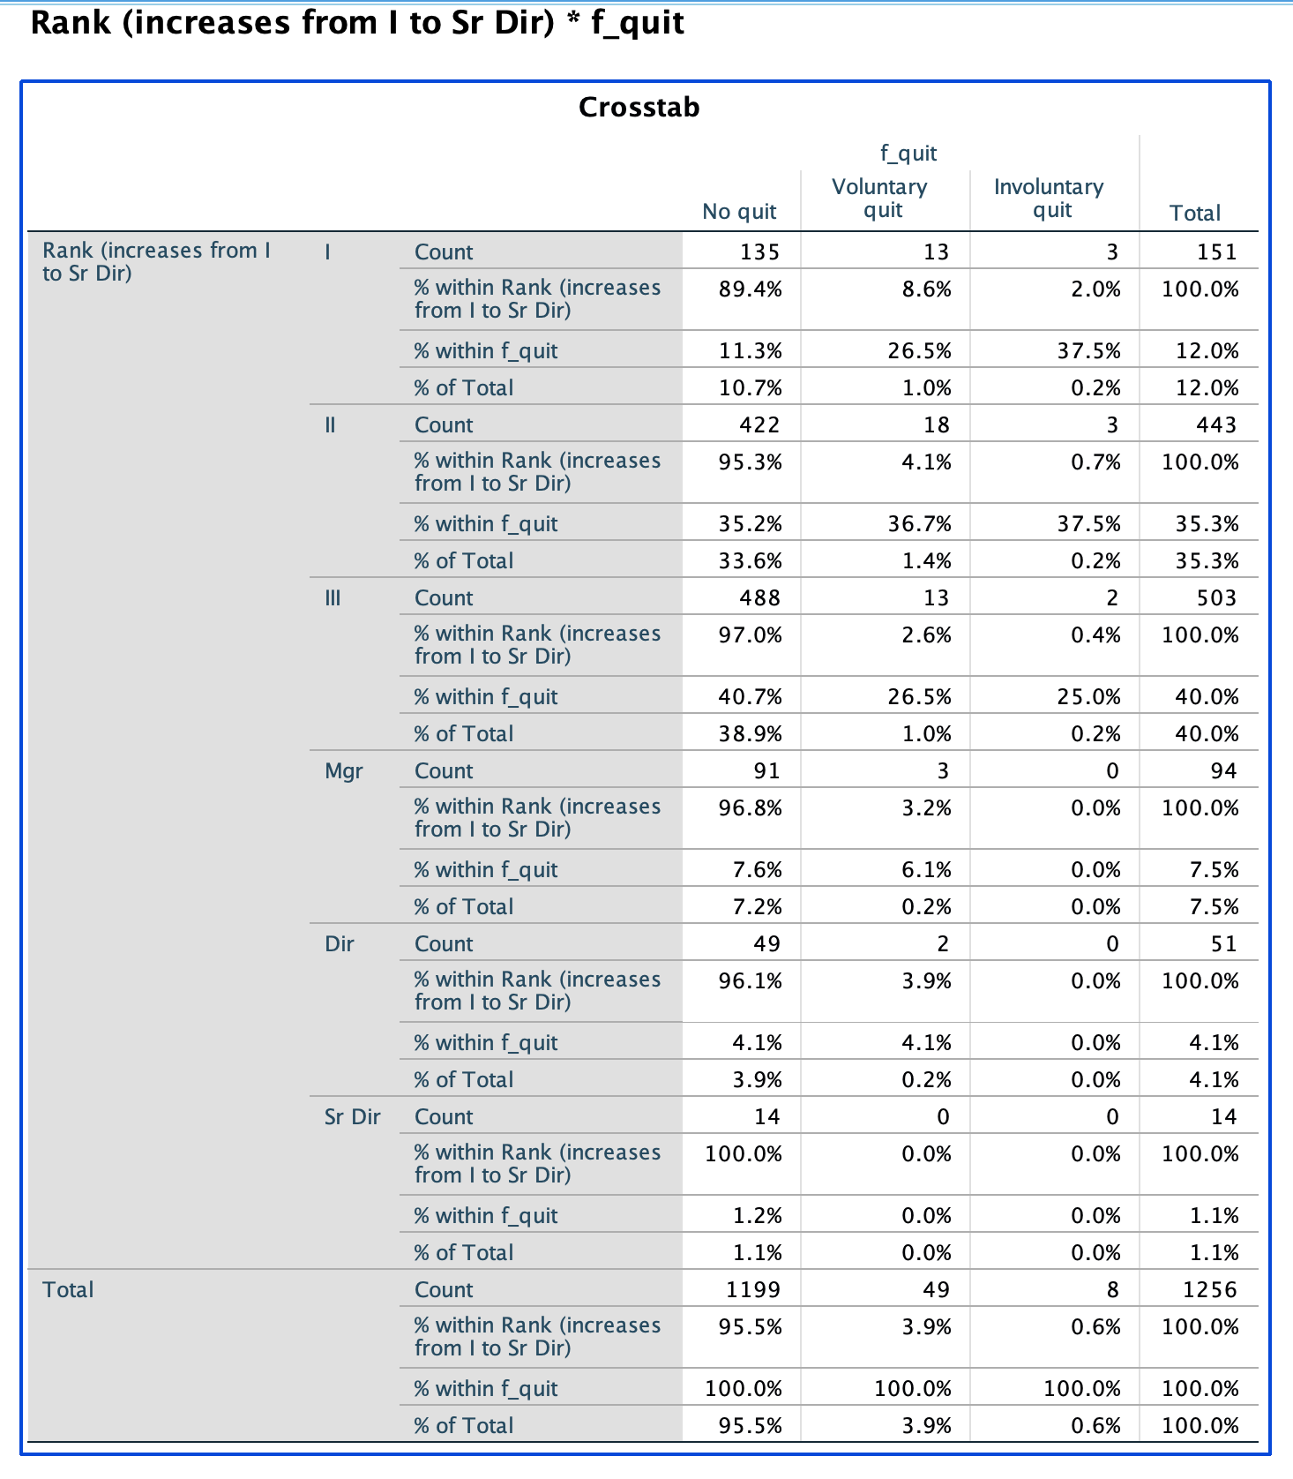

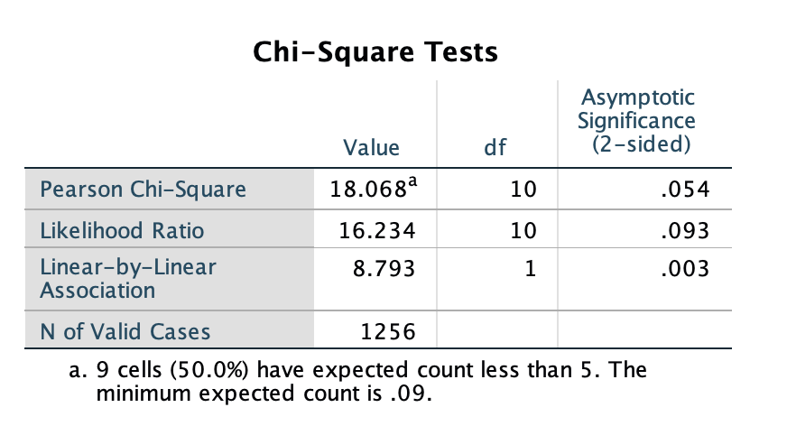

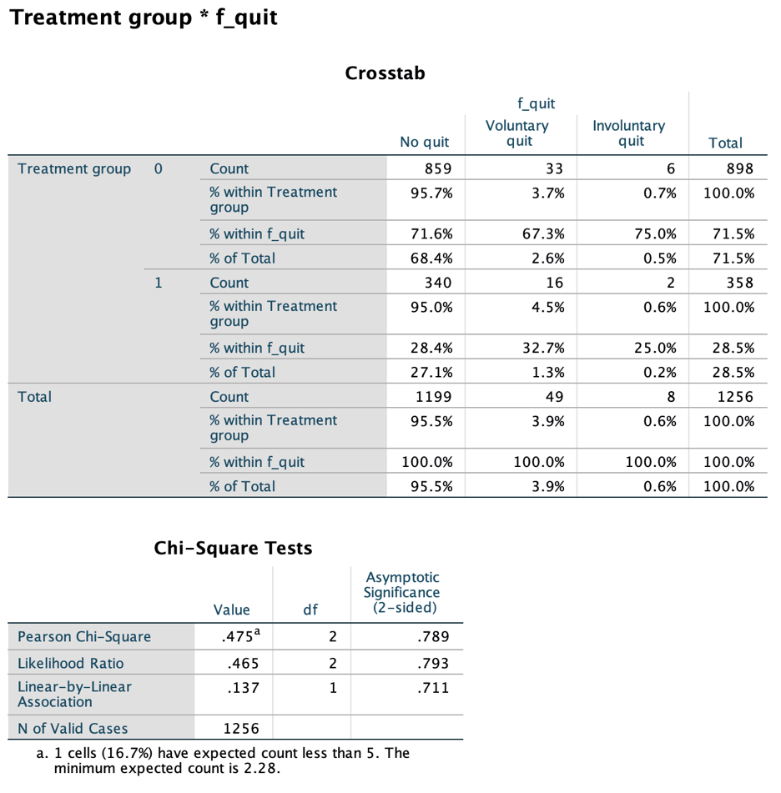

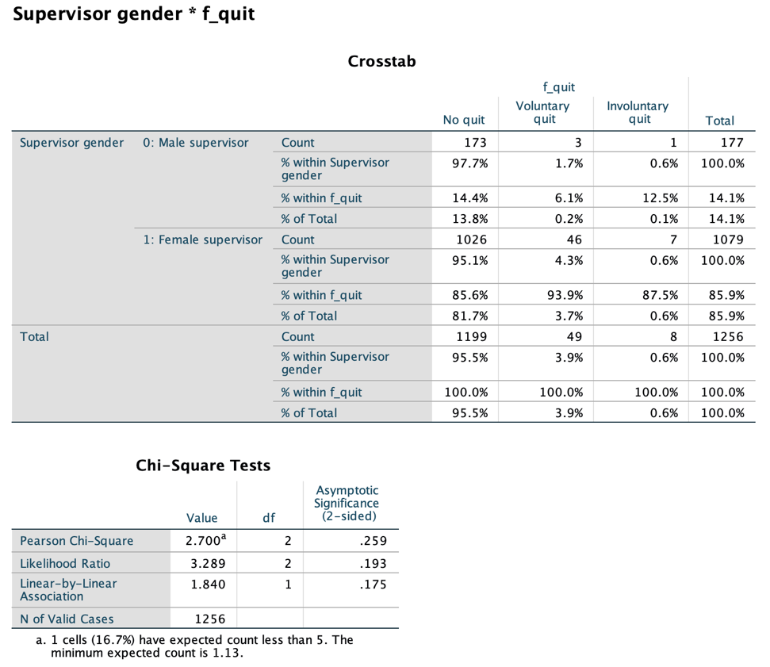

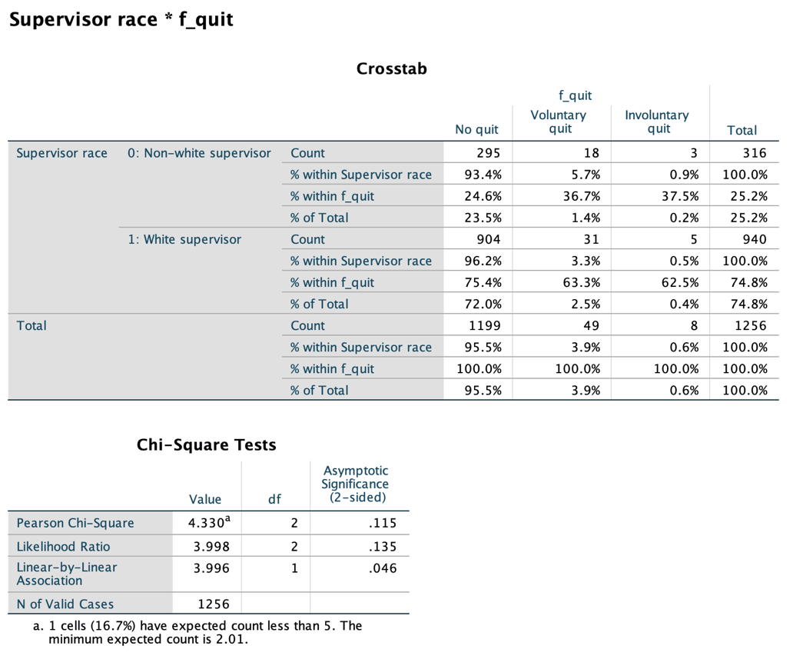

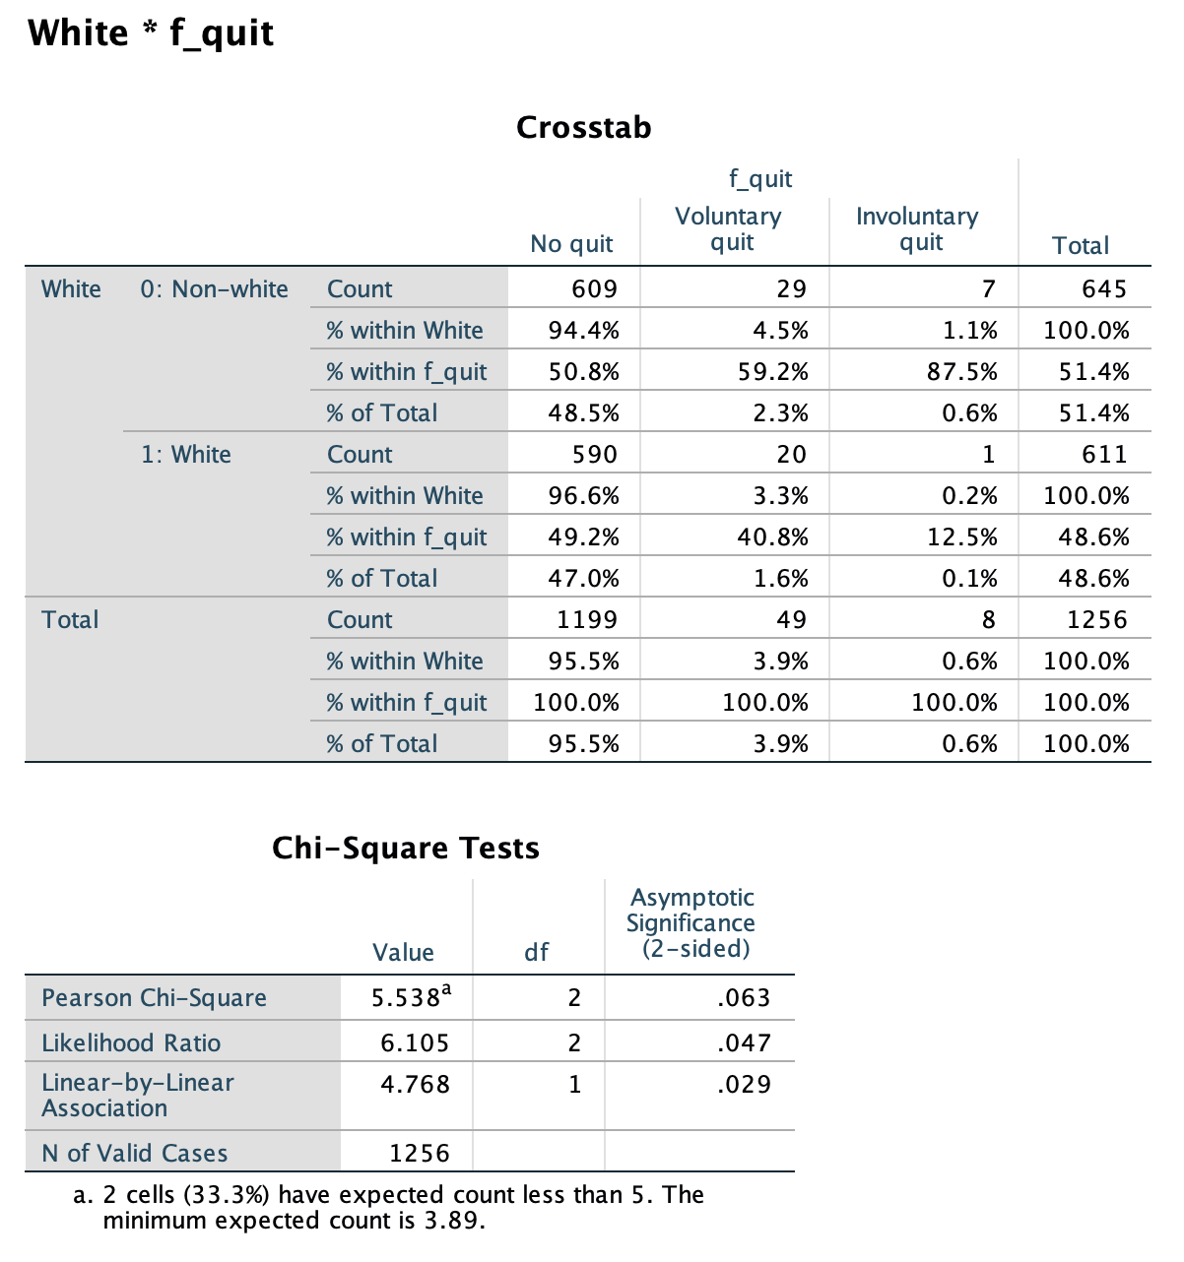

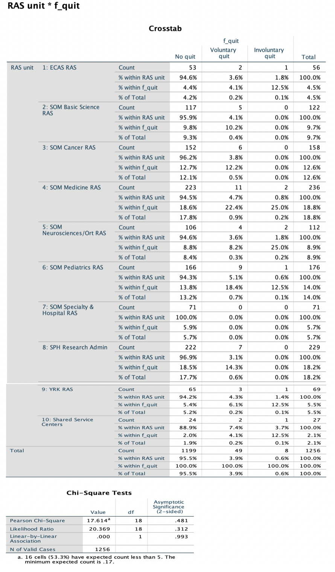

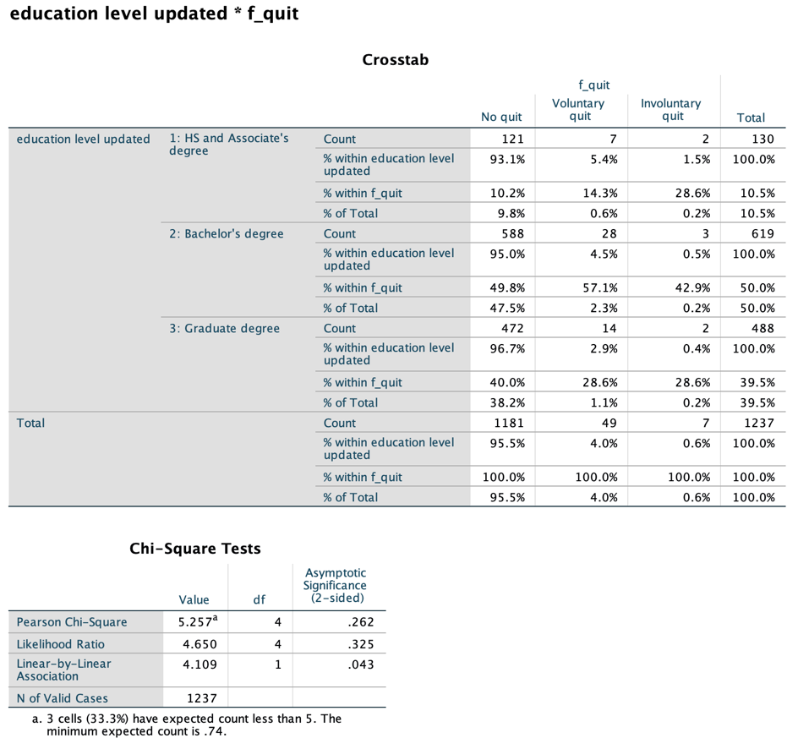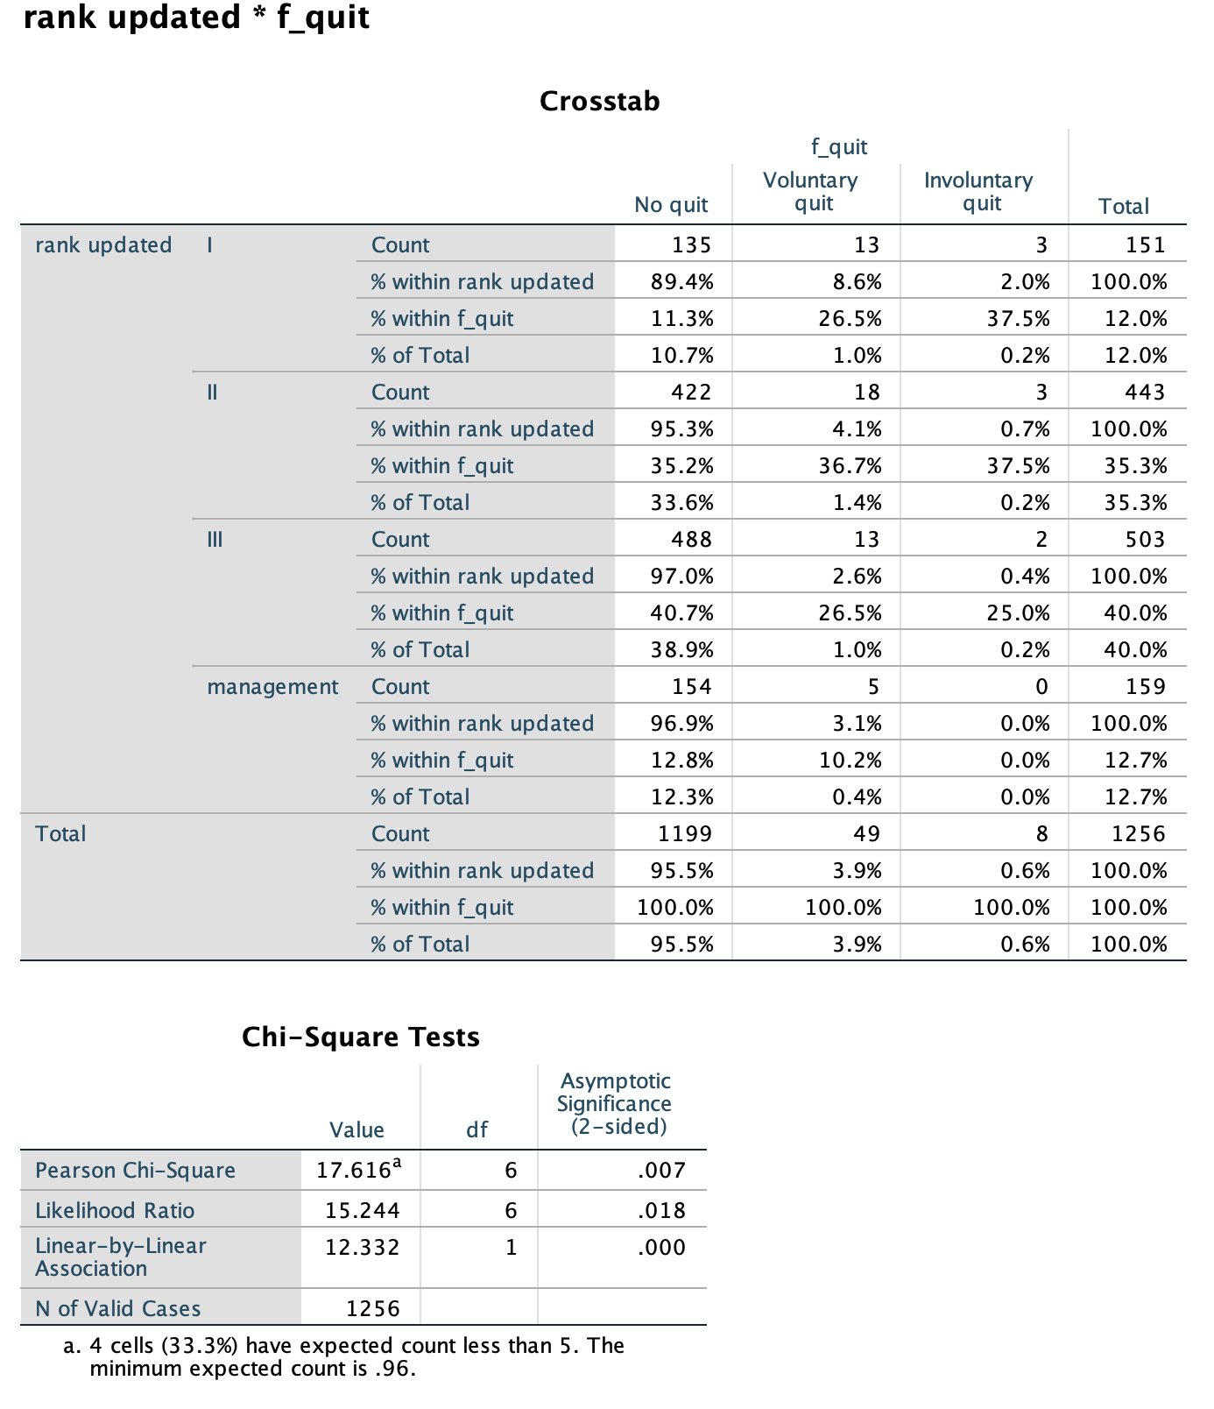

**III. Kaplan-Meier plots & Log-rank Statistics**

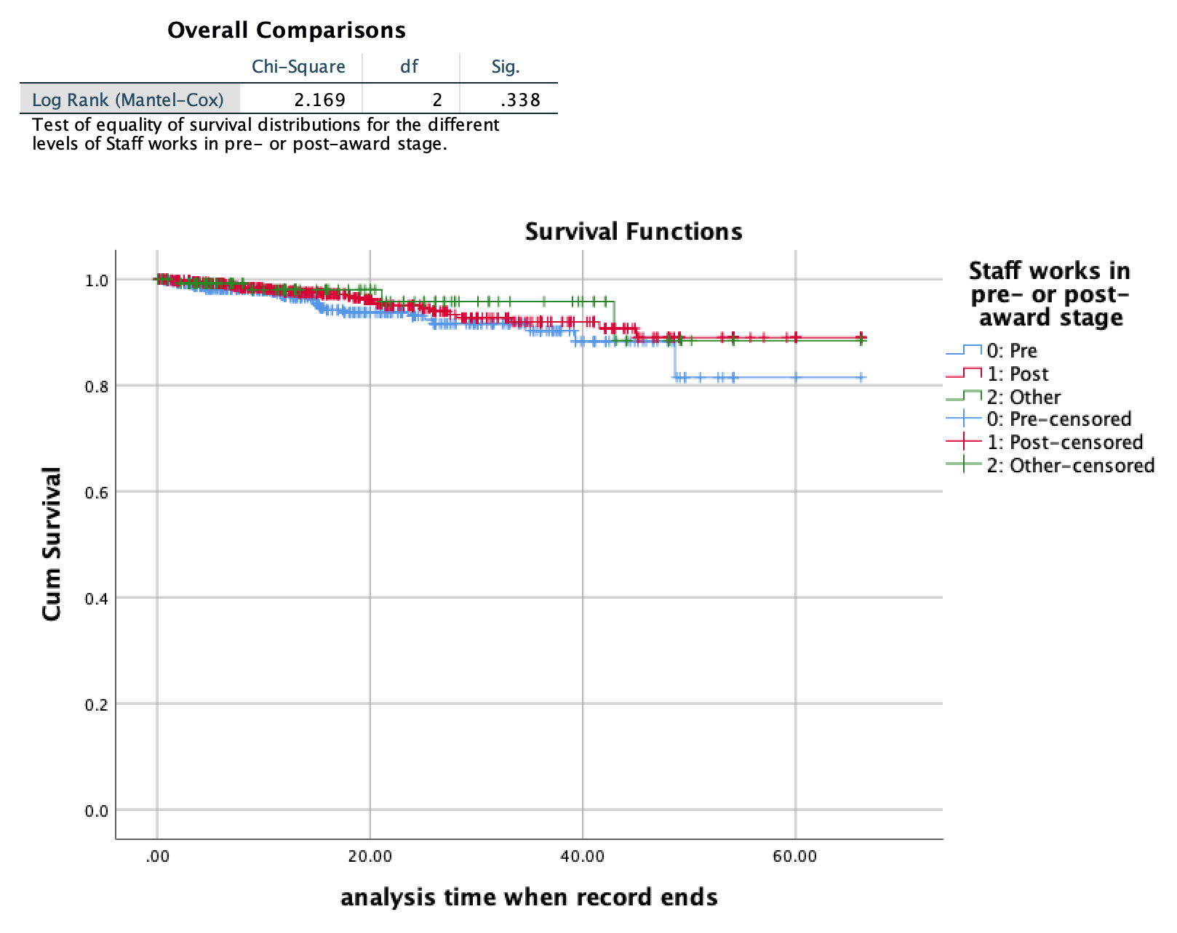

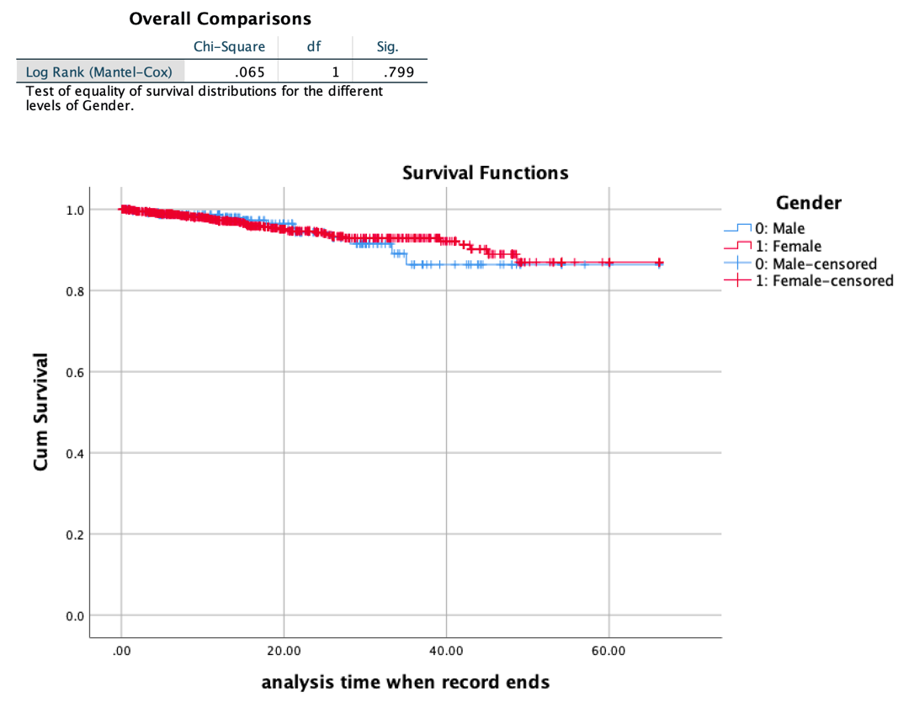

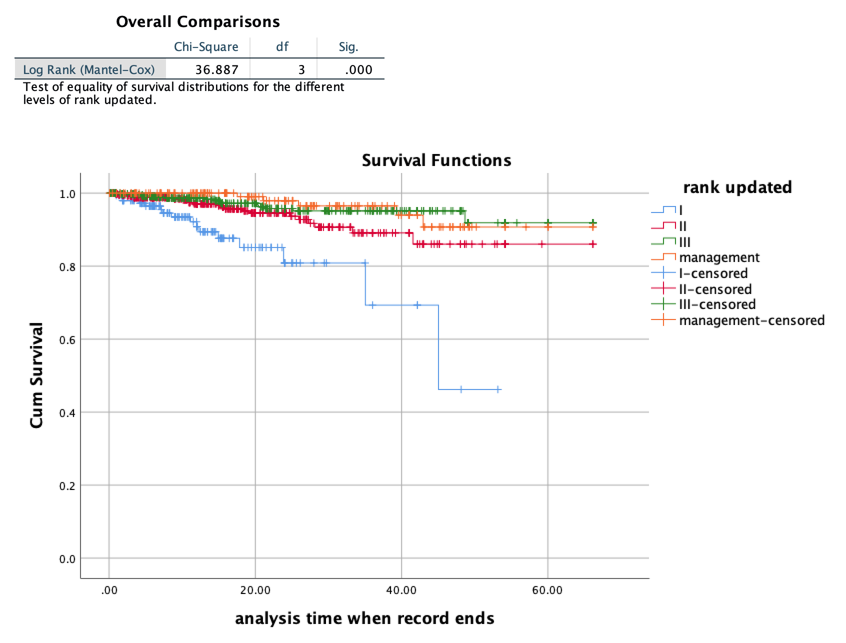

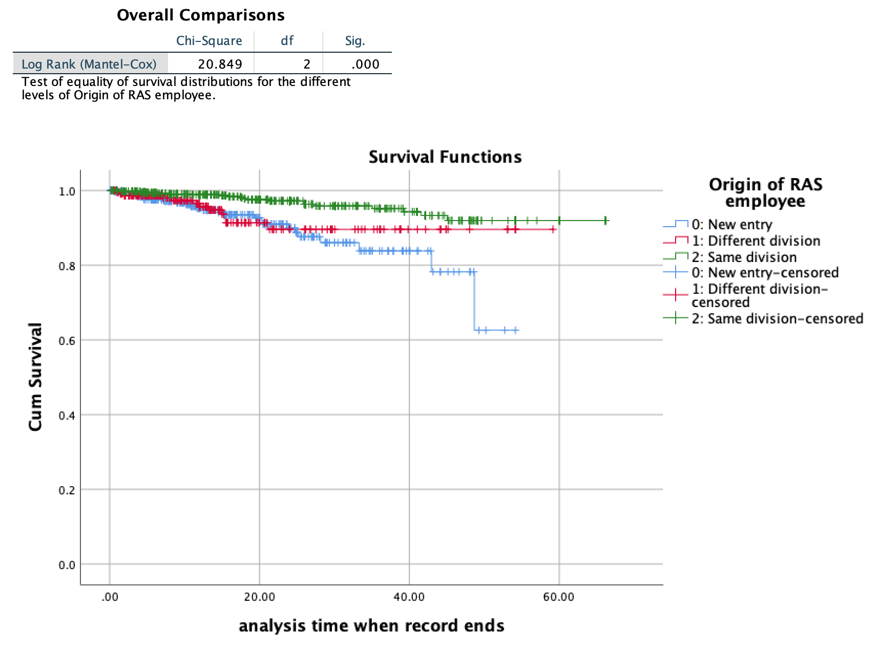

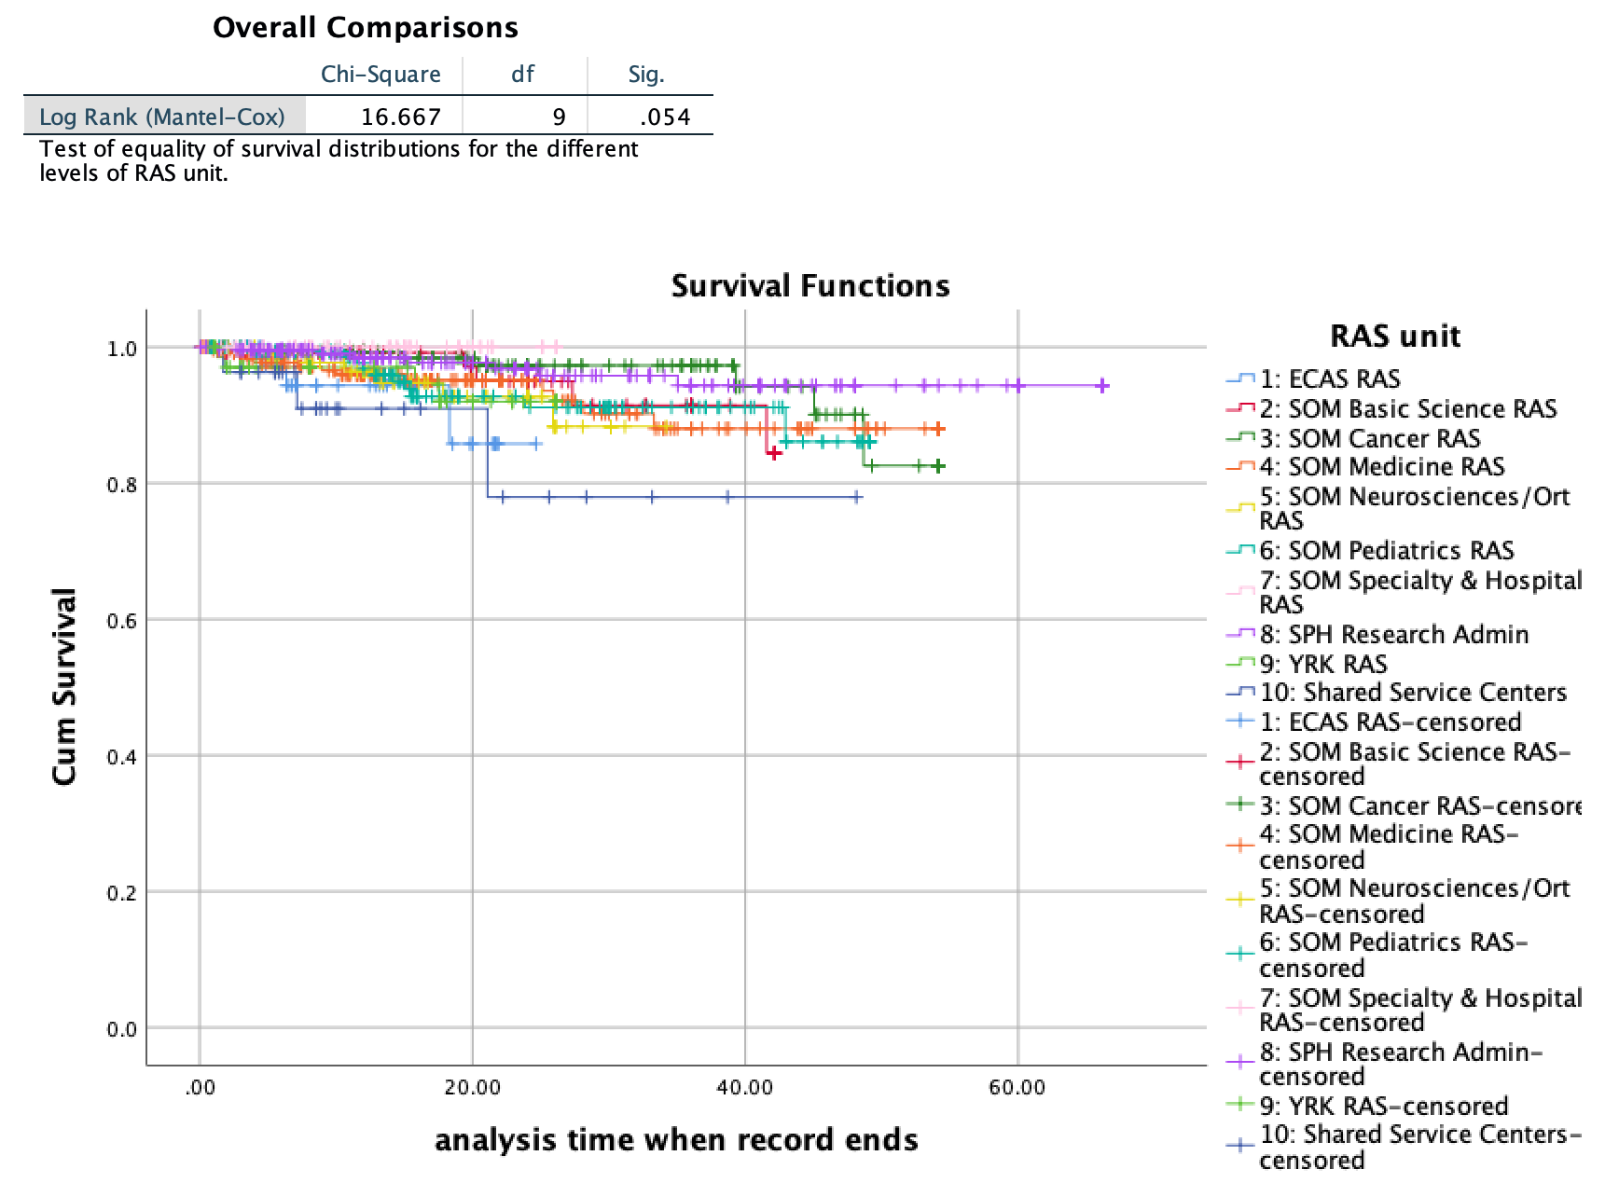

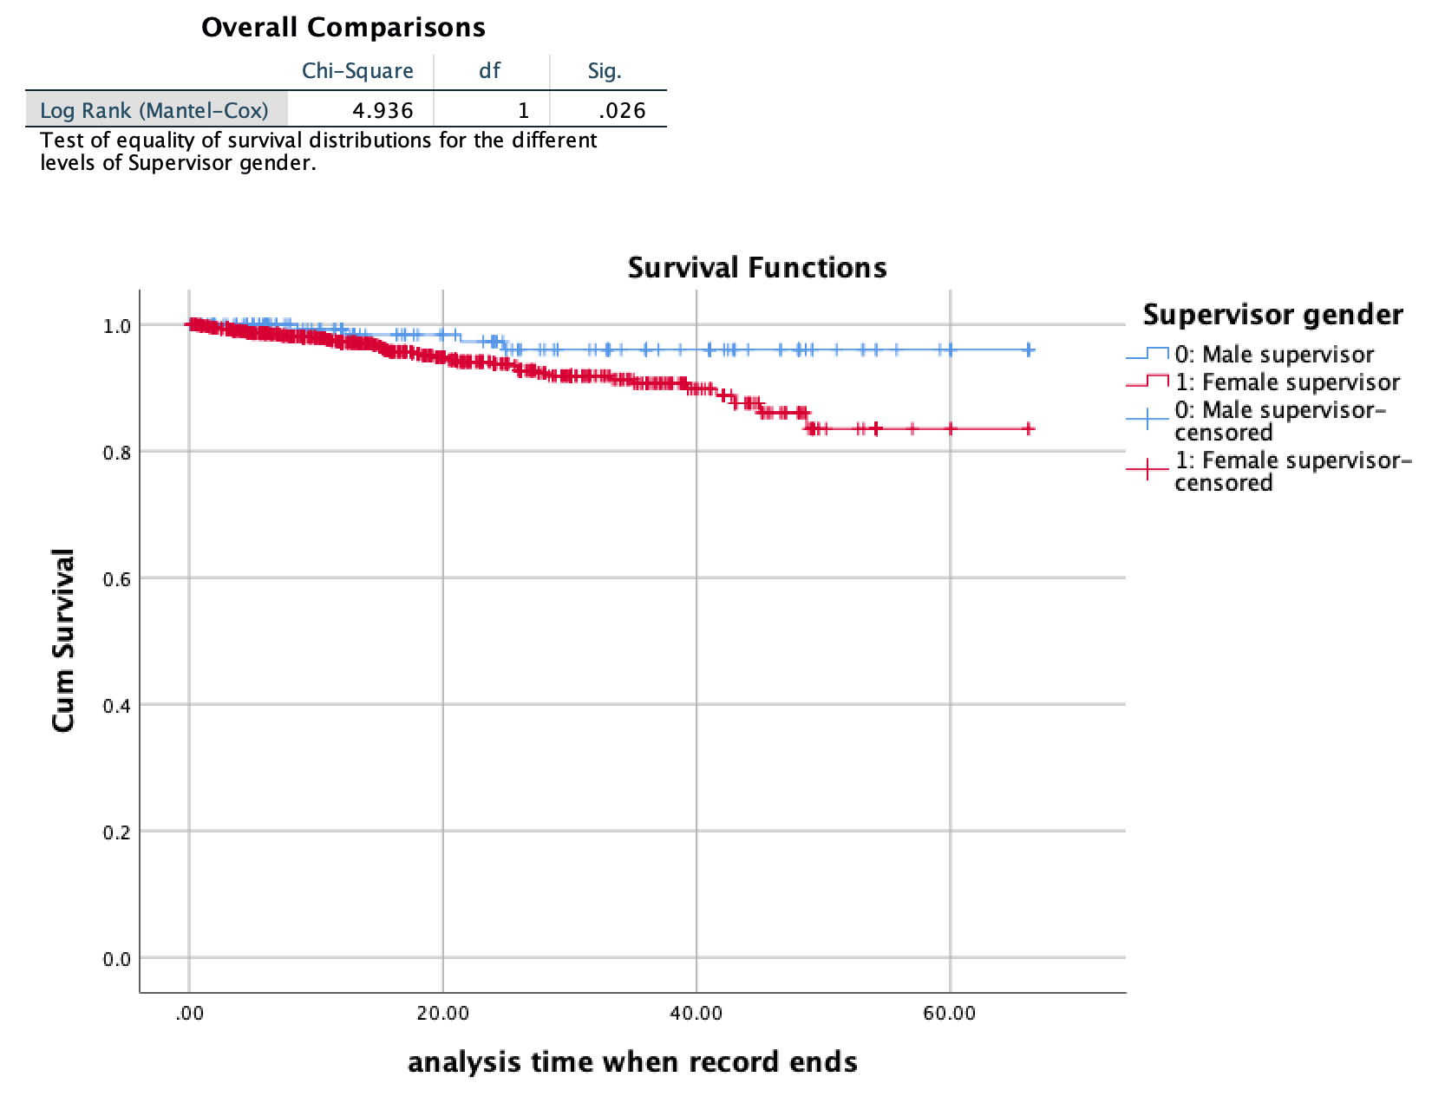

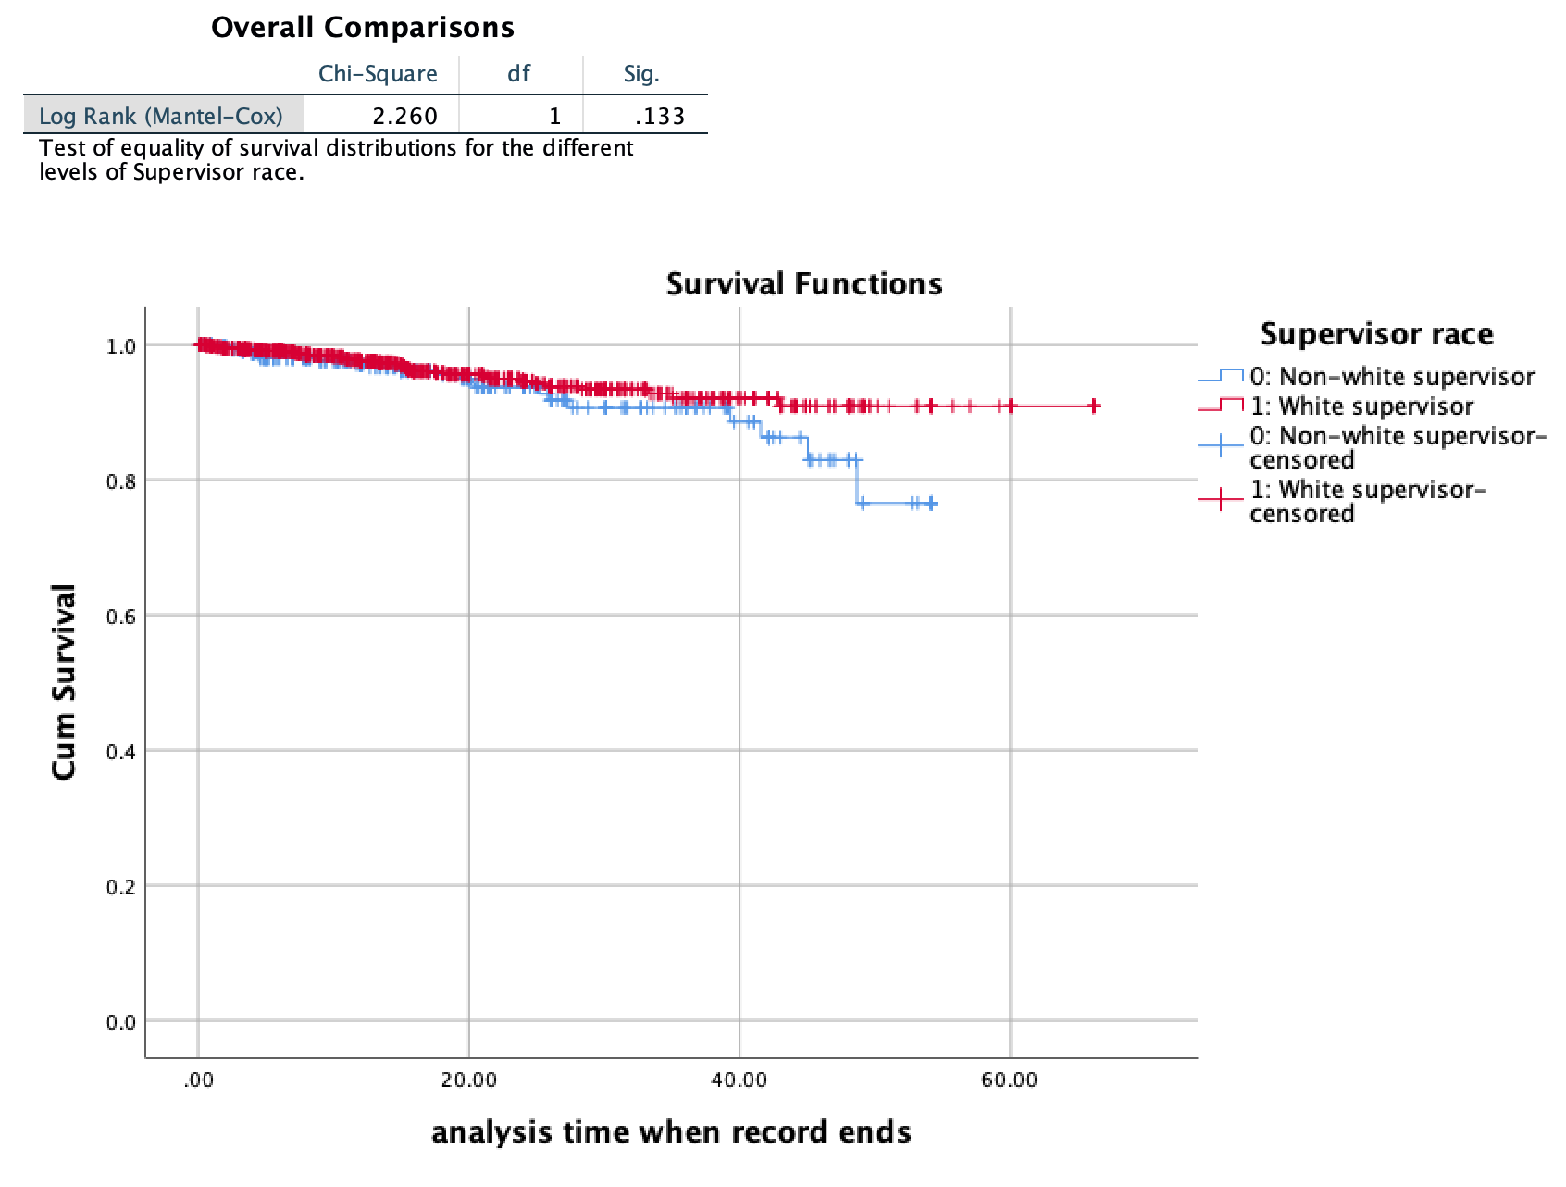

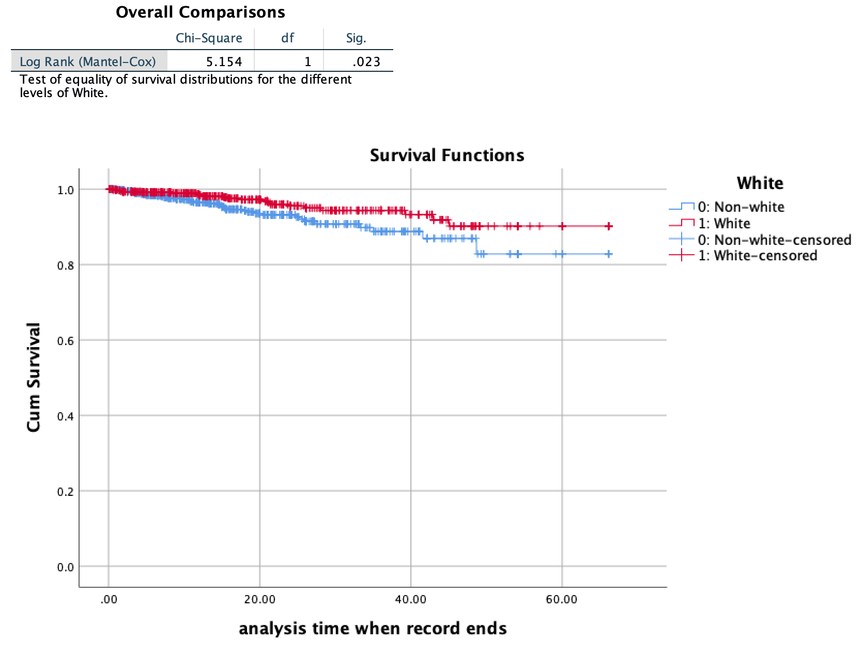

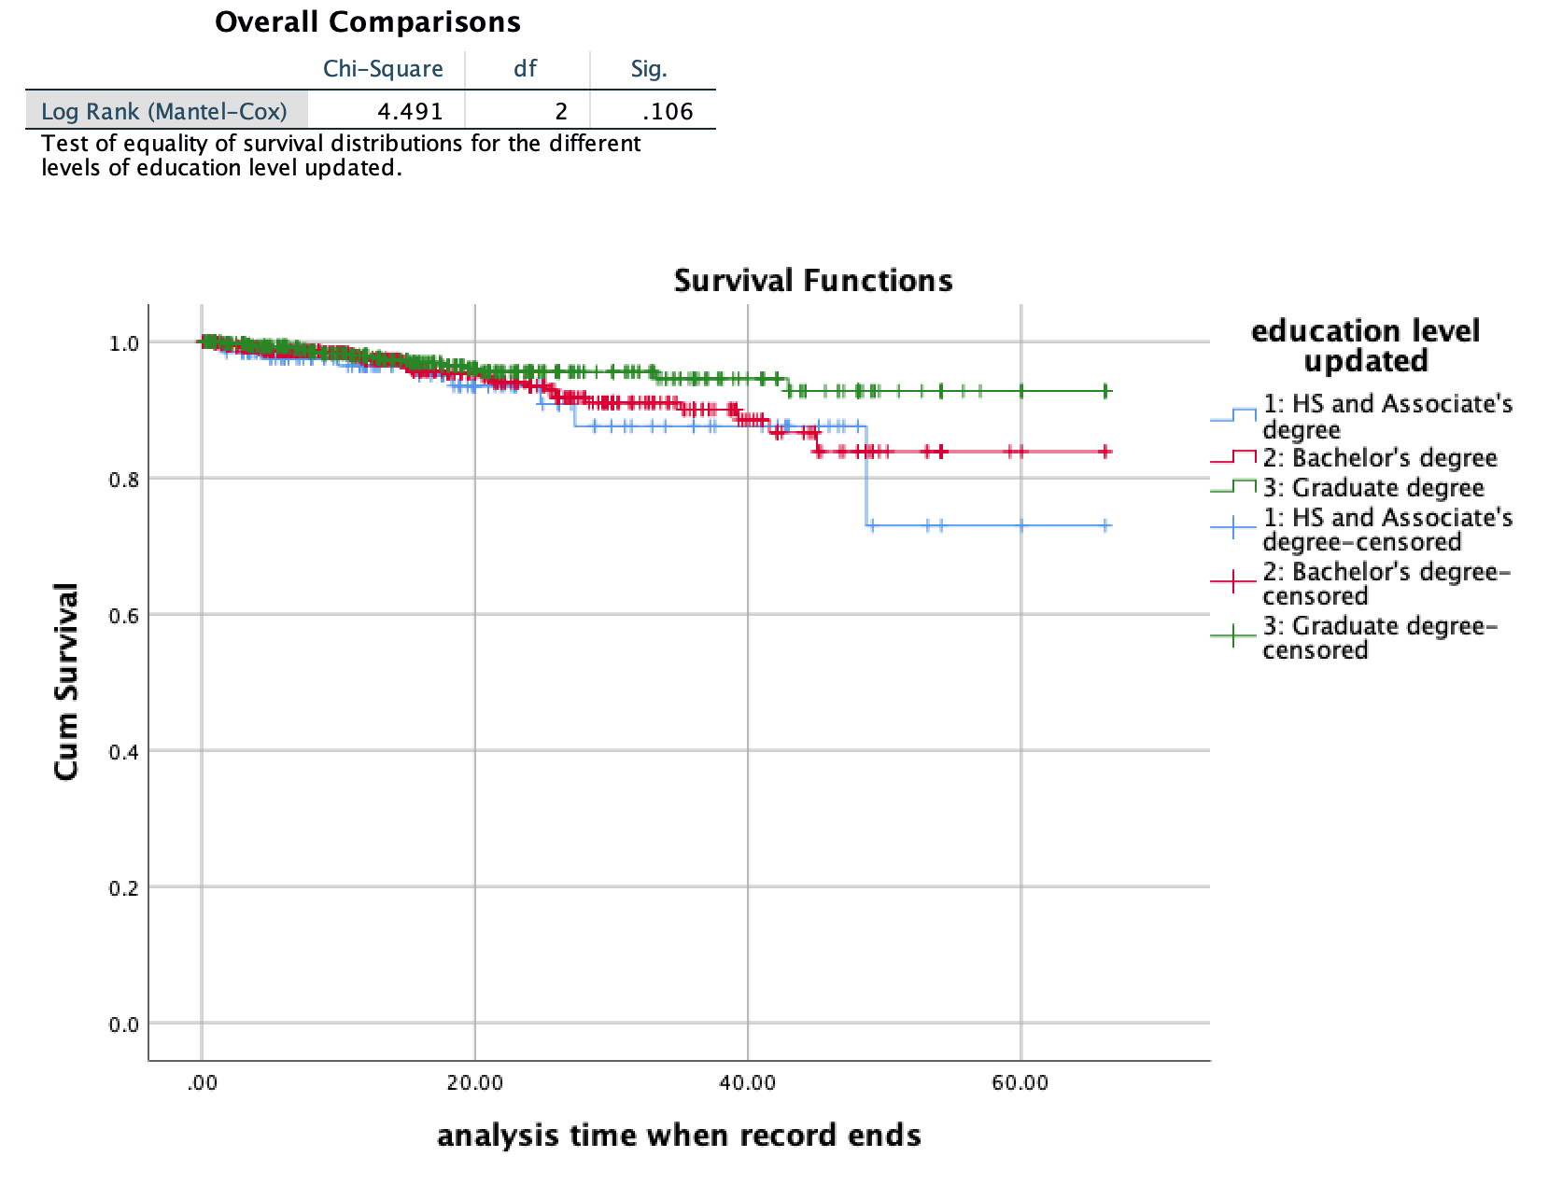

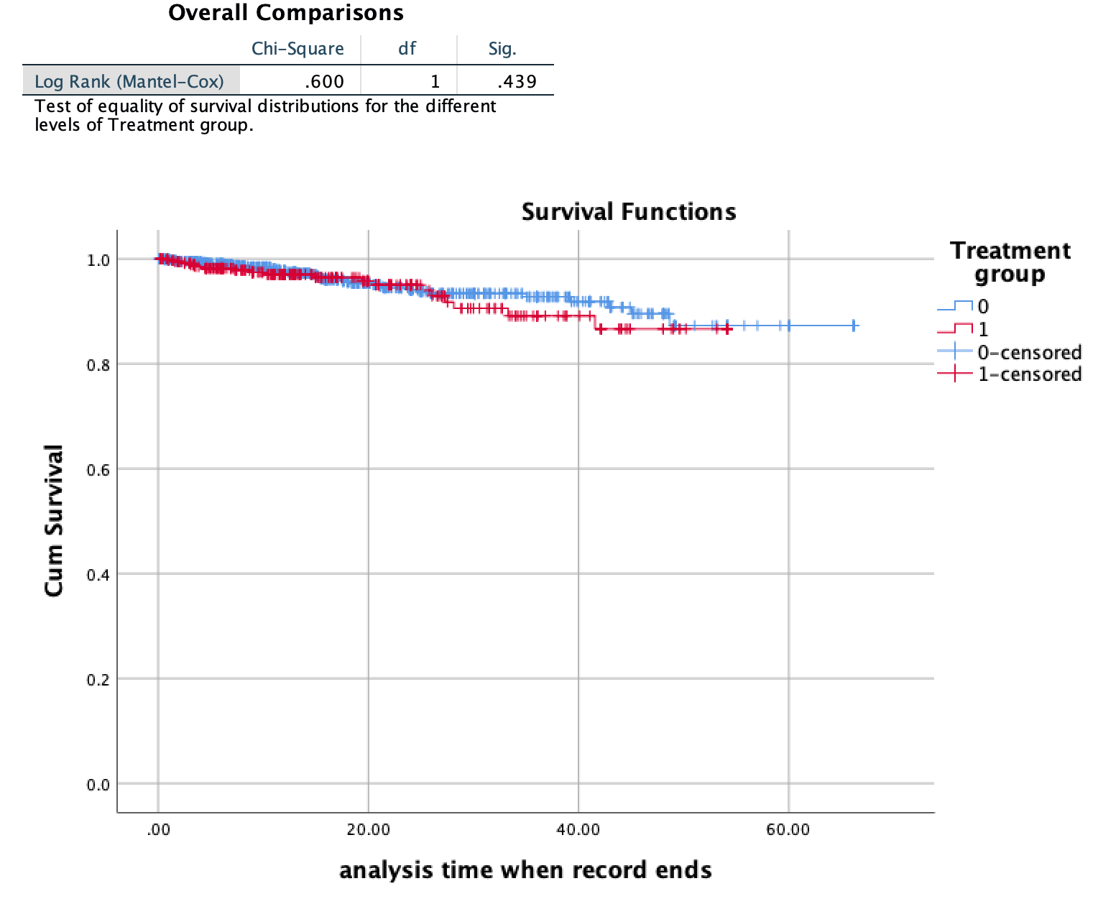

**Section 2:**

**I. Correlation Matrix (for reference)**

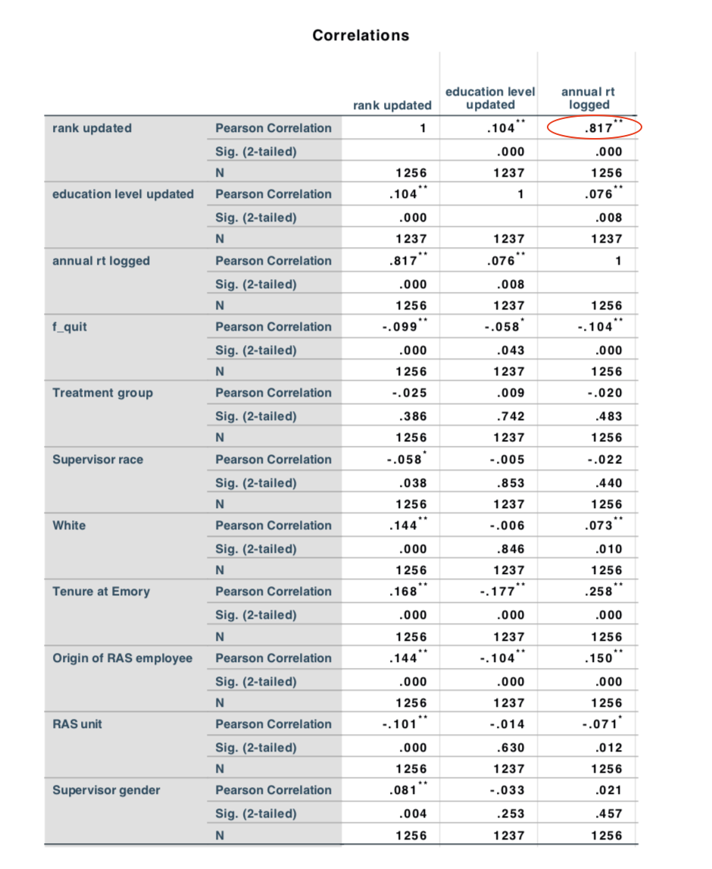

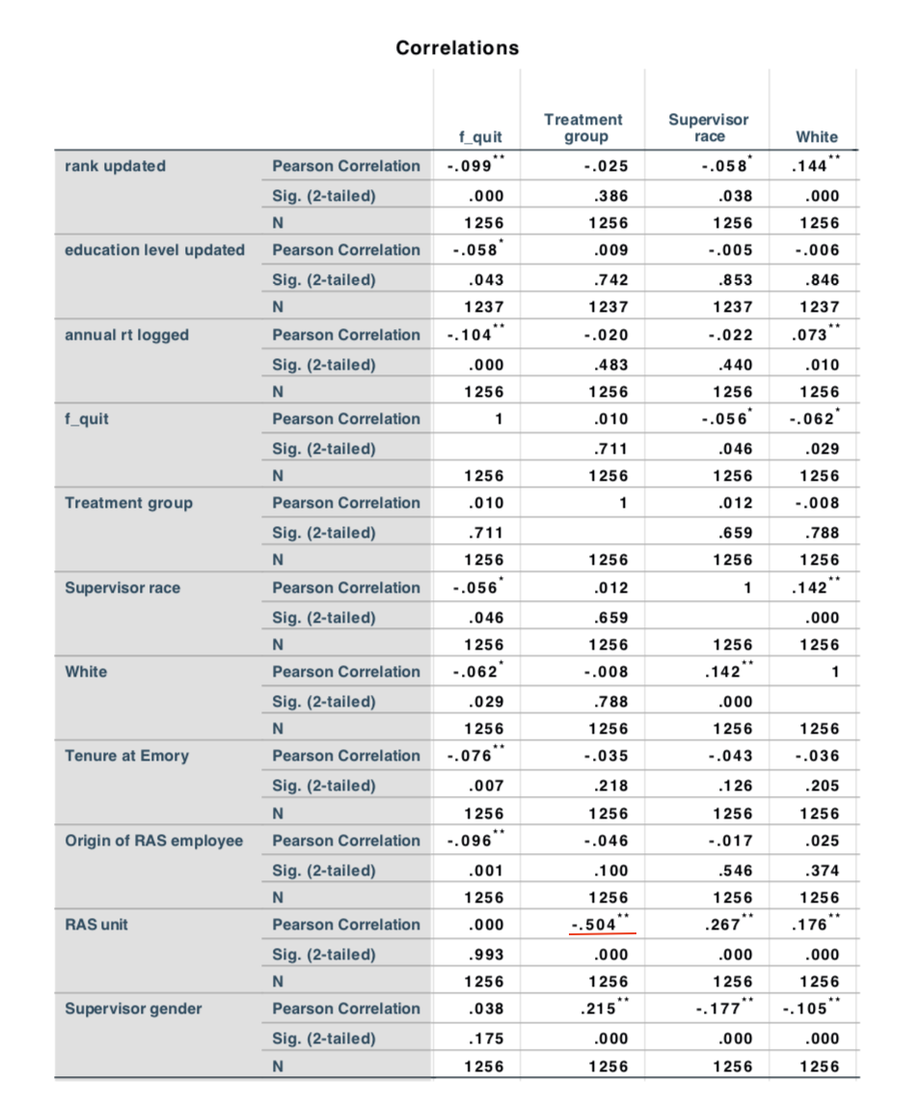

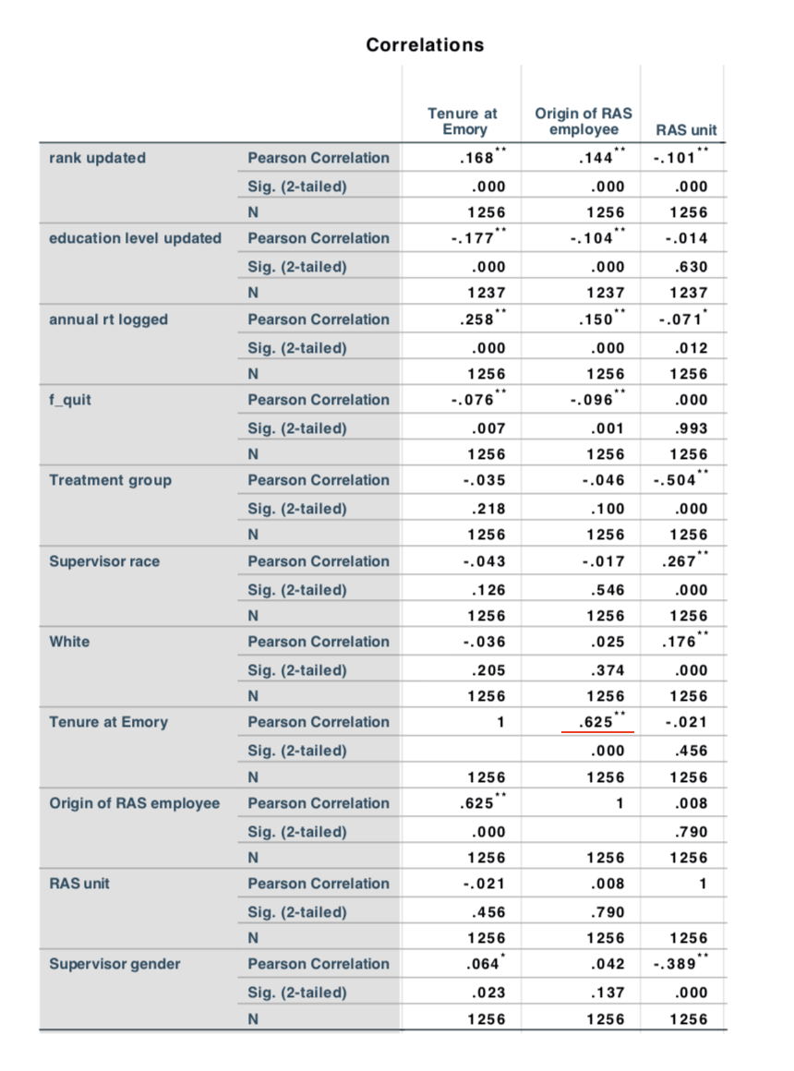

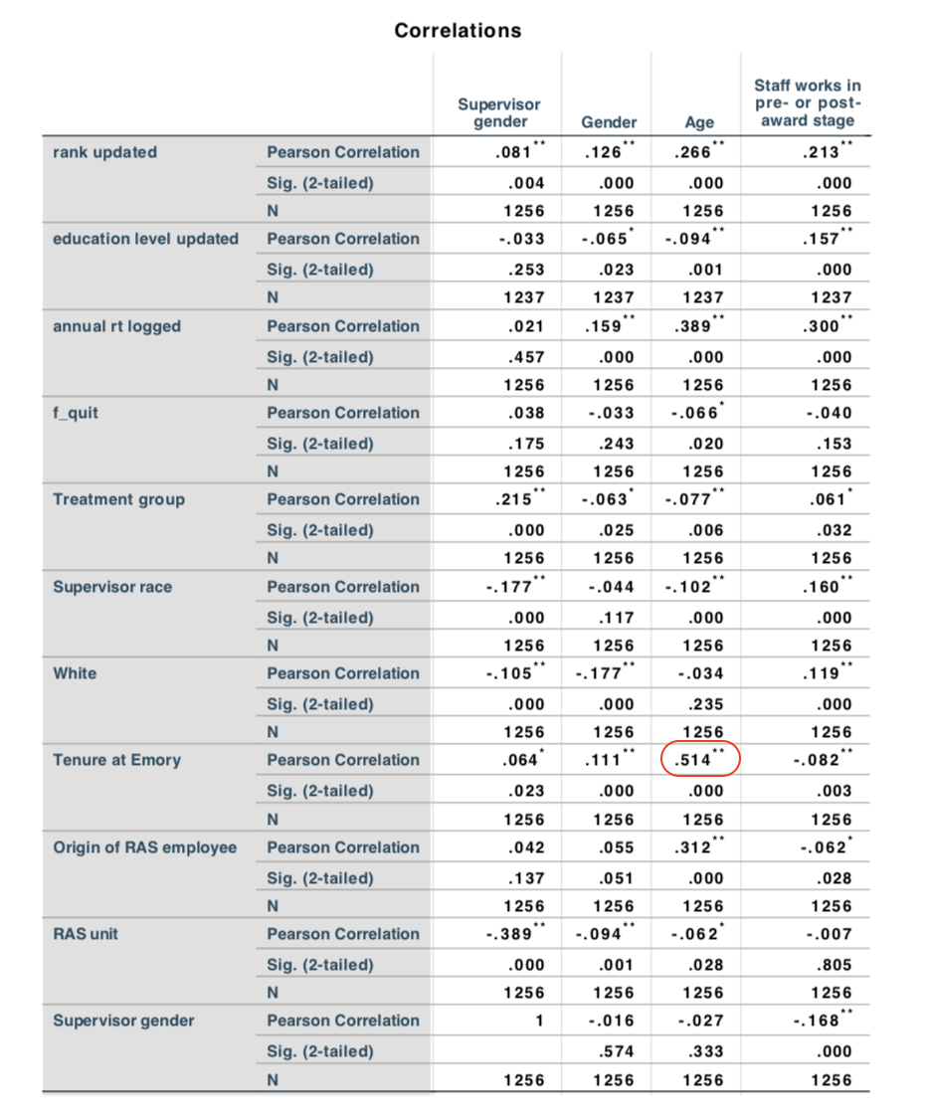

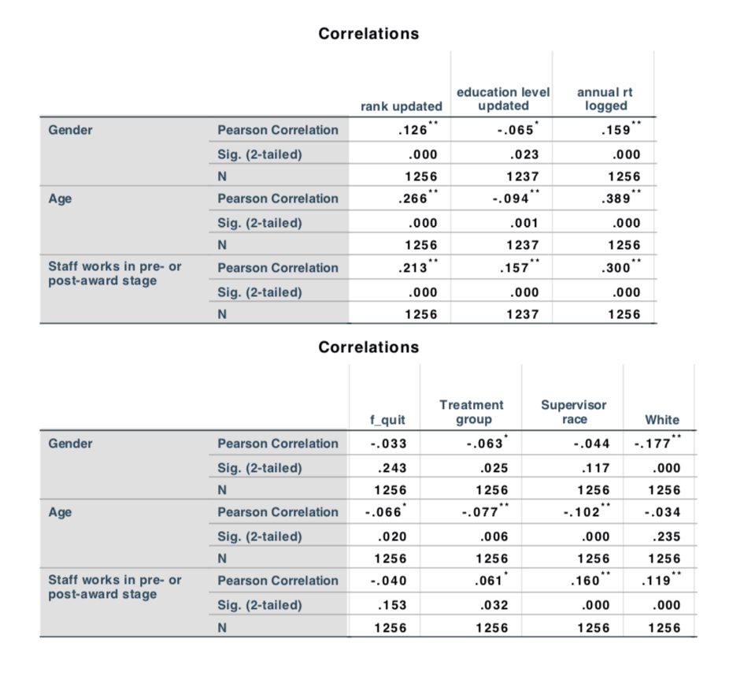

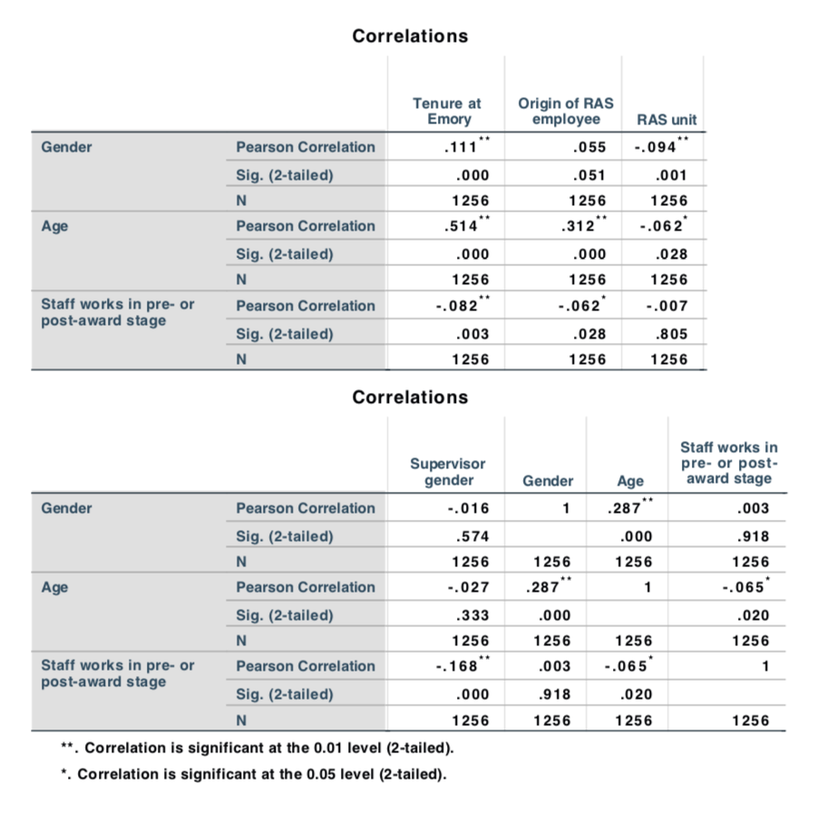

**II. Cox Regression Models for “All type of quits”** (the order here is corresponding to that in the summary table)

1.

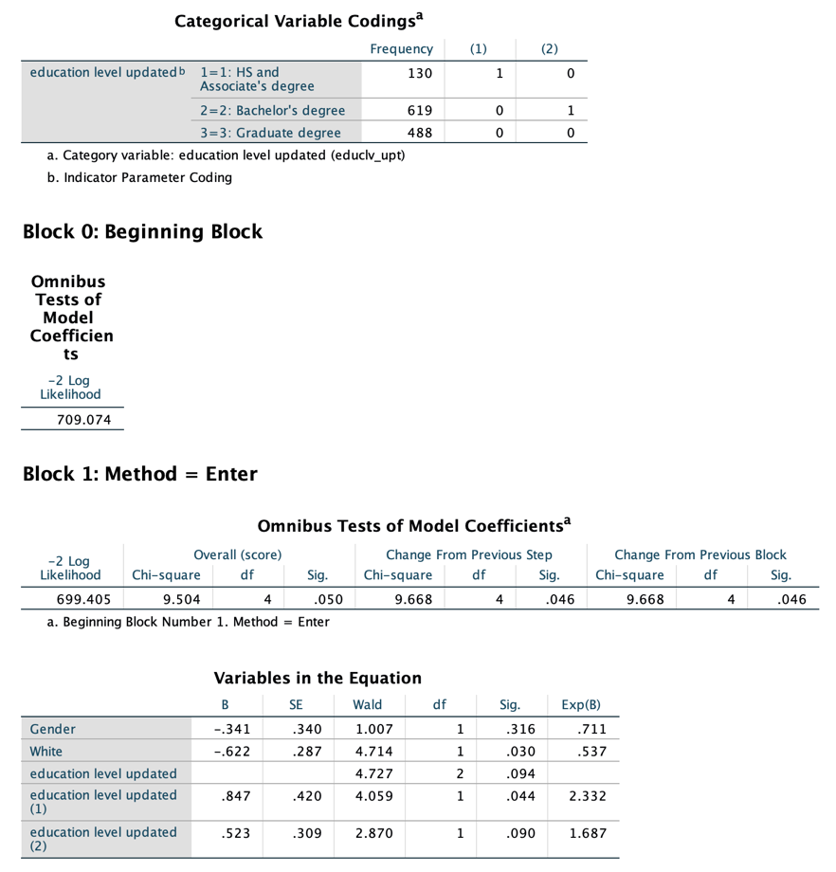

2.

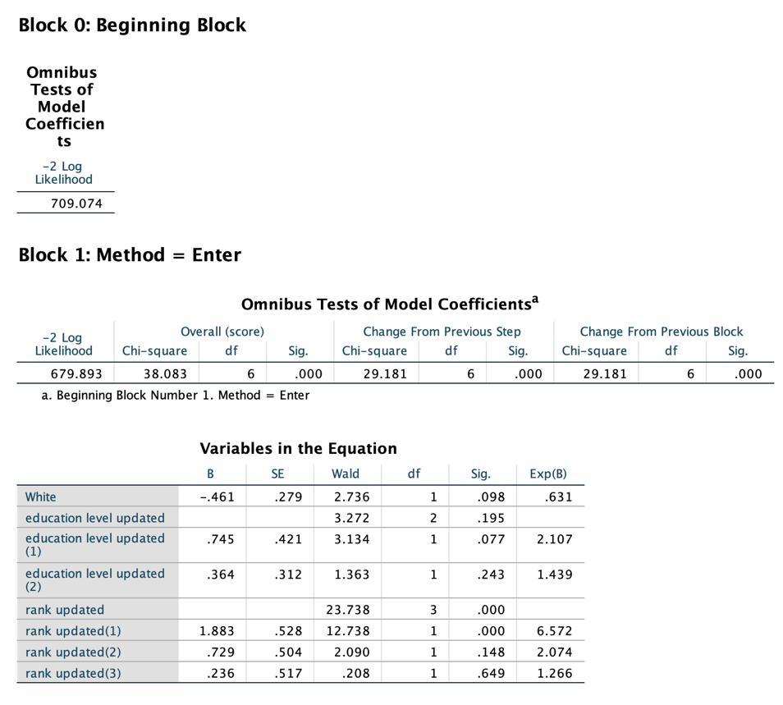

3.

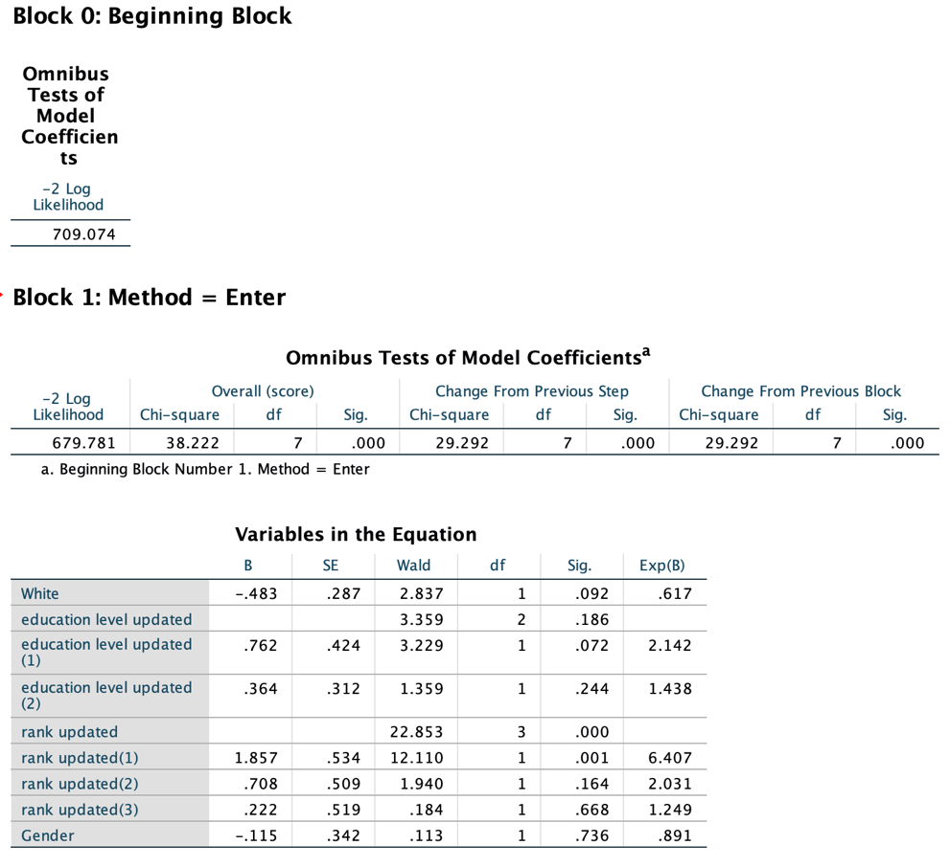

4.

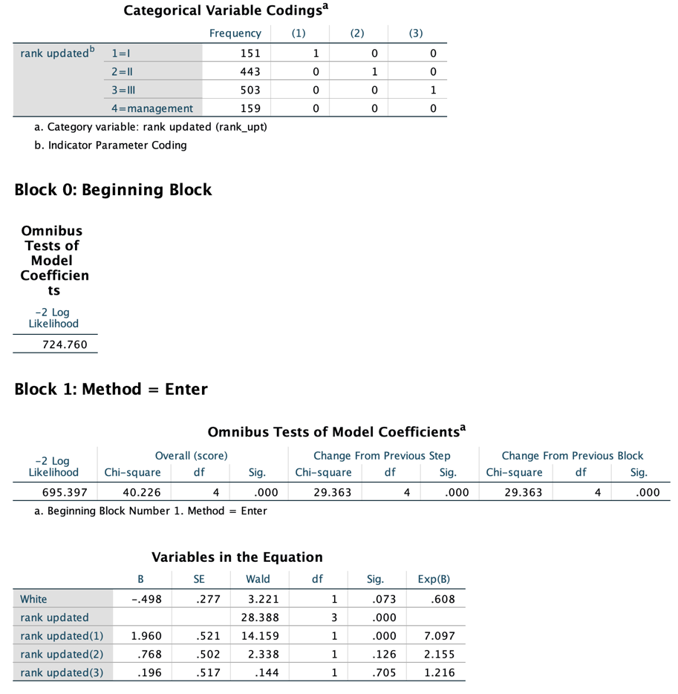

5.

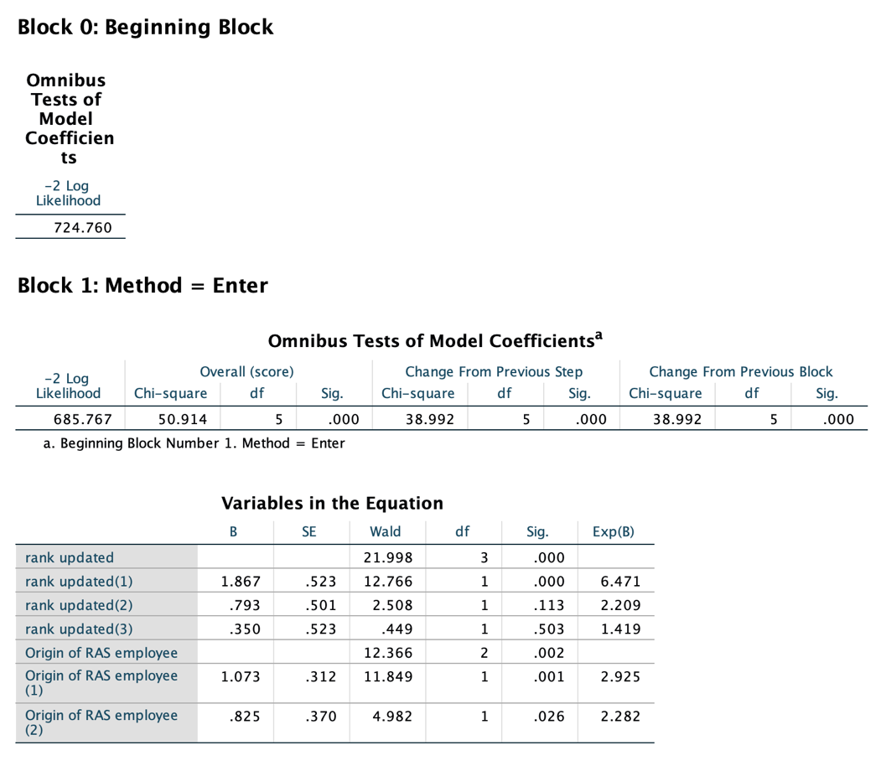

6.

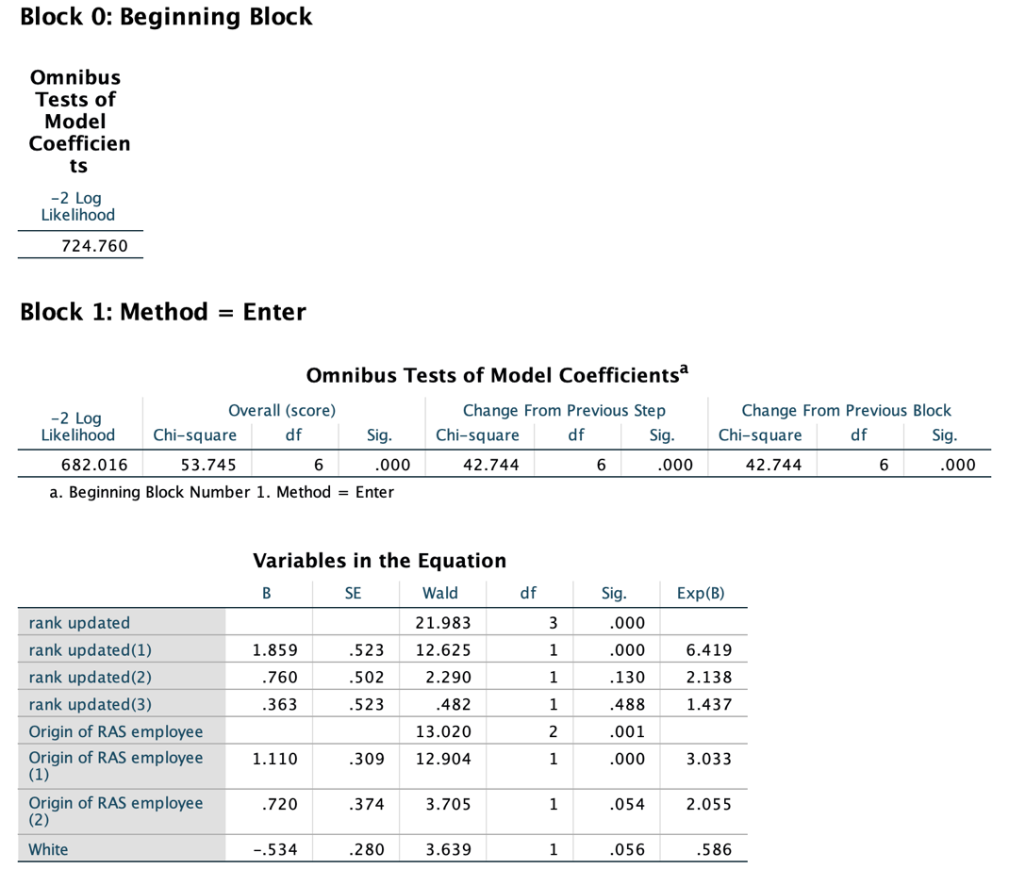

7.

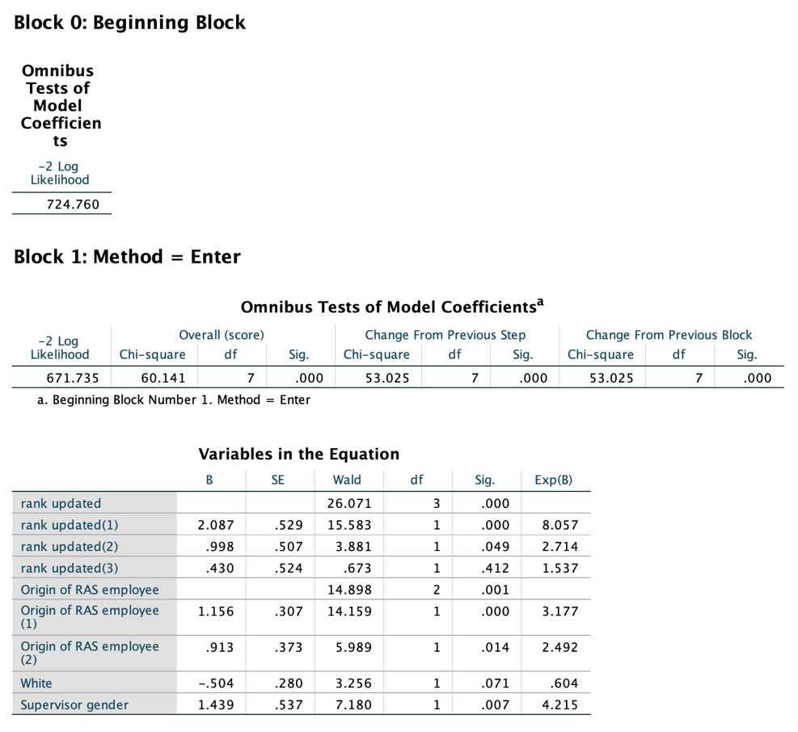

8.

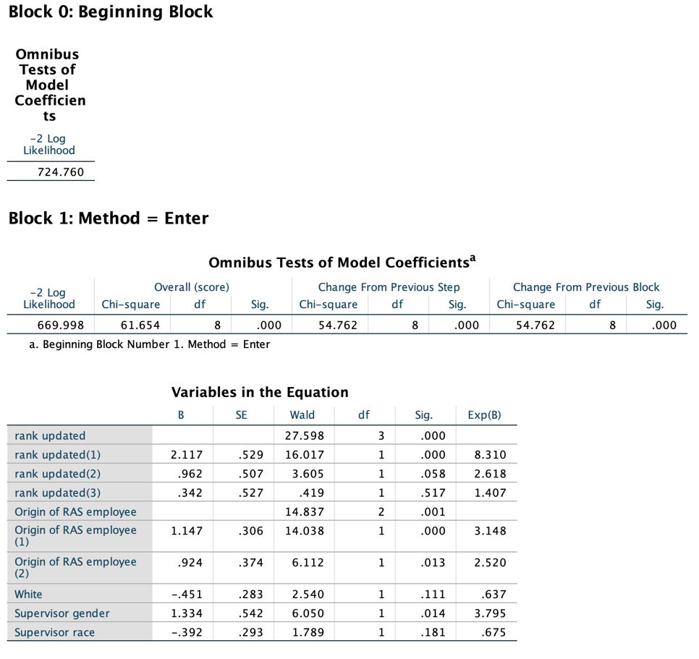

9.

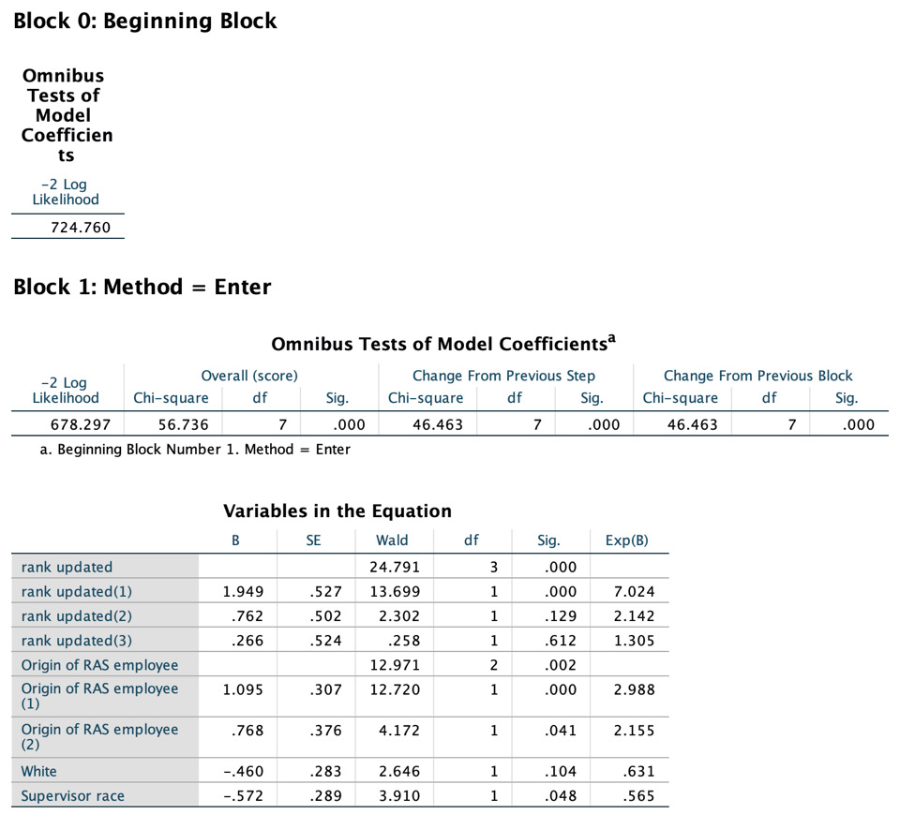

10.

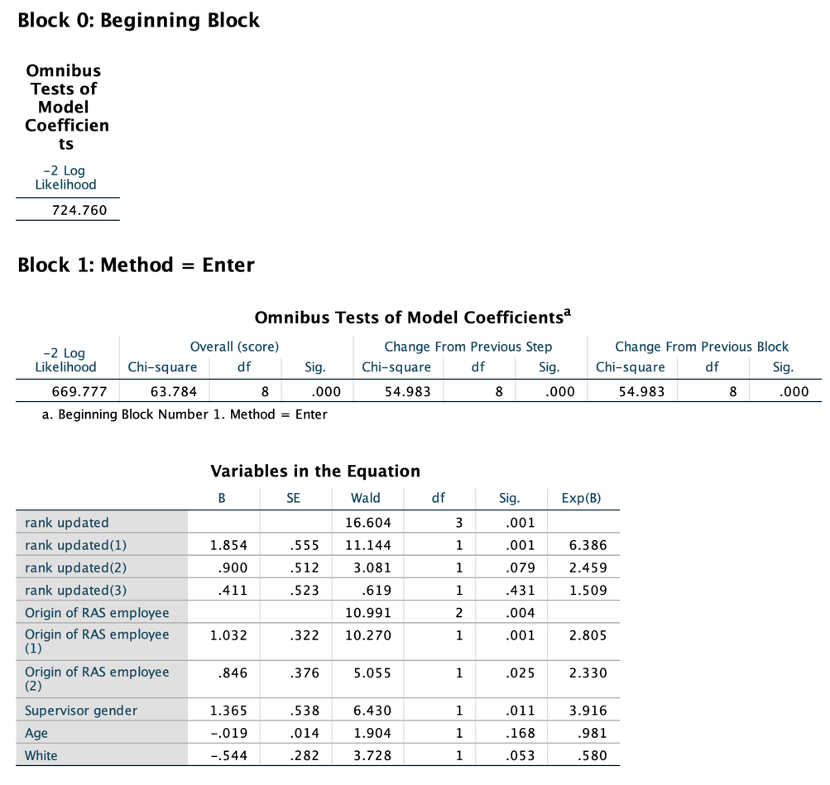

11.

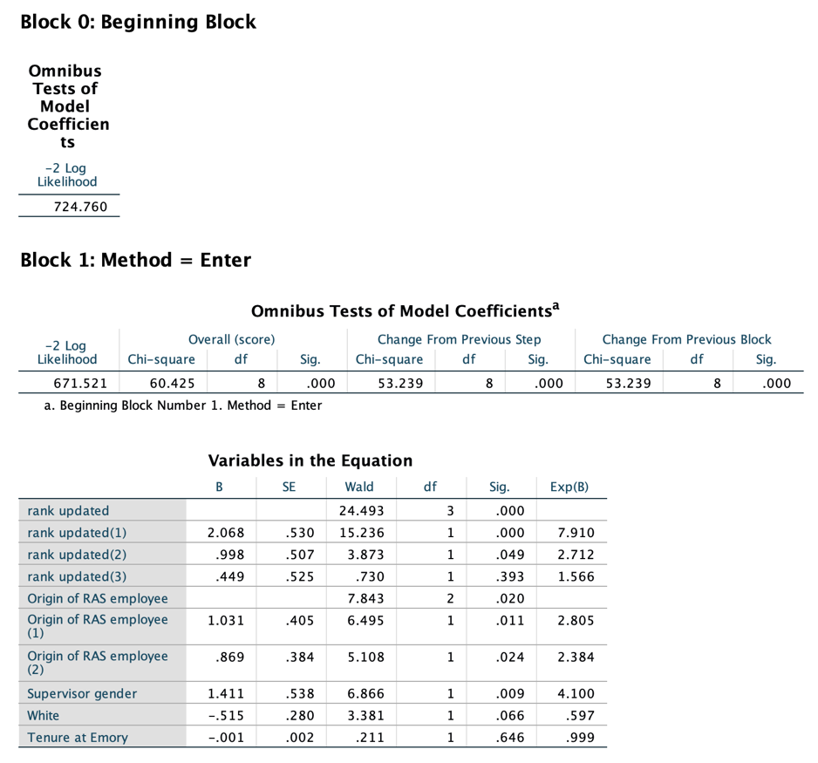

12.

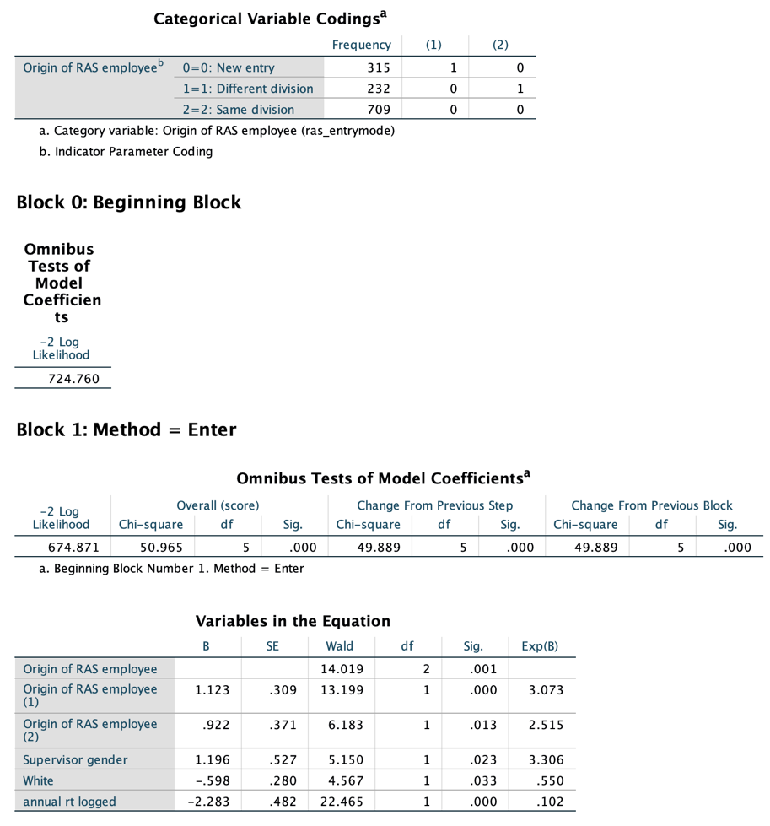

13.

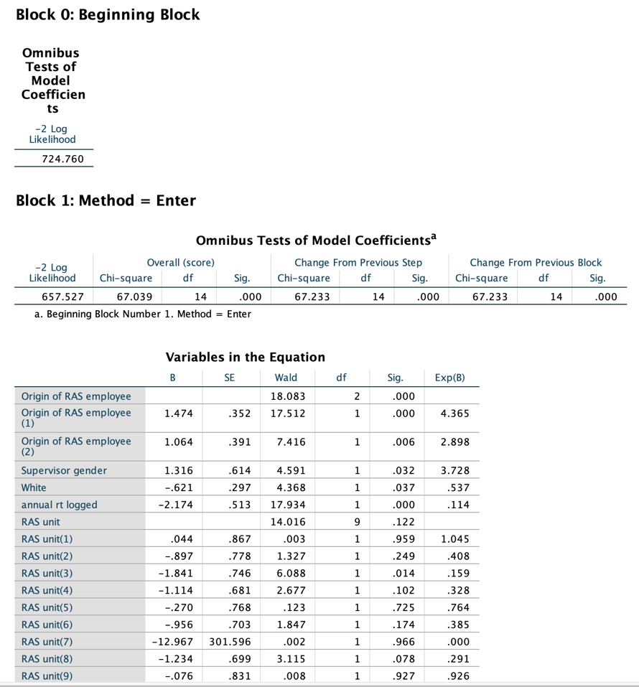

14.

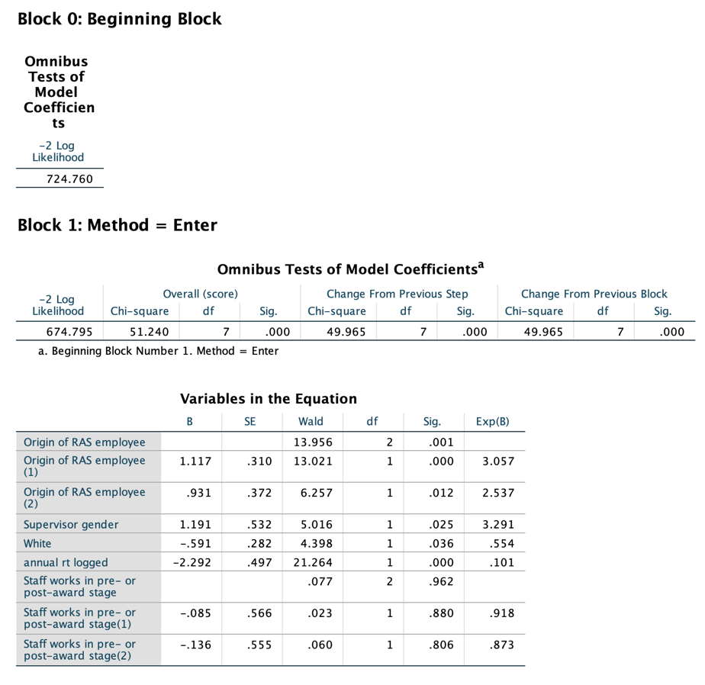

15.

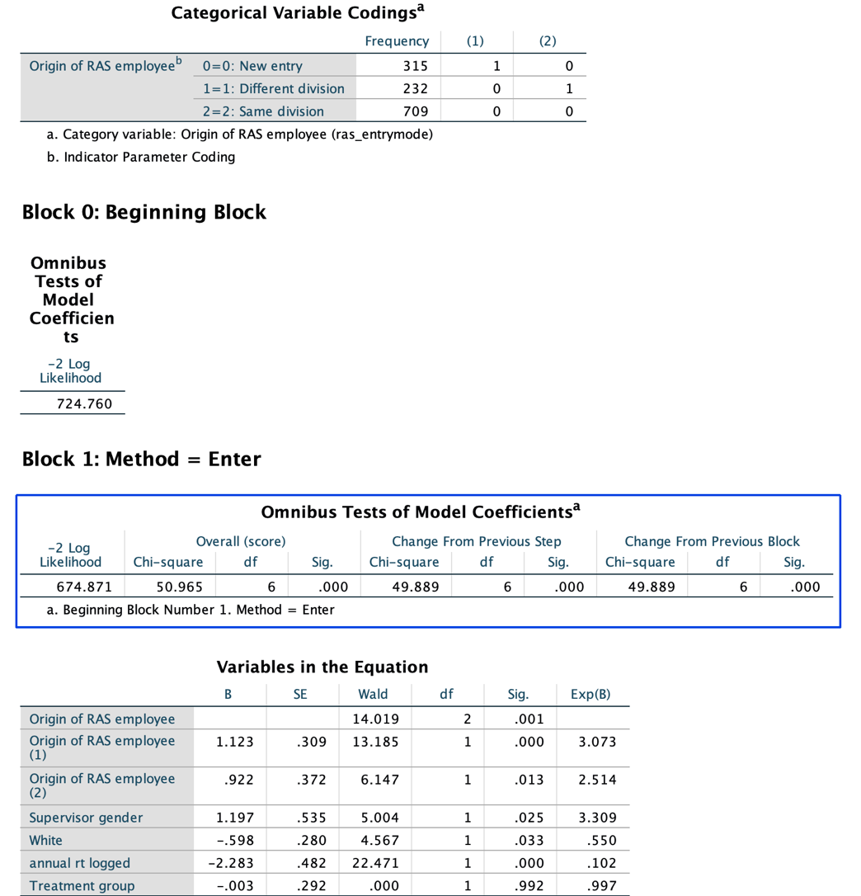

**III. Cox Regression Models for “Only Voluntary Quits”** (the order here is corresponding to that in the summary table)

1.

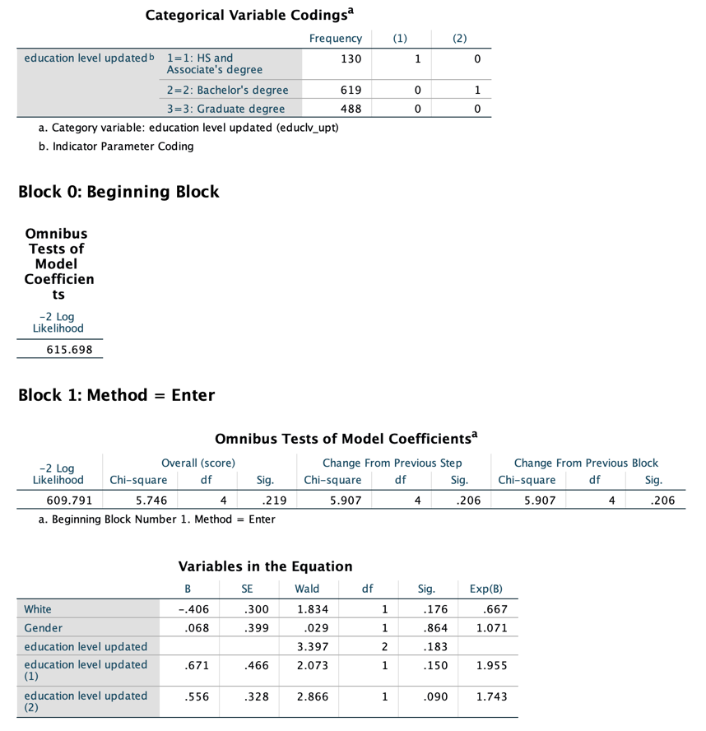

2.

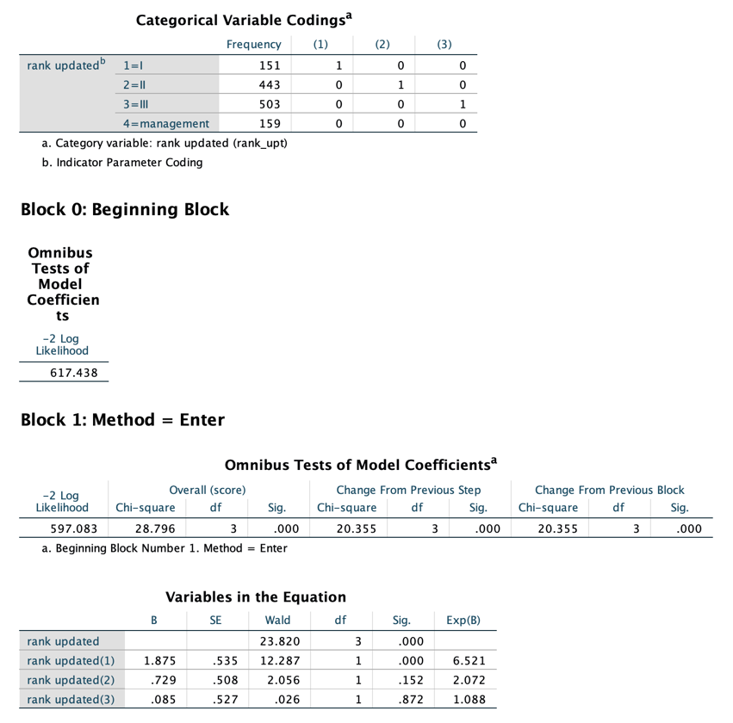

3.

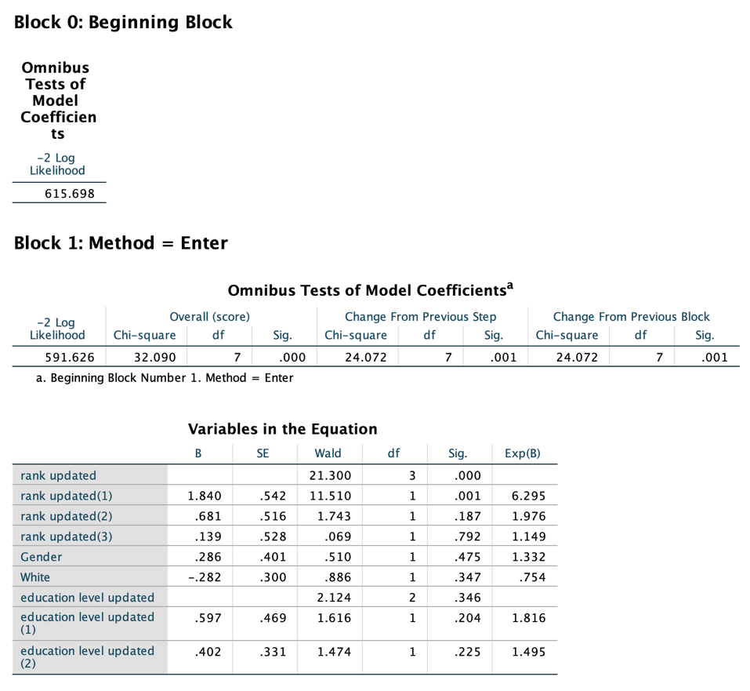

4.

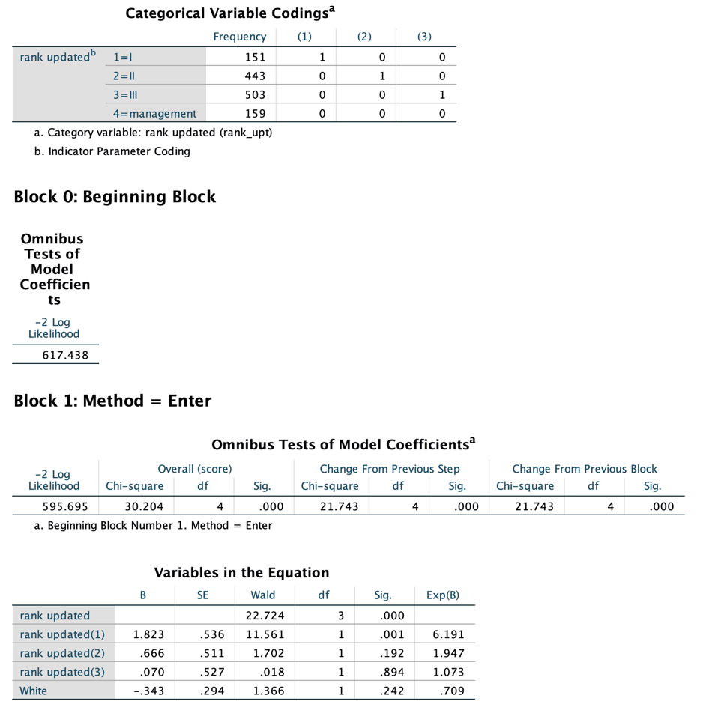

5.

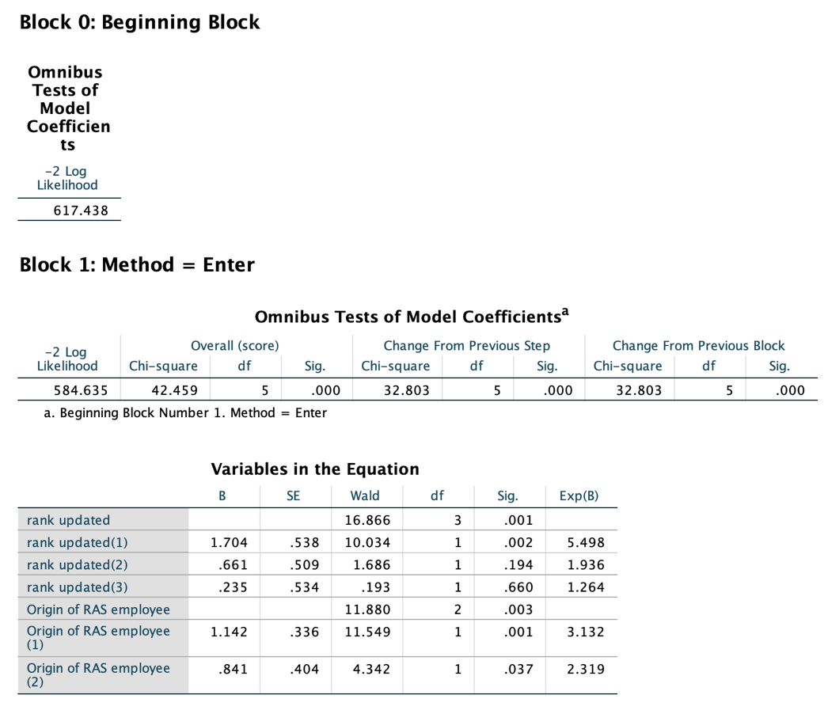

6.

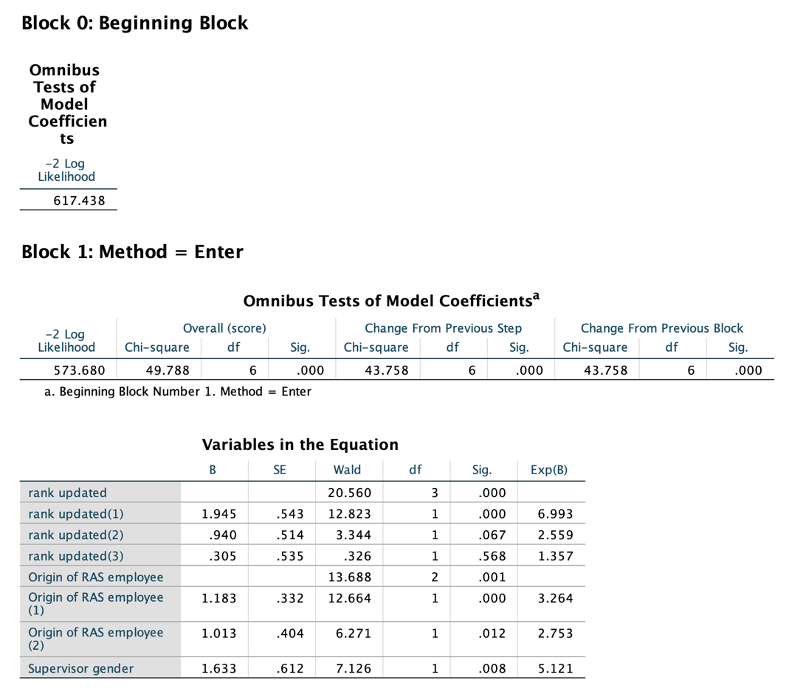

7.

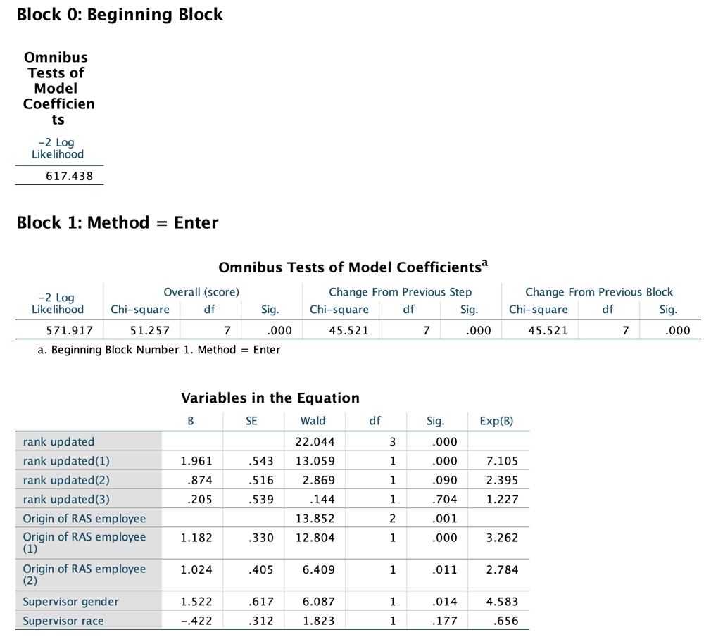

8.

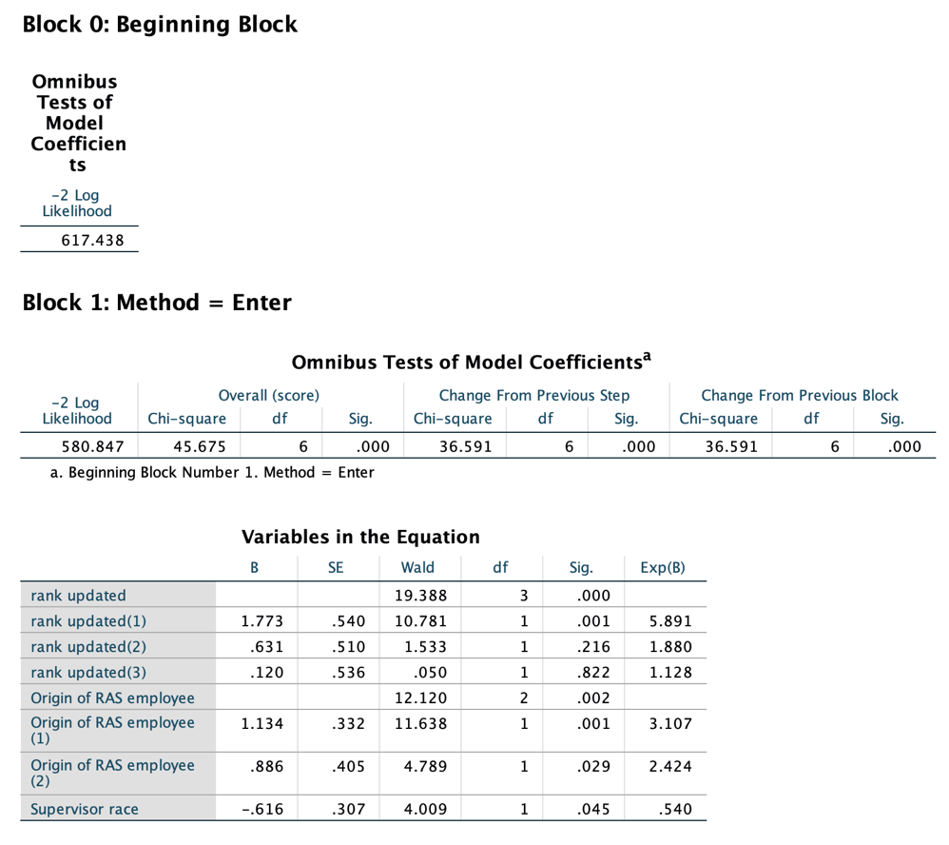

9.

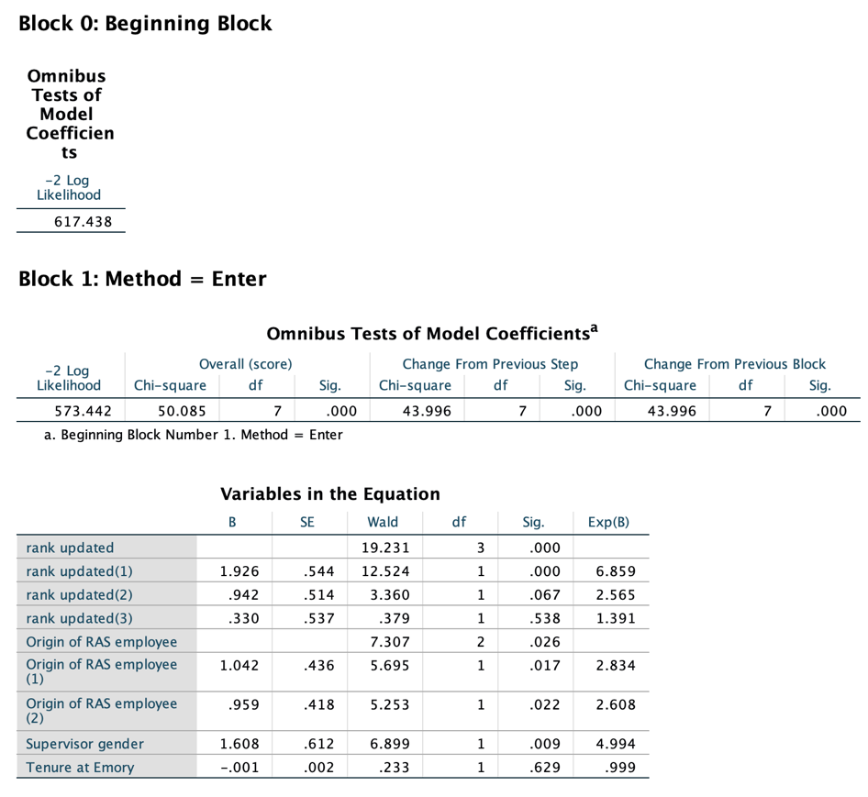

10.

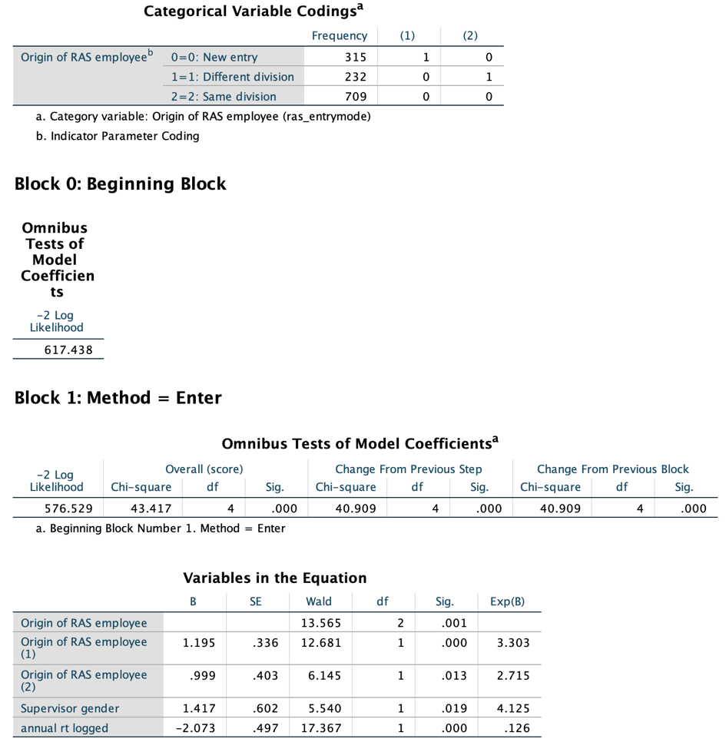

11.

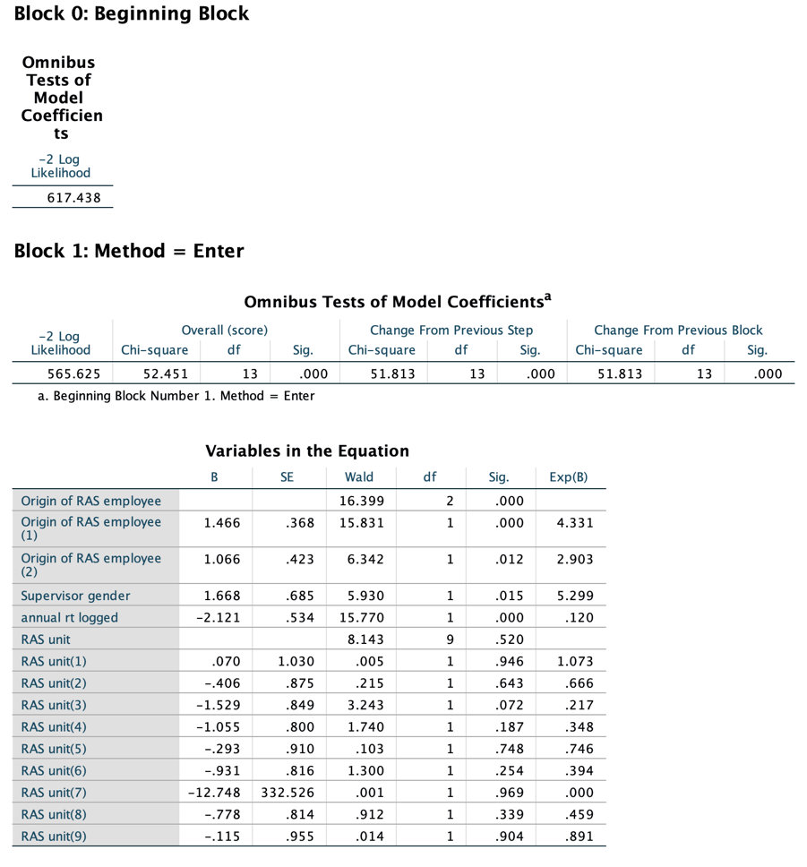

12.

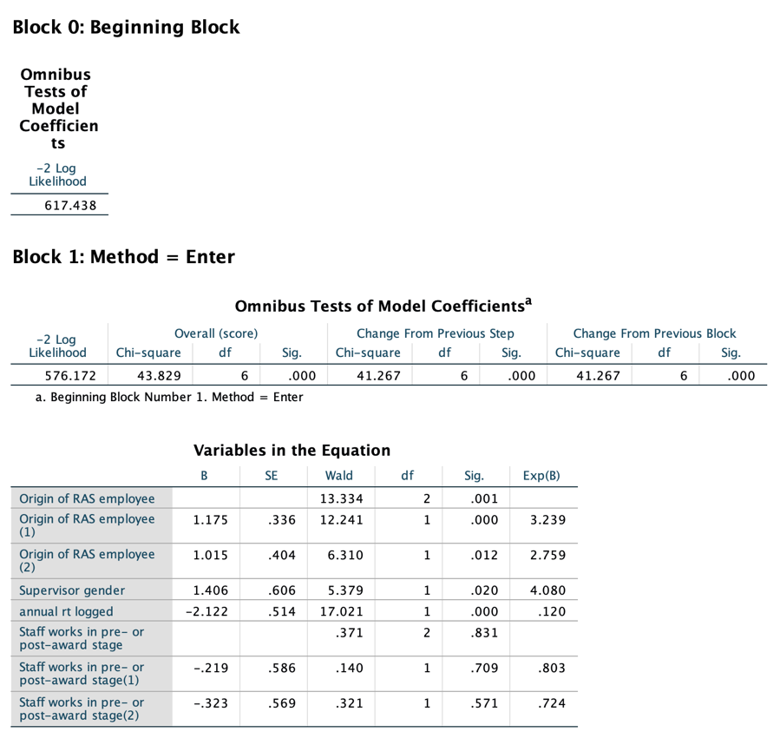

13.

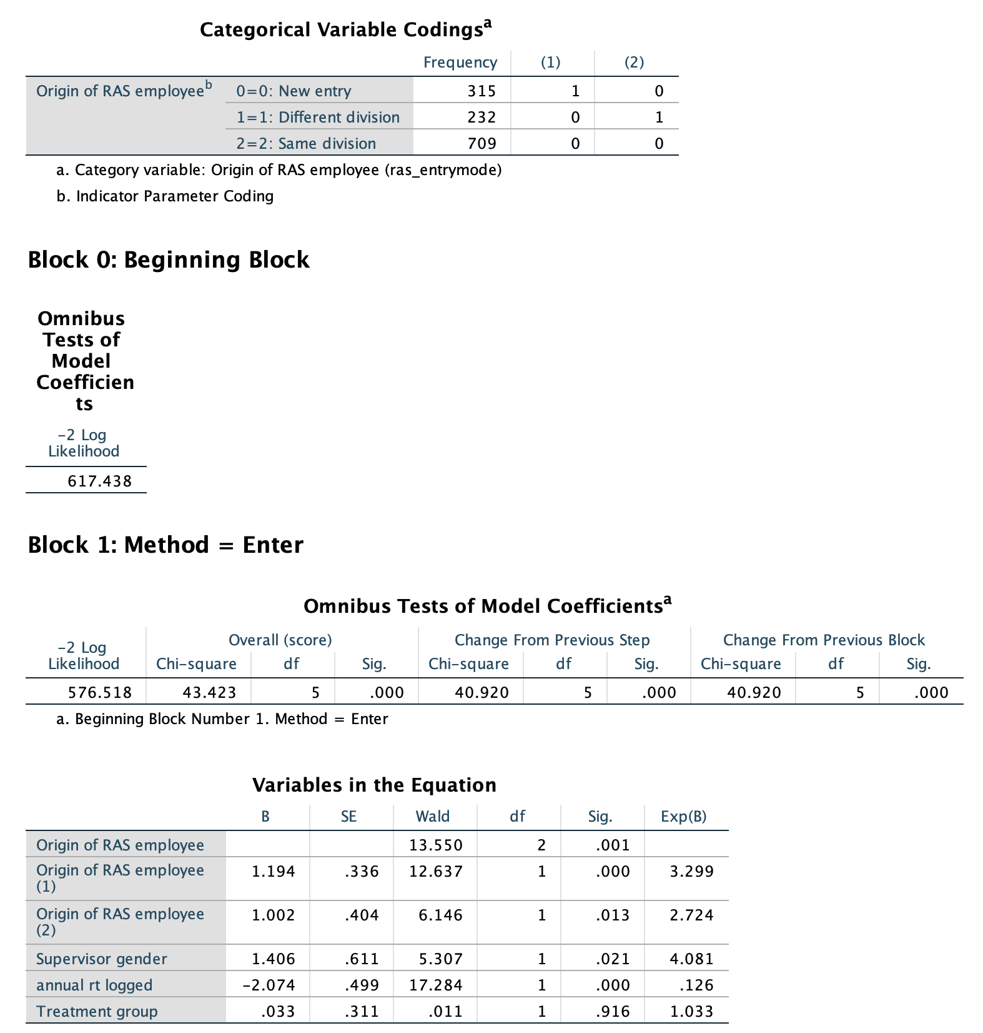

**IV. Cox Regression Models for “Only Involuntary Quits”** (the order here is corresponding to that in the summary table)

1.

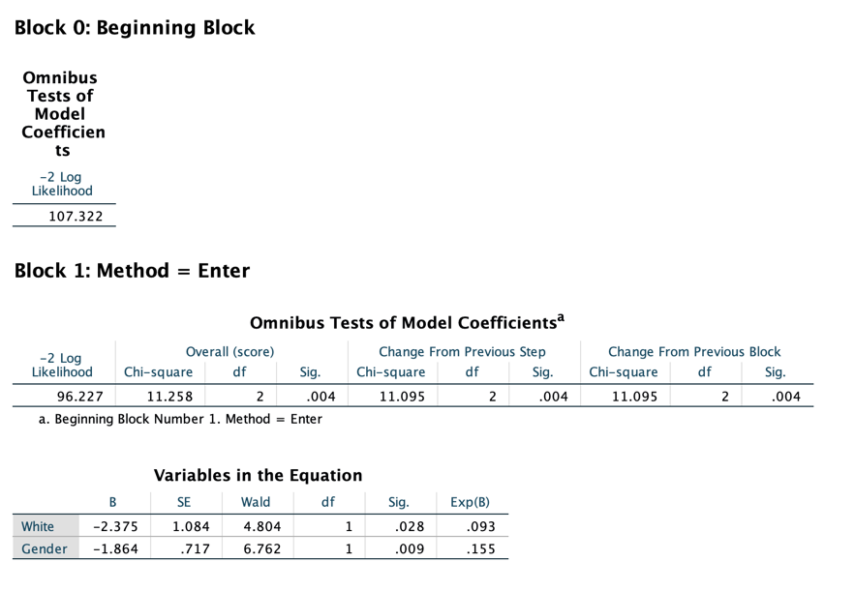

2.

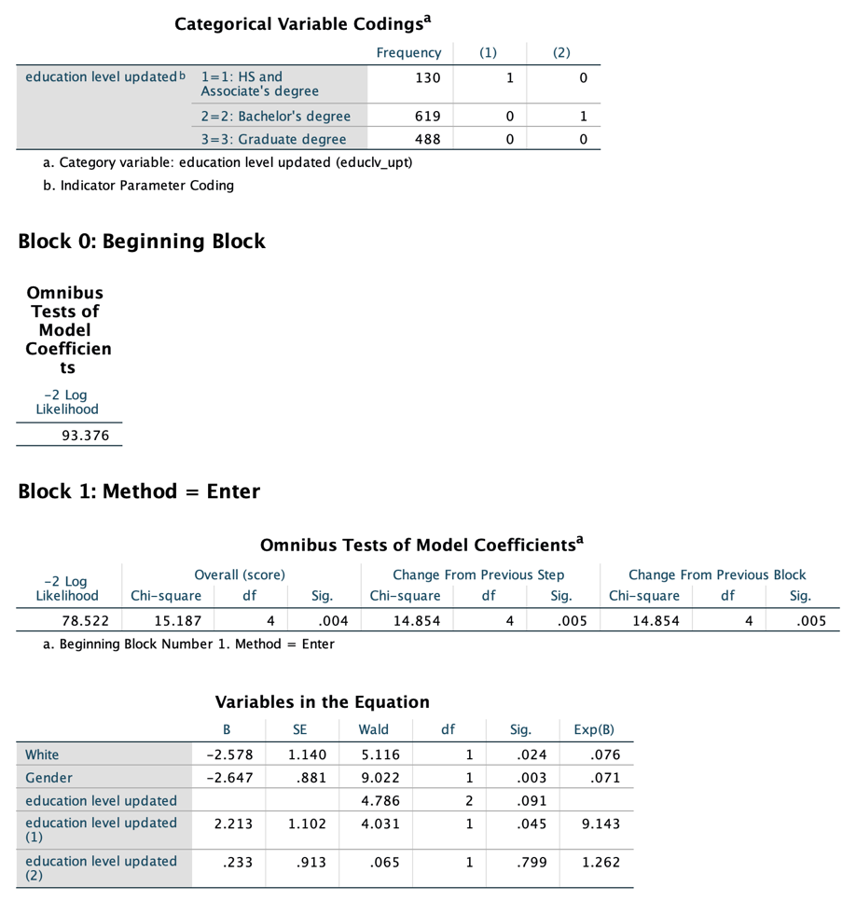

3.

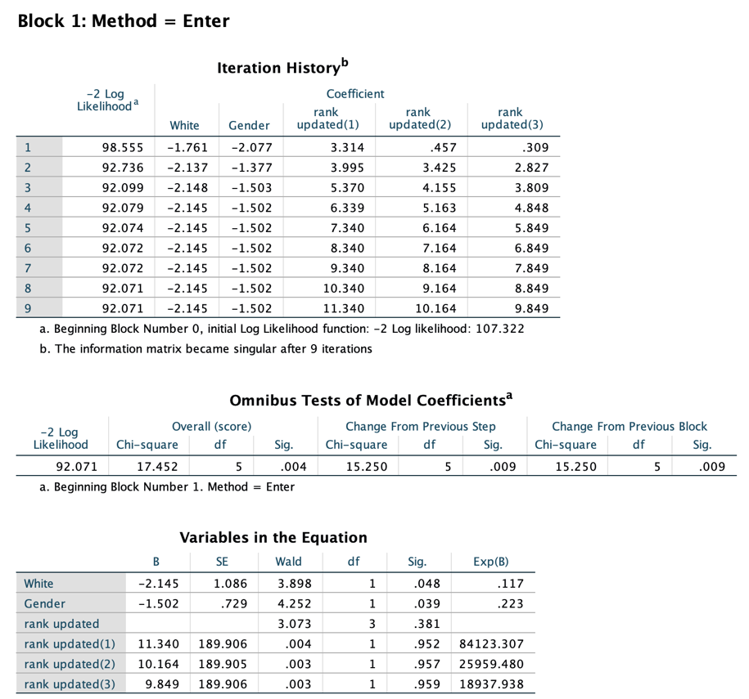

4.

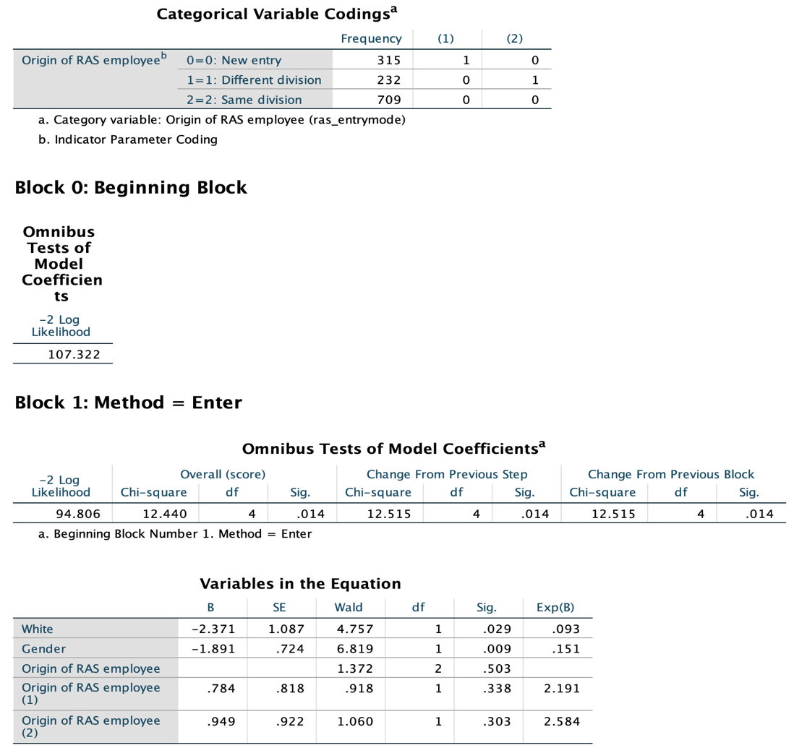

5.

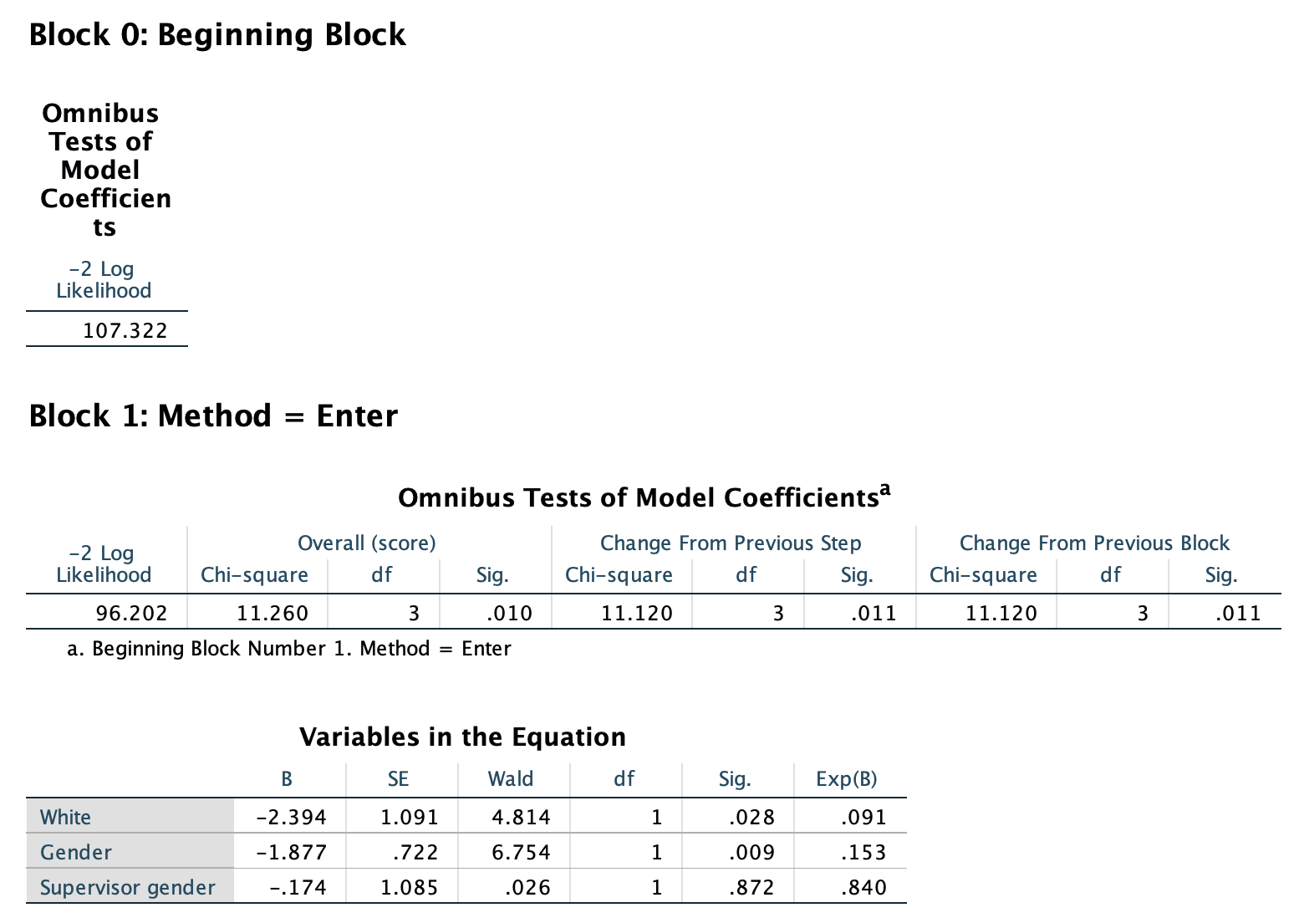

6.

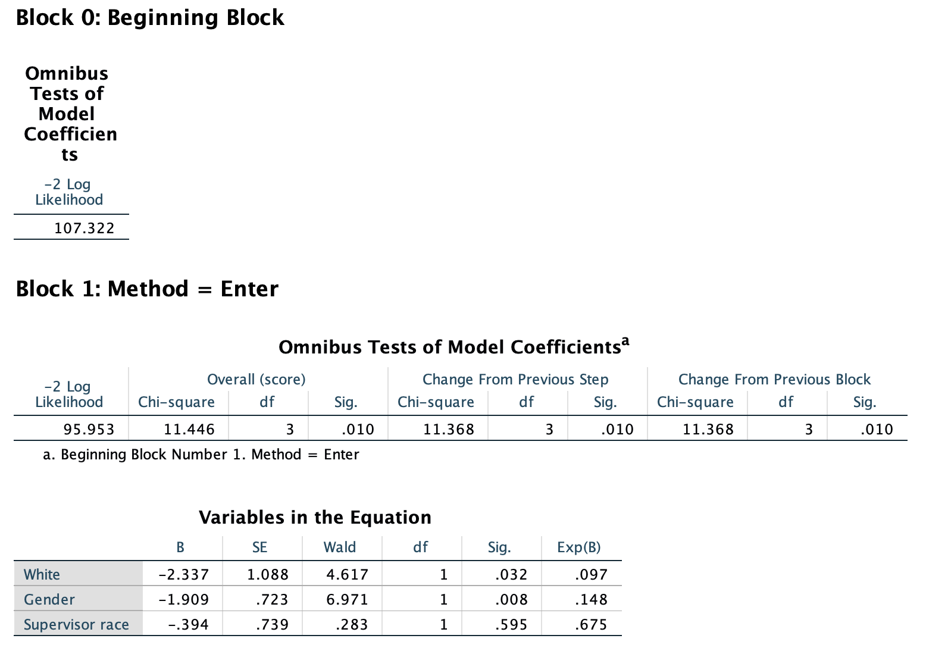

7.

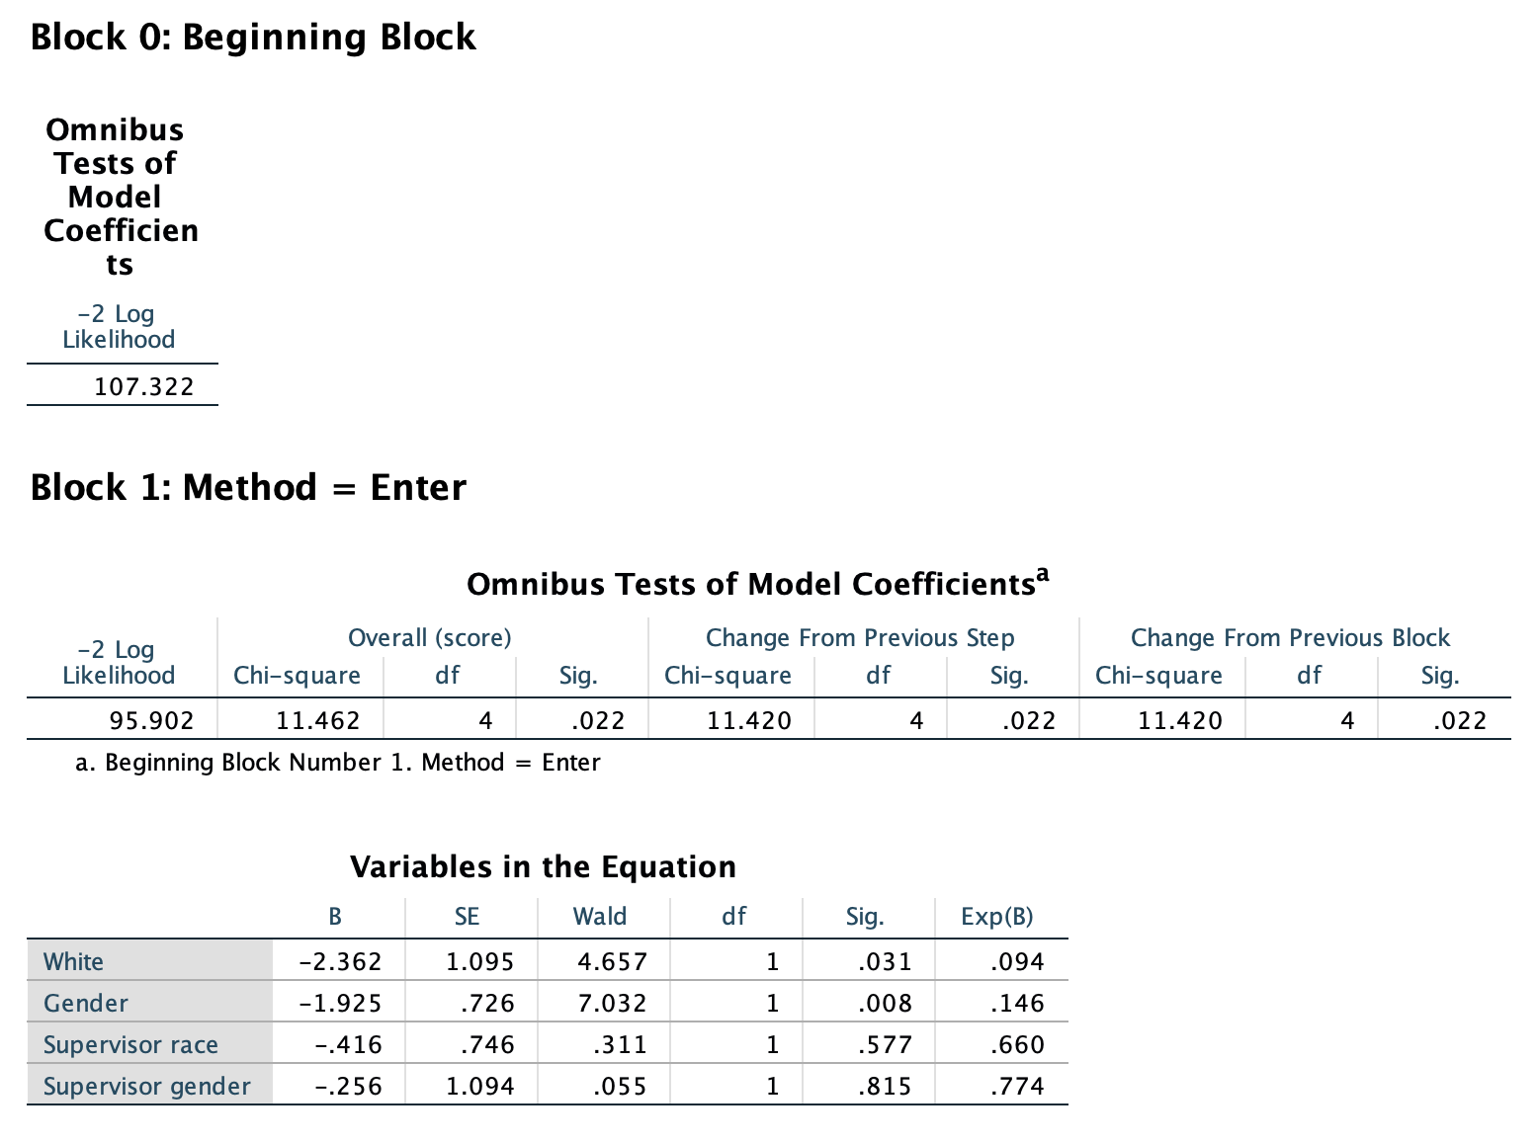

8.

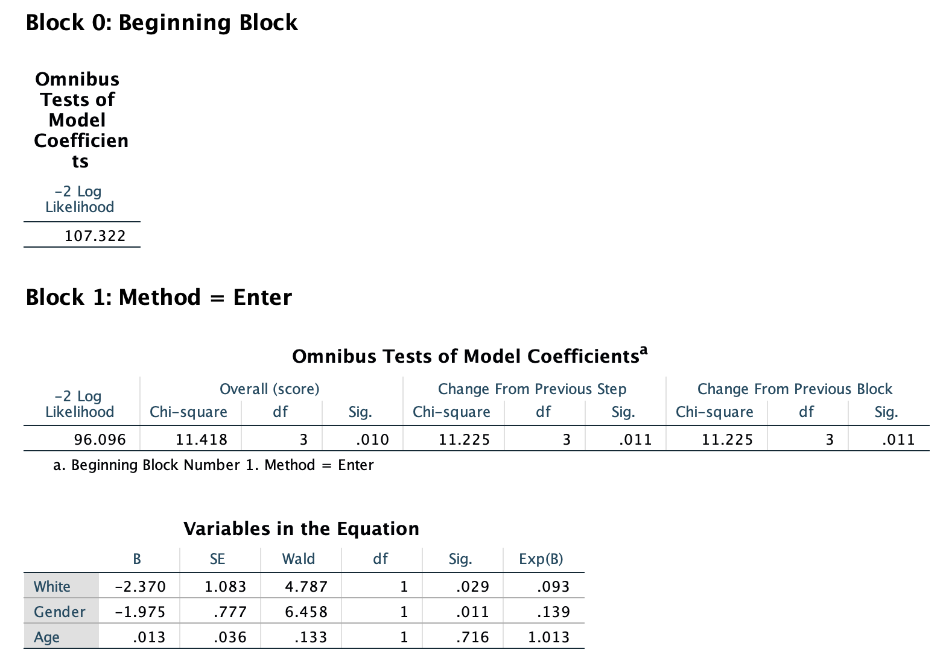

9.

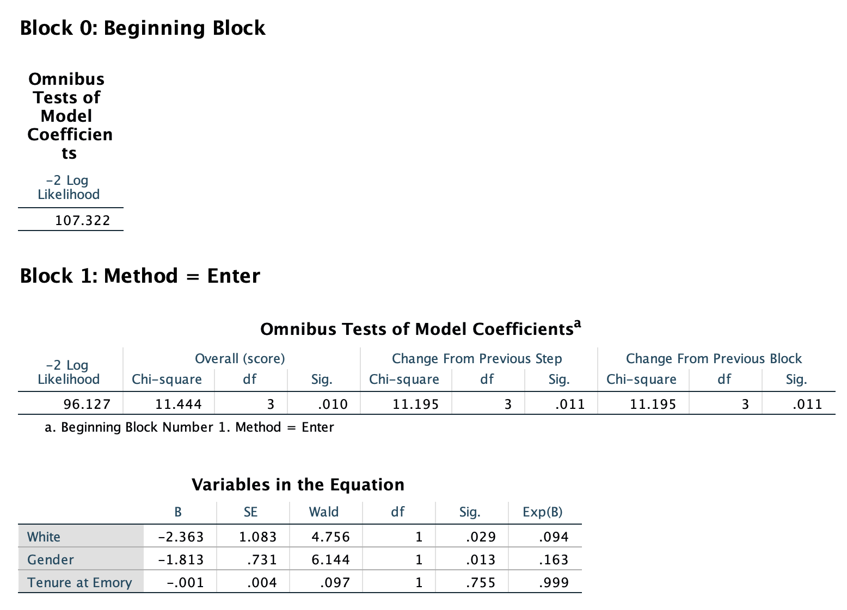

10.

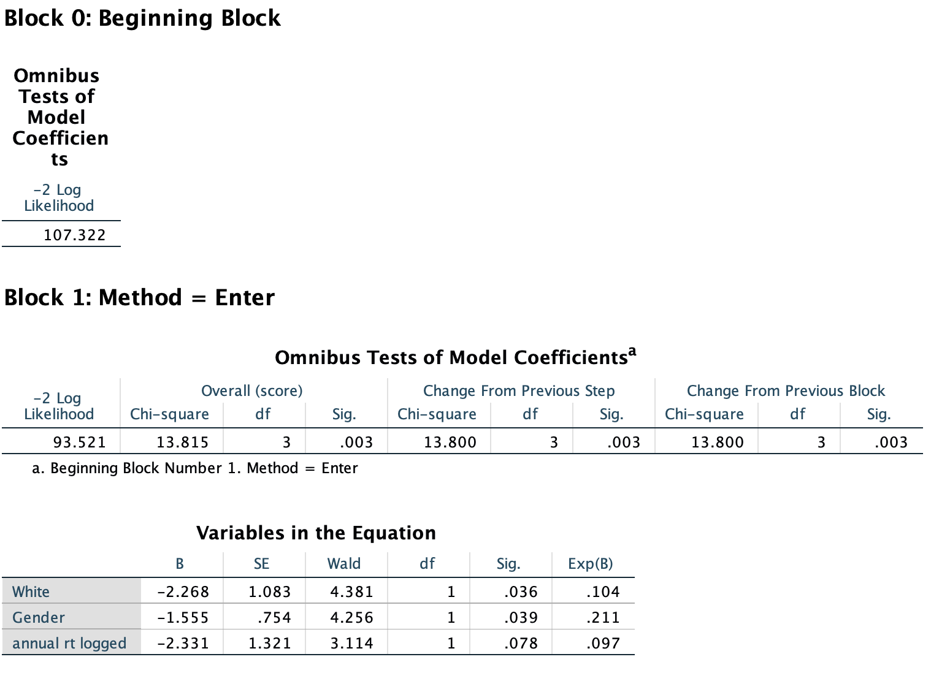

11.

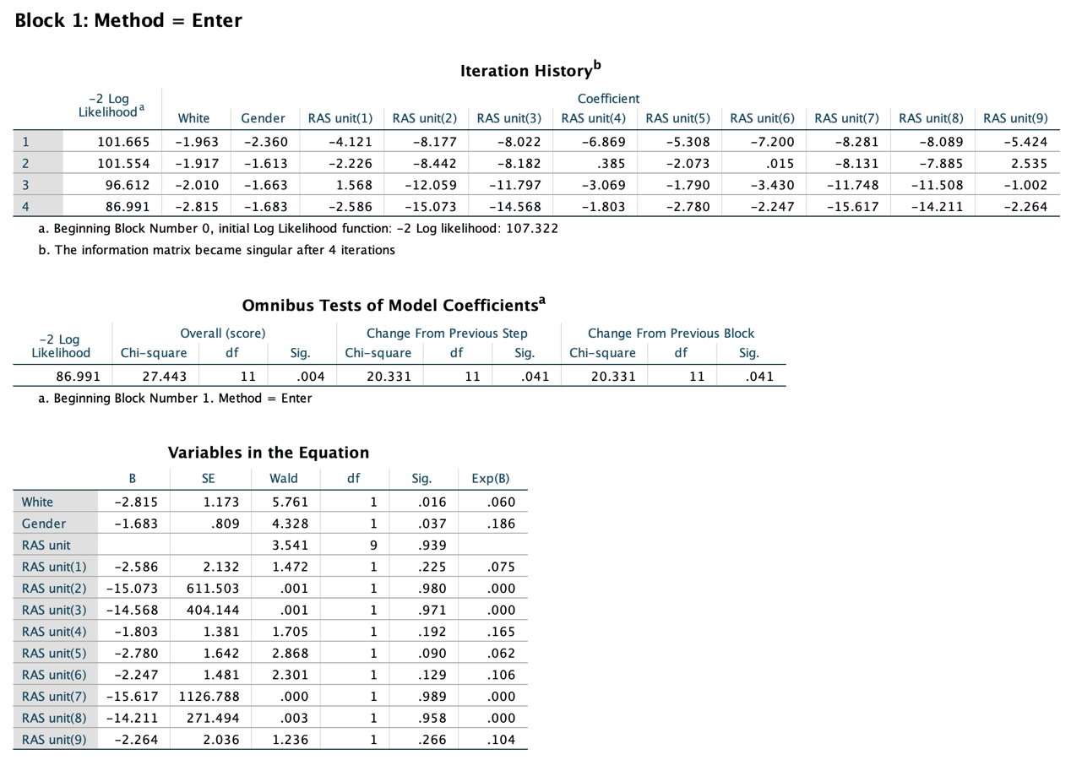

12.

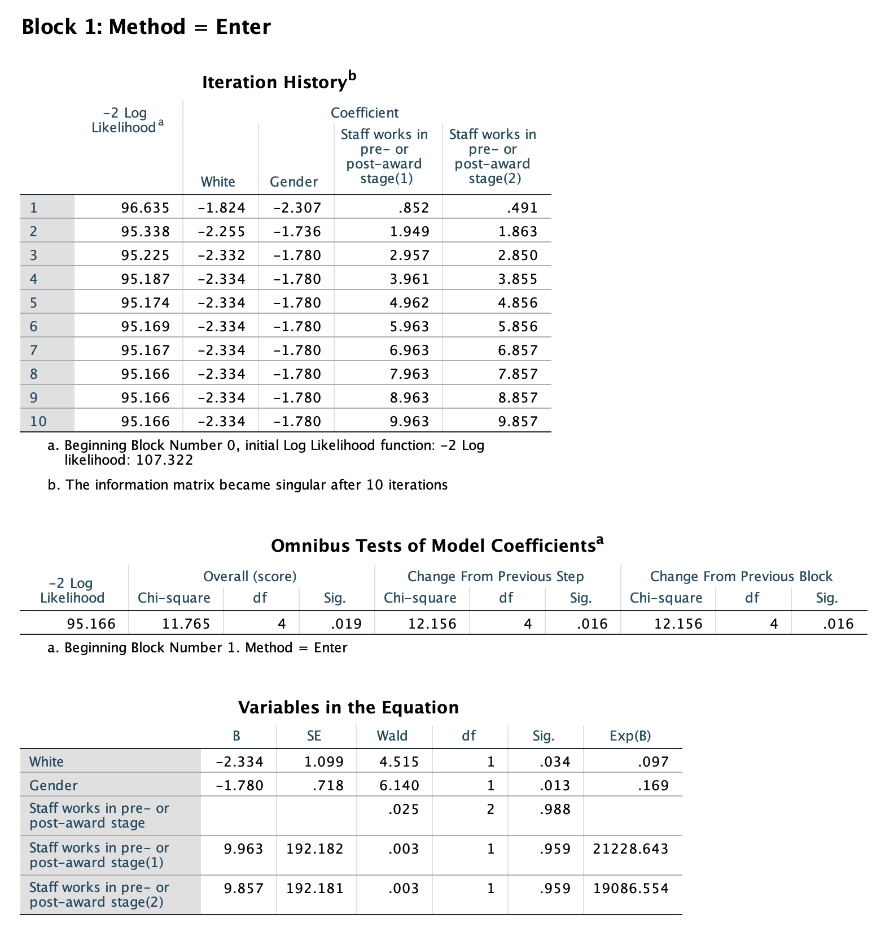

13.

